In the future I hope to become a Roboticist with a focus on helping the medical field. Vex introduced me to Robotics four years ago. Last year I went on vacation and visited the Massachusetts Institution of Technology Museum and got to see many different robots with many different functions. The robots I found most interesting were the robots that assisted in the medical field, such as the first robotic arm and an emotional intelligence robot. Visiting the MIT Museum and competing in robotics have both peaked my interests of the copious career opportunities there are in the STEM field.
Currently many doctors use robots to assist with surgery. “Robotic surgery, or robot-assisted surgery, allows doctors to perform many types of complex procedures with more precision, flexibility and control than is possible with conventional techniques. Robotic surgery is usually associated with minimally invasive surgery — procedures performed through tiny incisions. It is also sometimes used in certain traditional open surgical procedures.”-Mayo Clinic. I am fascinated that robots can help a Surgeon heal a patient with the help of a robot.
As a Roboticist in the Medical field I would like to focus on using my Vex experience to help improve mobility. One of my friend’s parents are both wheelchairs bound. I hope one day I can make wheelchairs more versatile to give individuals in wheelchairs more freedom of mobility. When I was out with my friend and his parents, I noticed how stairs are such a hurtle. The building we were at was massive yet only had one elevator. If the wheelchair had treads with traction and omnidirectional and gyroscopic capabilities, I think it would revolutionize wheelchairs. If wheelchairs had these capabilities it would have been easier for his parents to move up steep objects like stairs and not have to rely on the one elevator in the building. Along with stair the wheelchair would also be able to easily maneuver on trails in mountainous areas. This would be a great improvement for people in wheelchairs.
After recently talking with my grandma, who was a nurse in a hospital she told me a difficult part about her job was lifting bed ridden people out of their bed. There is currently a lifting mechanism for most hospital beds, but it is still hard moving bed ridden patients even with the complicated motorized hospital bed. This is a problem that I would like to help solve by designing a more efficient and effective way of helping patients move who are unable to help themselves move.
People working in the medical field risk their lives helping keep us safe and healthy. If I could make their lives easier alongside with the patient’s life more enjoyable than I would feel happy helping, make the world a better place. Even though I am only in Middle School and I may change my mind for a future career path there are so many careers in the STEM field that interest me. Some of these careers are Mechanical Engineering, Architecture and Astronomy. I have always had in interest in Robotics and Mechanical Engineering because there is never one specific solution to a problem. There are many unique ways to solve the problem that fits your specific needs. I love architecture because it is not only a science but also an art. I went to the Walt Disney Concert Hall in Los Angeles I found this building and its structure remarkably interesting. It felt to me more like a piece of art than an actual building and really inspired me. Finally, I love astronomy and am drawn to it because of its beauty and complexity. I have visited the Griffith Observatory in Los Angeles and the Lowell Observatory in Arizona. These two places really interested me in astronomy and the beauty of the universe. Vex has prepared me for any Stem career I choose. Vex has taught me critical thinking, teamwork, and grit.

Title of Essay: Robotics in Healthcare
Name: Michael Stahl
Location: Chandler, Arizona USA
Team Number: 4751Y
Team Name: Phantom Phoenix

Sources: https://www.mayoclinic.org/tests-procedures/robotic-surgery/about/pac-20394974

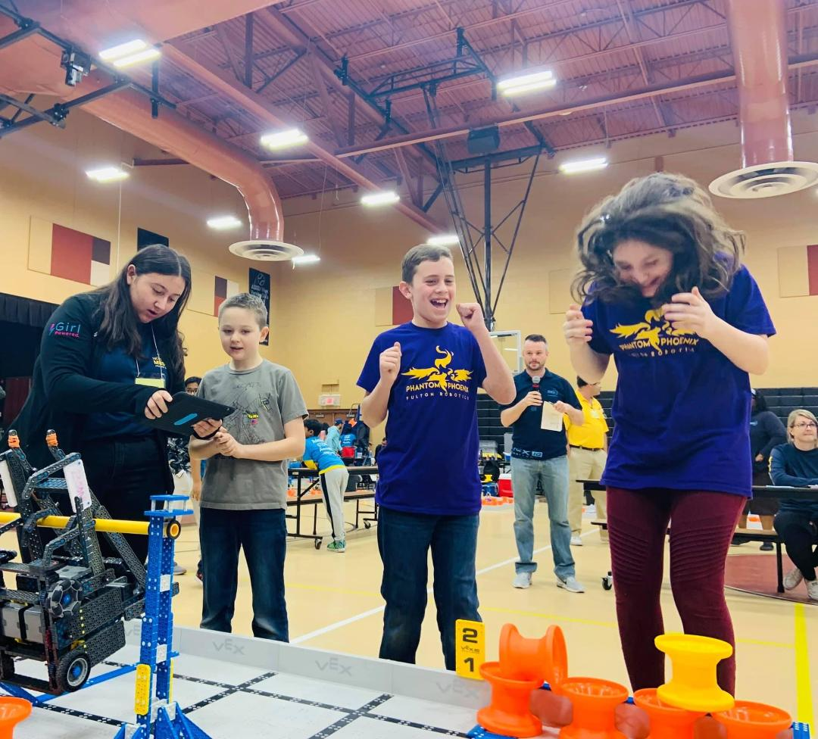
Vex Robotics
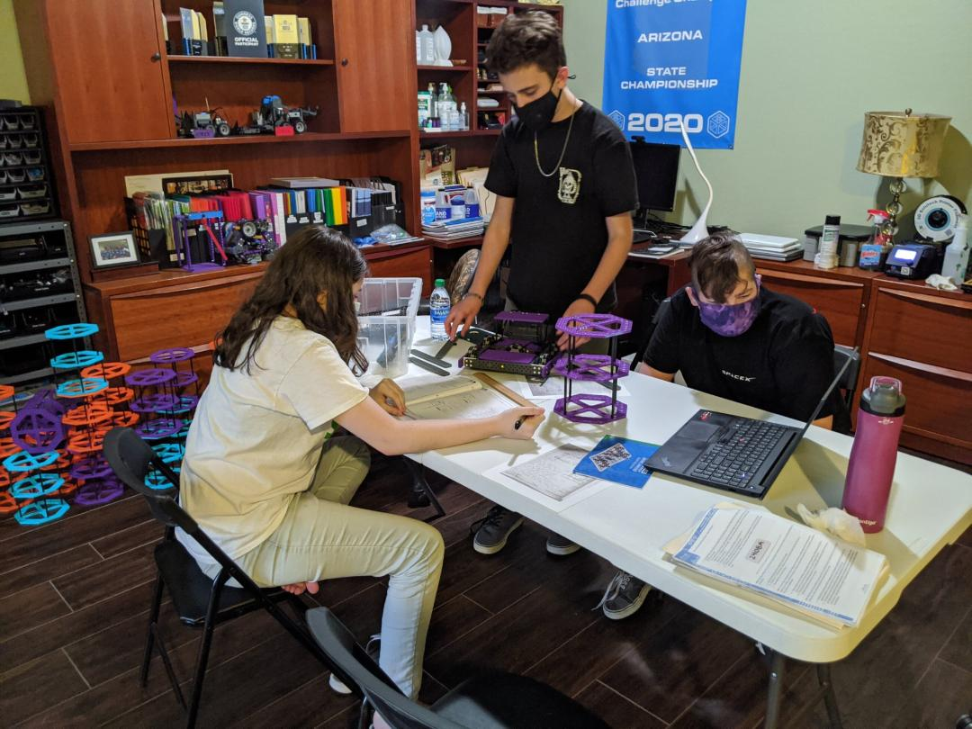
Vex Robotics 2020
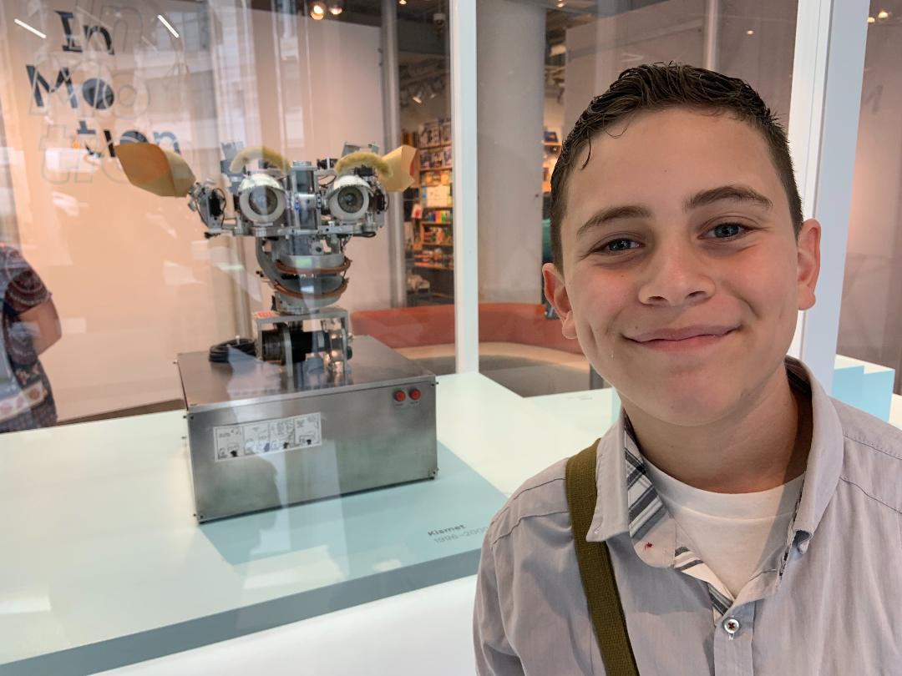
Emotional Intelligence robot at the MIT Museum
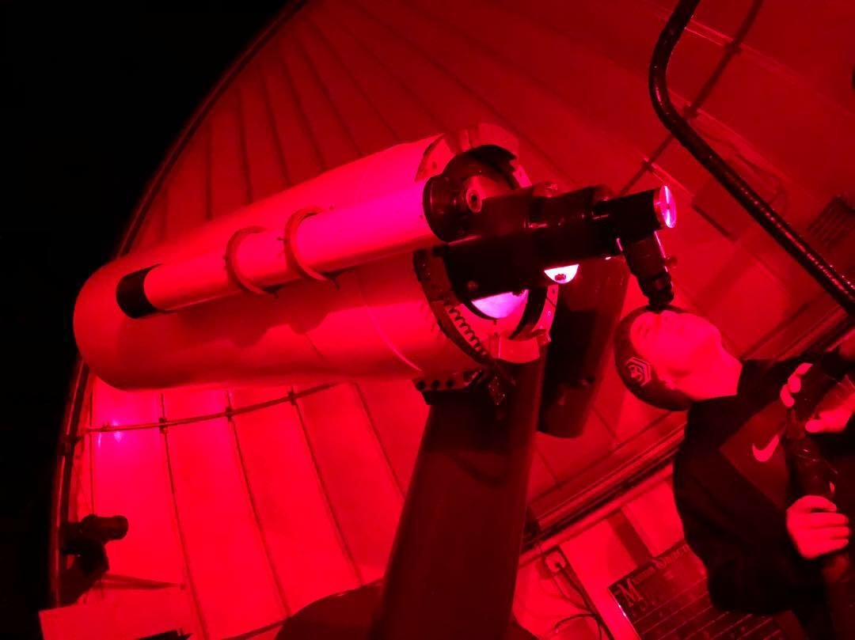
Looking at Mars at the Lowell Observatory
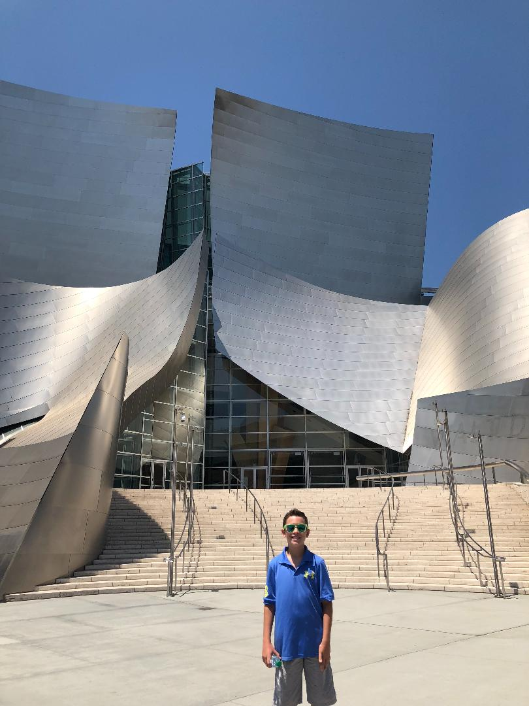
Architecture at the Disney Concert Hall

