Liam Murphy
Team: 4154 X
3D Printed Spacer

Introduction
I decided to create the custom spacer because it is a great vex part to make customizable. Custom spacers let a robot have extremely accurate spacing in its axels and screws. It also lets you use only one spacer in an area where you would normally use many.

Use of Part
The custom spacer would be used in situations where it is favorable to use one spacer instead of many and in situations where precise spacing is needed. Axels that need specific spacing can be serviced with much more ease. This can allow the making of a robot with absolute perfect spacing so that it can perform more efficiently.

Design Process
First, accurate measurements of parts and spaces are made with a caliper and a ruler. These measurements are used to determine the length and diameter needed for the job that the spacer must accomplish. Depending on the situation that the spacer will be used, we can change how thick the spacer will be. In situations where the spacer would be under more stress, the thickness of the spacer is increased. In situations where the spacer is under less stress, we can reduce the thickness, since the diameter of the spacer will affect the print time. Once the dimensions of the spacer are determined, the spacer gets modeled in cad. After the spacer is sent to the printer and it is finished, it is taken out of the printer and utilized in the robot.

Conclusion
From this project, I learned how to better apply Tinkercad to create parts that can help my robot. I will probably use 3D design software in the future in my robot because it opens up many possibilities for improving the robot’s quality. I think that 3D printing parts are good because it allows for more specificity in your robot.

Images of Exmple 3D Render
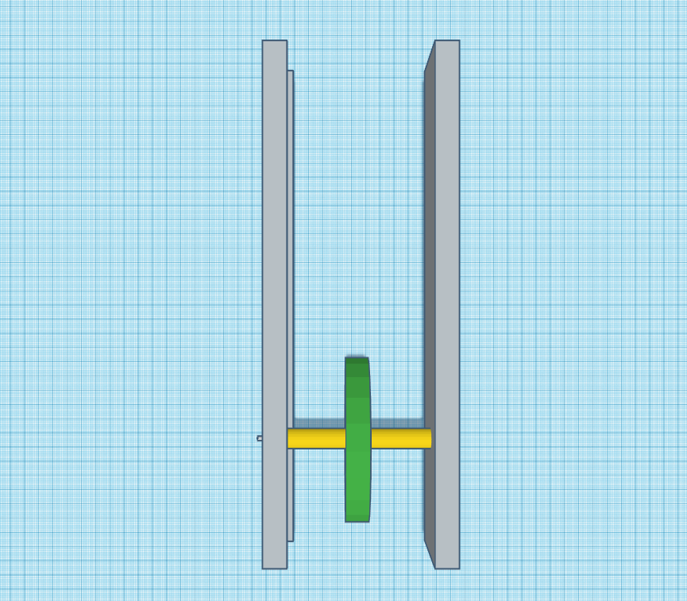
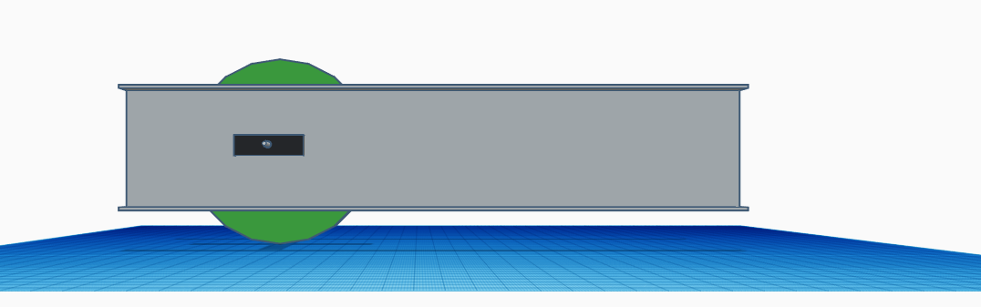
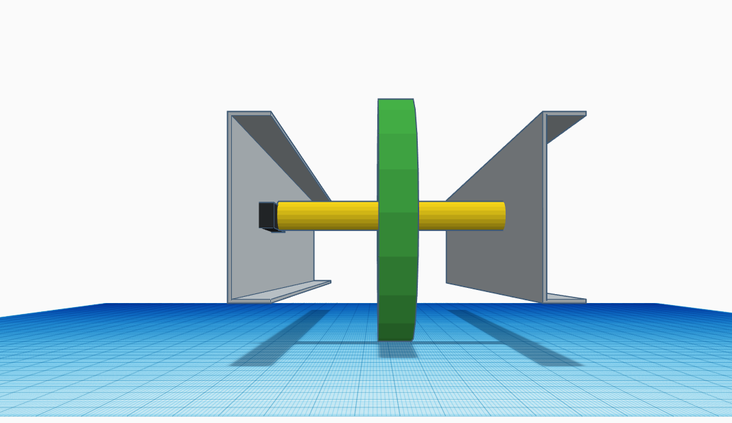
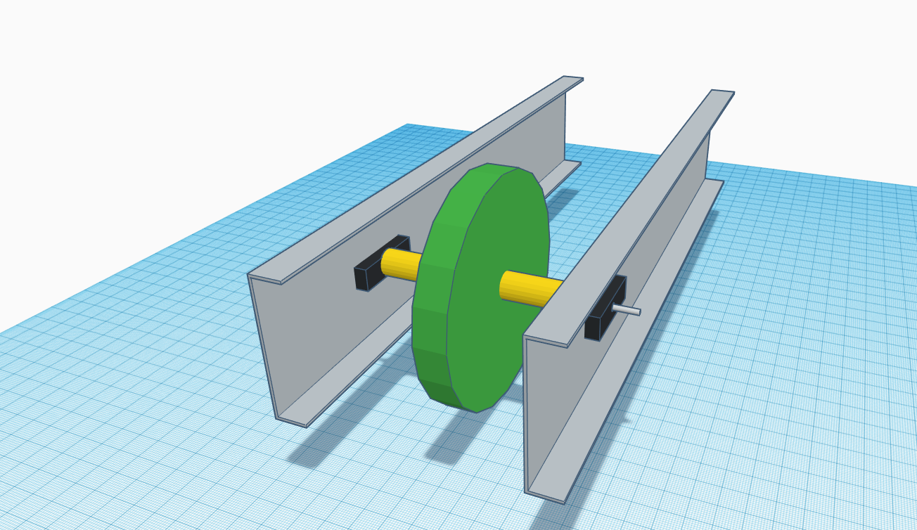
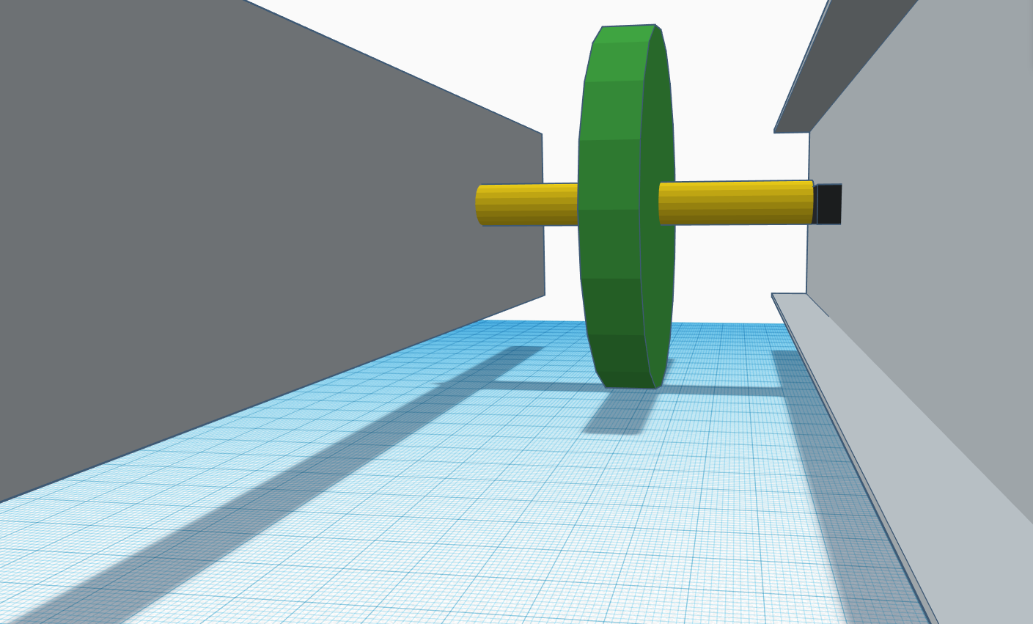
1:1 Scale
Dark Grey: 25 Hole C-Channel
Light Grey: Axel
Green: Wheel
Black: Bearing Flat
Yellow: Custom Spacer

Images of Example 3D print
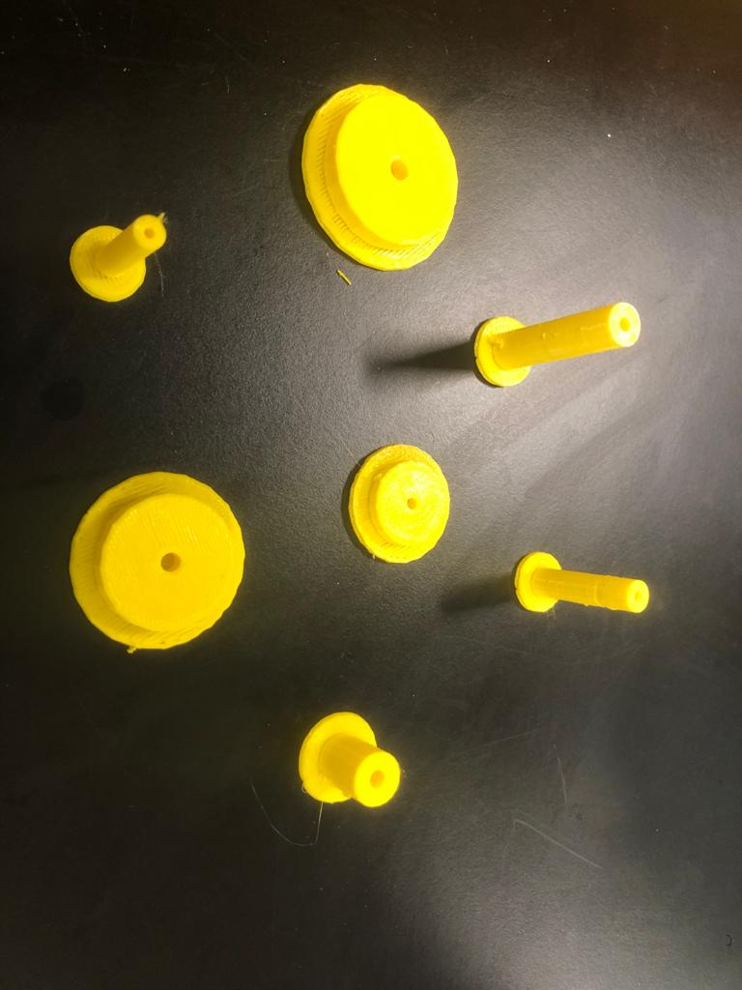
Spacers after printing
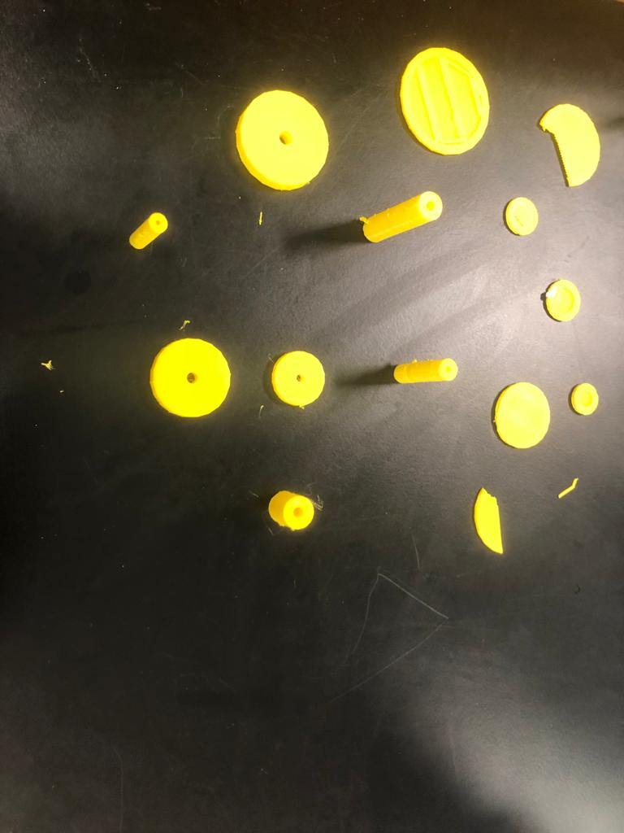
Spacers After Molds Removed
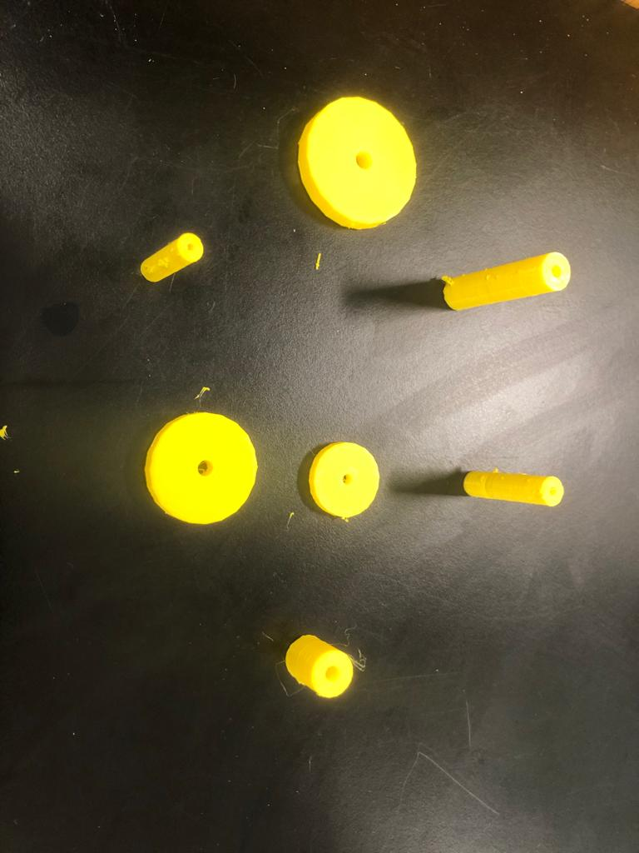
Spacers ready for use
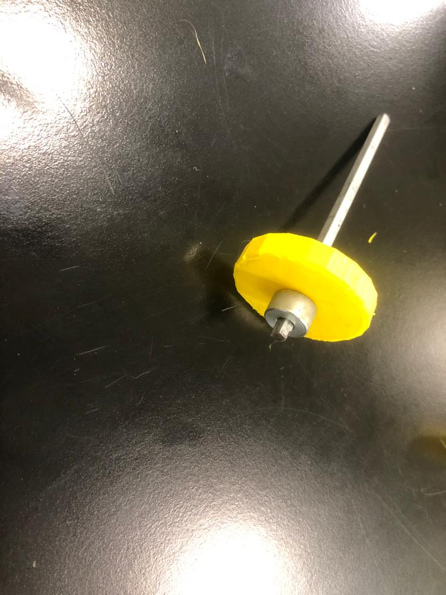
Example of Custom Spacer Use

