Cole Lefka
Robotics Team: 4154V
12/4/20
Texas Instruments Online Challenge
I chose a scientific calculator because it is cheaper than a graphic calculator from Texas Instruments but more complex than a simple calculator. This calculator has three main parts: it has the battery which is connected to the circuit board by two wires which are both positive and negative. The buttons all are recorded when typed into the circuit board and then calculated. After it has calculated the problem the information is transferred to the screen and can be seen for the user. The computer chip is the main part of this calculator and the buttons are attached to the chip and immediately records the information inside the chip. When you remove the circuit board from the calculator you can see how the buttons transmit the information. The buttons have a thin layer of rubber in between the buttons and the circuit board. The top part of the rubber is ordinary but the side for the circuit board is a bit harder. Which I assume is how the information is transferred because on the actual board it is just little cubes which are flat and do not stick up at all. The screen is most likely where the actual chip is stored but I couldn’t find it because there is foam blocking it. The screen is by what looks like plastic but has several black wires in between the plastic. I assume that the thin black wires are how the information is sent to the chip. The chip processes the problem and projects it on the screen which isn’t that big but it the information from the chip is projected on the screen so that it can be seen by the user. I learned from taking apart this calculator that there is a lot more to a calculator than meets the eye and they are more complicated than I originally believed. I also learned that I would like to learn the code for these chips and how they are able to calculate these math problems so quickly.
List of Parts:
- Positive Wire
- Negative Wire
- Keyboard Membrane
- Plastic Keys
- Circuit Board with Processor Chip
- LCD Screen
- Cover
- 6 Screws
- AA Battery
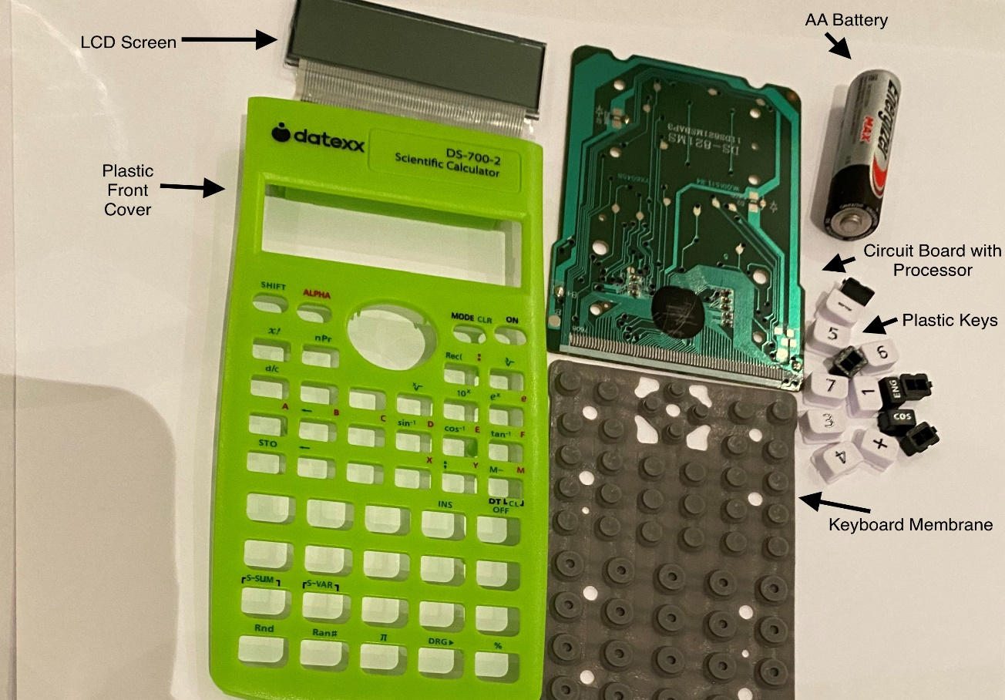
- Input (plastic Keys : 45 tiny plastic keys with a rubber membrane underneath and a touch-sensitive circuit underneath that.
- Circuit Board with Processor: This microchip does all the work and significantly smaller than it would have been a decade ago.
- Output: A liquid crystal display (LCD) for showing you the numbers you type in and the results of your calculations.
- Power source: 1 double “A” battery

