So today I will be showing you my Vex IQ online challenge piece. I made a brace to sandwich parts together, and add structural integrity. See Example 3.
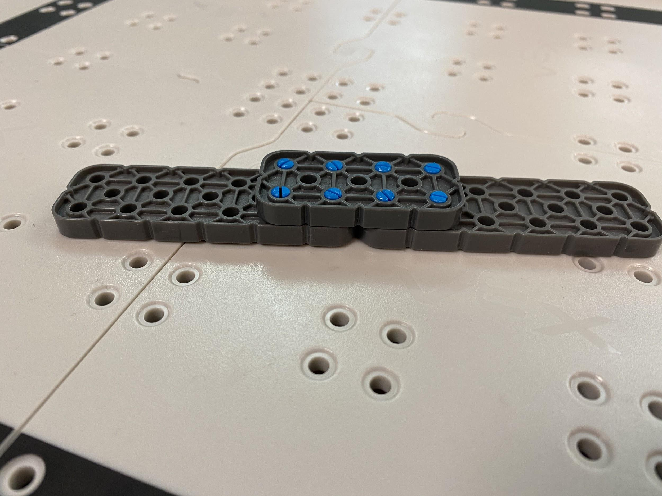
Example 1
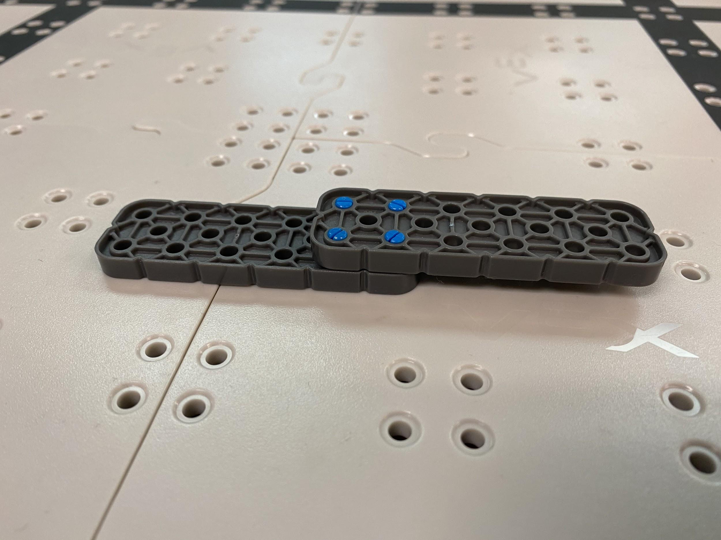
Example 2

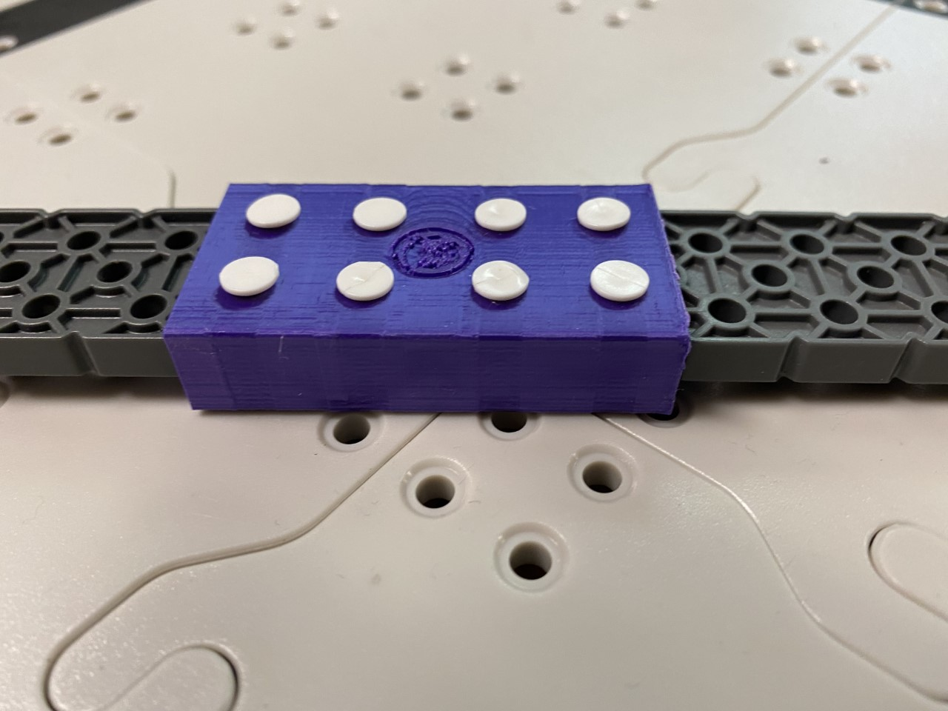
Example 3

The Problem

Each year height is an issue. What do teams do when they need a longer piece? They will either do Example 1 or 2. But the bad thing is both are weak and both lack structural integrity. Example 2 most of all lacks alignment which could throw off your bot’s whole alignment especially on a lift. But my design will improve structural integrity and alignment (Example 3.) Like in Example 1 you have structural integrity on one side but not on the other. In Example 2 you don't have much structural integrity at all and you're also throwing off your bot's alignment. But in my new design you are not sacrificing any alignment or structural integrity. That is the goal I'm trying to achieve.

When I was asked to come on the robotics team to do the online challenge I went home and I immediately started to brainstorm. I used tinkercad to create my part. Creating the basic design was easy. However, getting the sizing right was hard, and now I use tinkercad on a day-to-day basis. I learned how to use tinkercad tools easier. It has opened my mind to the possibilities of tinkercad. I learned how to use the ruler, and how to use the align button. I like that tinkercad already has the shapes to offer you and a sidebar unlike other cads where you have to import the shape.

Various Prototypes

My robotics teacher and I have printed this several times. The first print we did was too thin. The second one did not have enough spacing for the two parts to go in, and the holes were too small. The third print we were just adjusting hole size and trying to align it and we did that for the rest of the prints. We tried several times to align the holes. I was trying to use the ruler and everything in between. Finally, we took a Vex IQ piece in cad and put it up to the brace and aligned the holes.

Conclusion

I use 3D cad on a day to day basis. I don't like that tinkercad does not support zip archive files. I would love to use 3D printing for a job. The experience with tinkercad was great.

