Girl Power

Team number: 88892G: Lisa Wright, Harley Jinks, Avindi Thomas, Tatum Canady
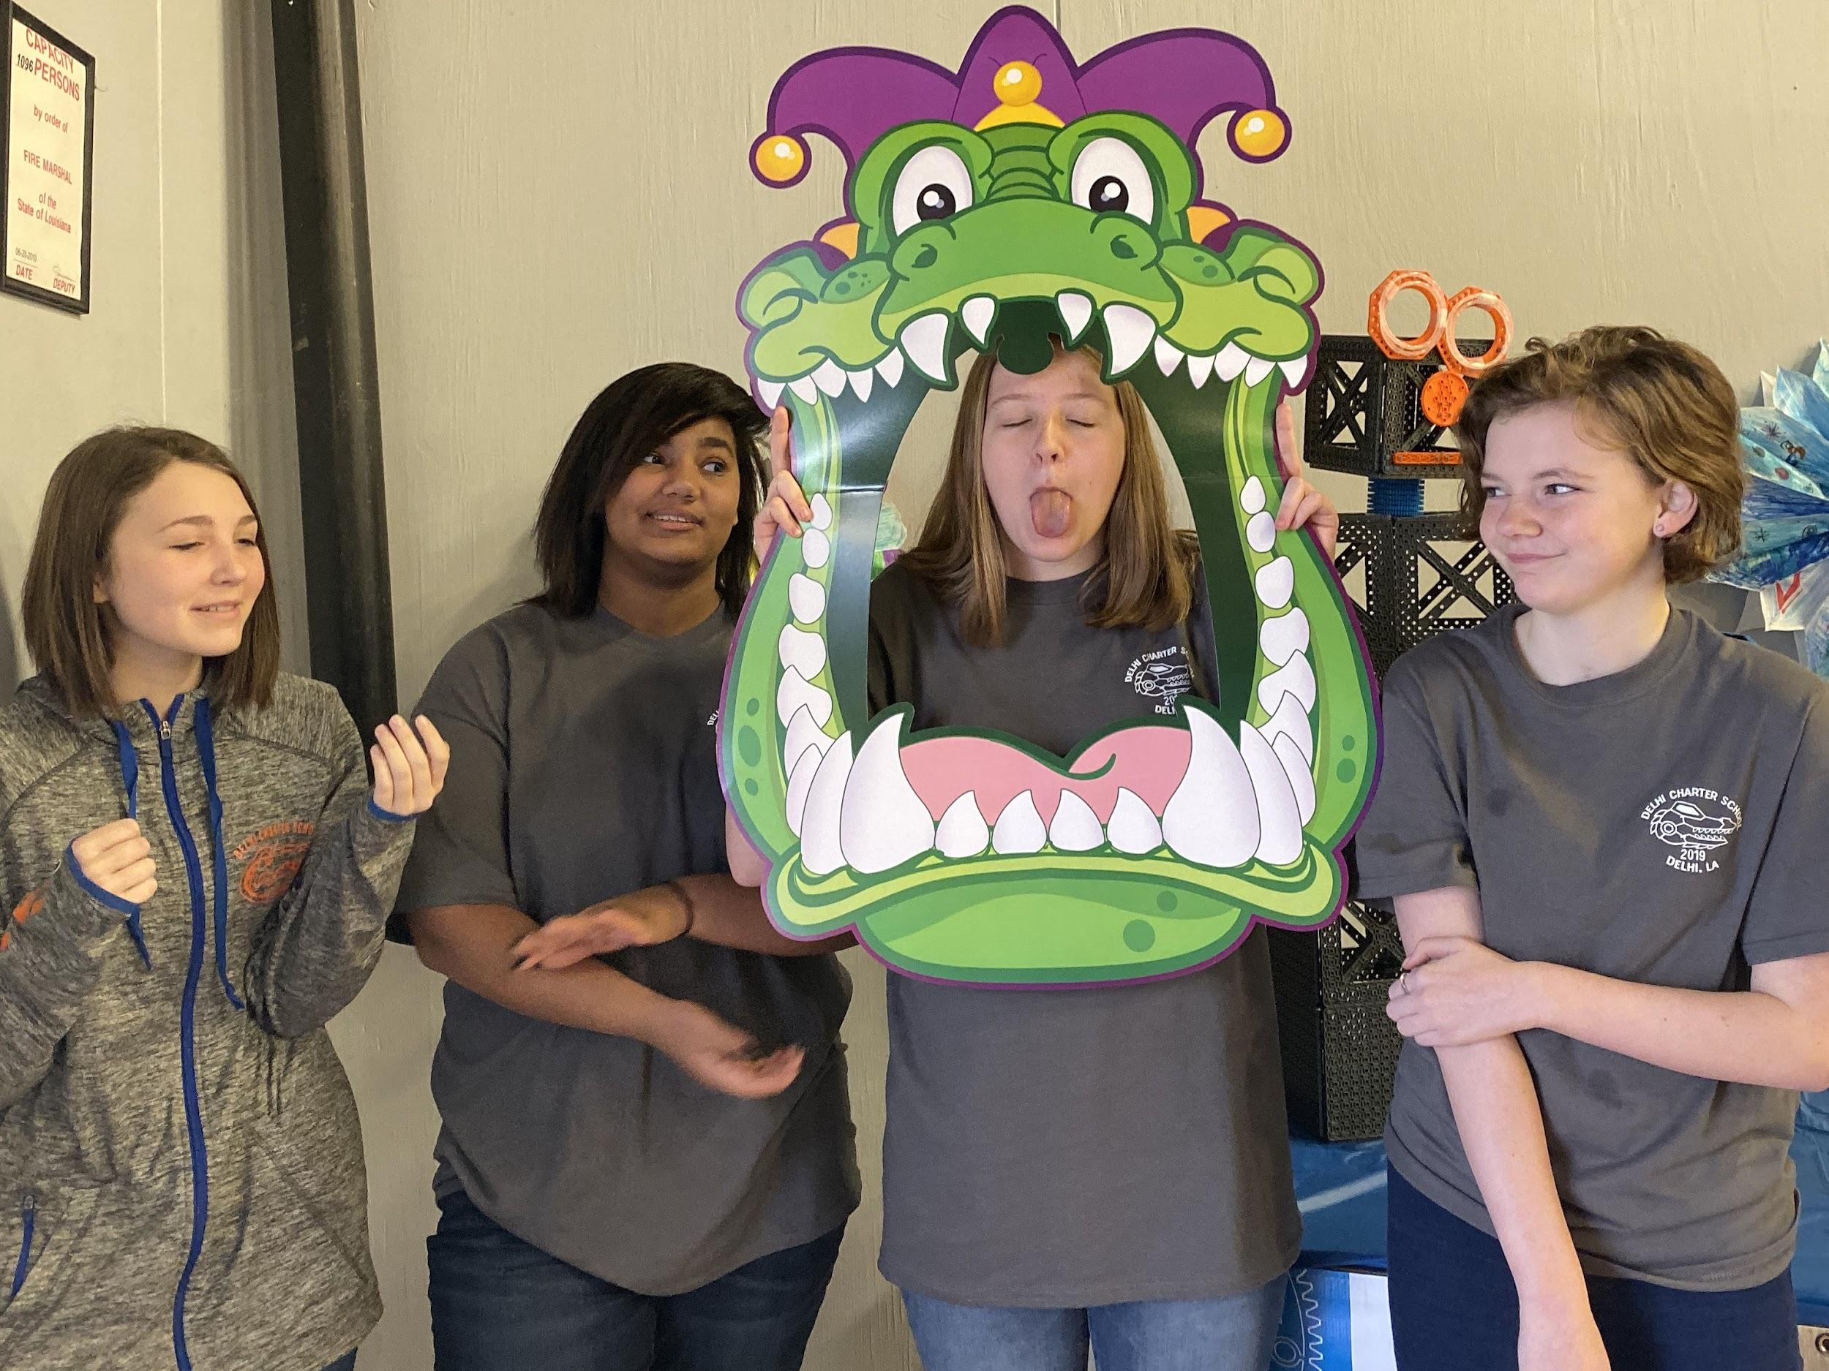

This is our girl-powered VEX IQ robotics team. Our school has had a girls team every year since we started VEX IQ robotics in 2016. We like being on a girls-only team because we work well together, and we aren’t being overshadowed by the boys.

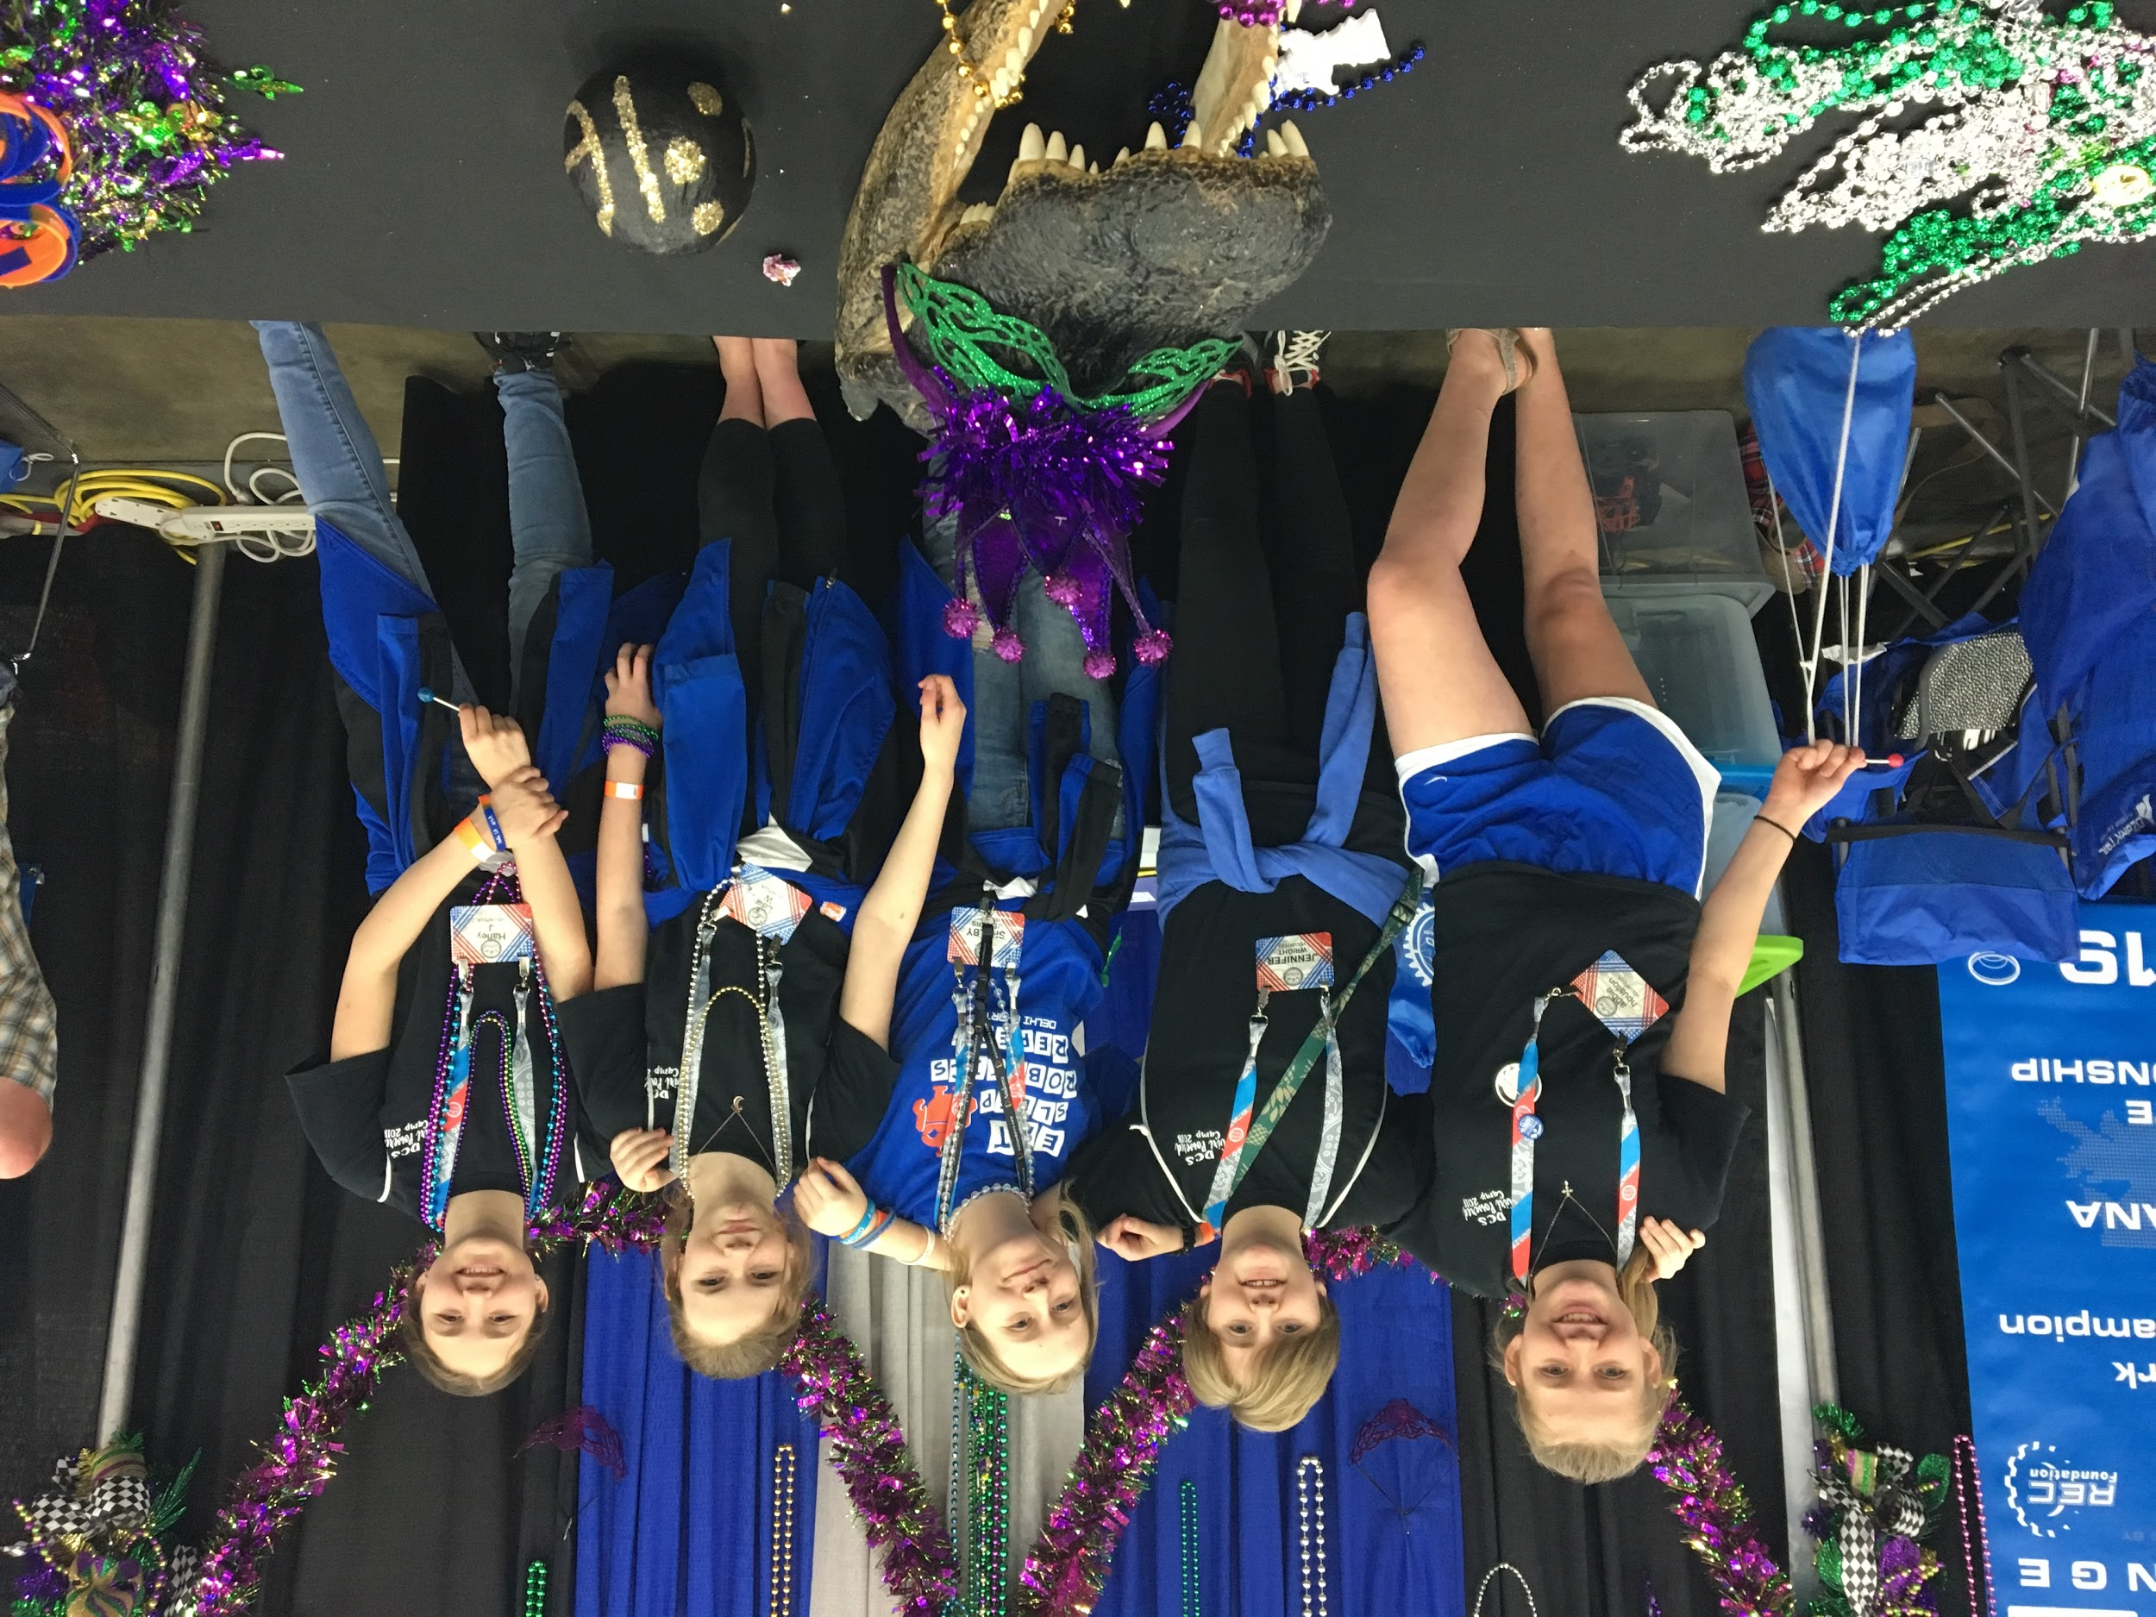

Girls can do just as much as boys. The boys teams often actually ask for our advice on things like: how they should build parts of their robot, how to program, how to organize their engineering notebook, and more.

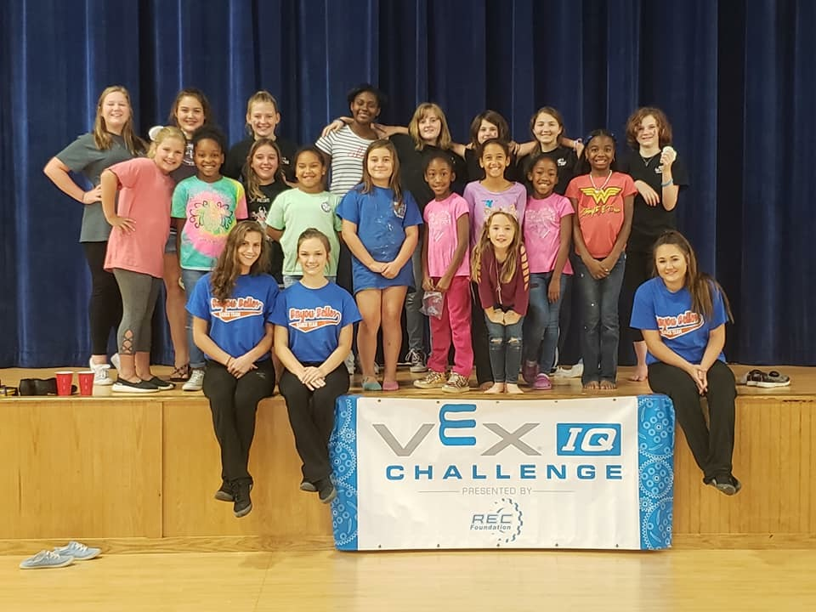
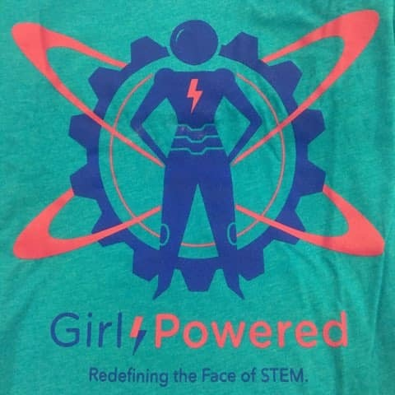
Our team has worked to create a more inclusive robotics program by holding girl powered camps at our school to attract more girls to join robotics. We want young elementary age girls to know that robotics is not just for boys, and that it can be a lot of fun for girls too.

Many of the boys teams focus on driving skills and winning matches, whereas we have worked to win awards like the STEM award, the Design award, and the Excellence Award by focusing not only on having a good robot, but also an excellent engineering notebook, practicing our interview skills, and working well with other teams at competitions. Our team is really good at focusing on the details that the other teams often miss.

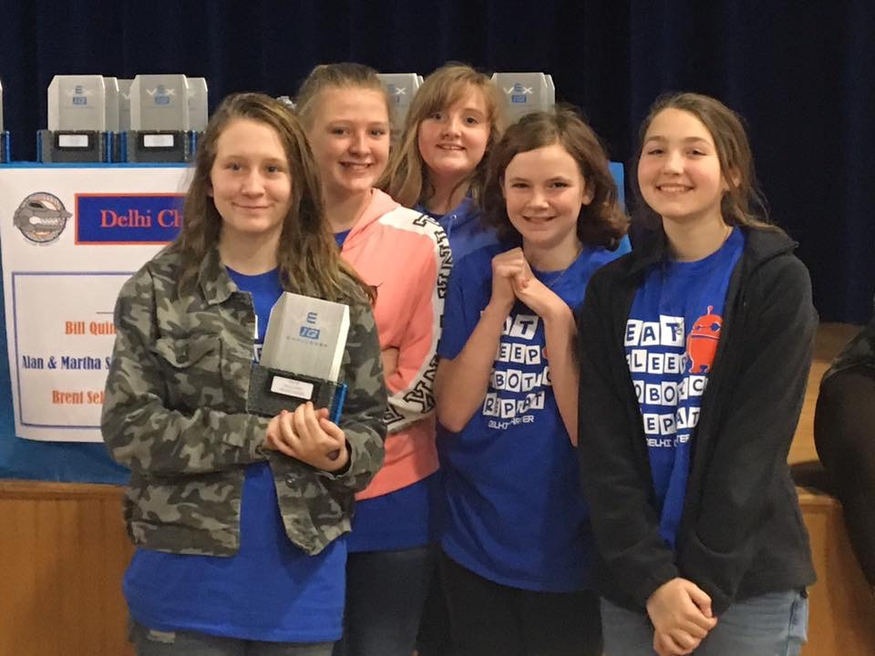
This is a picture of our team in 2018, at one of our regional robotics competitions after we won the Design award. Our team was the only team to win an award at that competition. This is an example of how our team aims to win awards that require more than just driving skills.

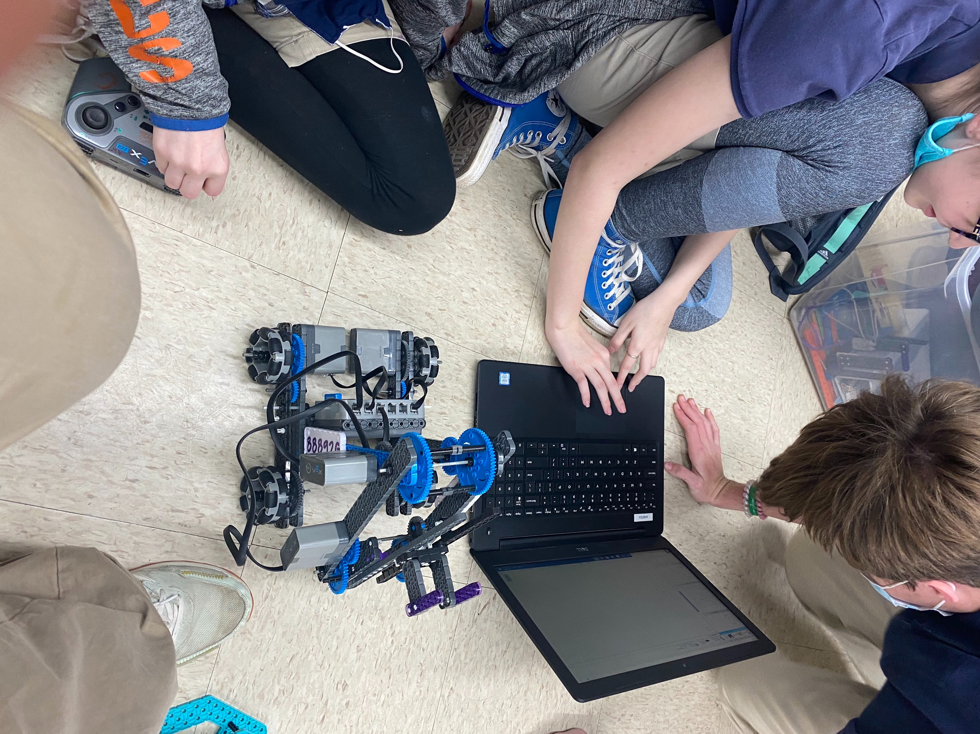
Each member of our team takes turns in different roles. For example, we all write in the engineering notebook, but we have one specific person who checks the notebook after each meeting and fixes any mistakes. Another example is our co-captain, Harley Jinks. She is the main programmer, but we can all program to an extent.

This is a picture of Harley programming our robot for this year. (It isn’t exactly complete yet, and it needs way more stability).

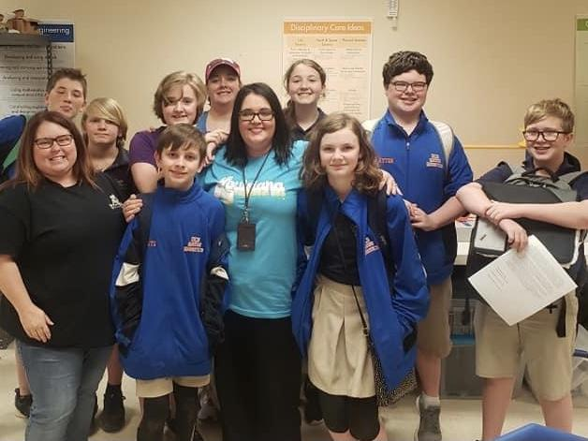
Our team’s STEM role model is our robotics sponsor, Mrs. Misty Kirkland. She continuously pushes us when it comes to driving, STEM, online challenges, and robotics in general. She is a very supportive woman when it comes to all of her teams. She is always telling us that we can compete just as well (or even better) than the boy teams, and to not be intimidated or bullied by the boys. She makes sure we speak up for ourselves, and get the respect we deserve.
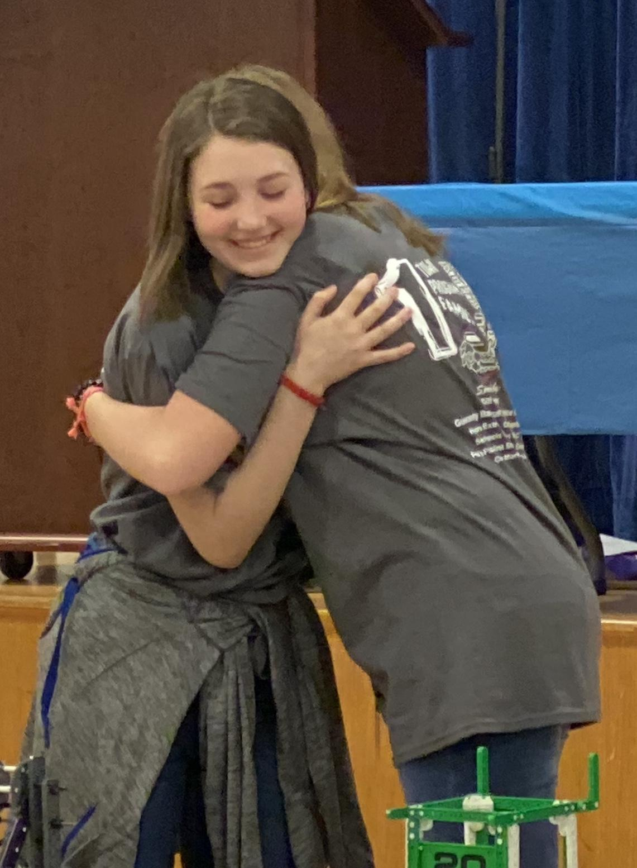

Being on a girls robotics team has also helped us make really good friends. We have a lot of fun together. While we work on our robot, we tell stories, listen to music, and laugh a lot! It is a lot of fun going to competitions because we not only get to compete for awards, but we get to spend time with each other. We work hard to encourage one another and cheer each other on when things get stressful and overwhelming.

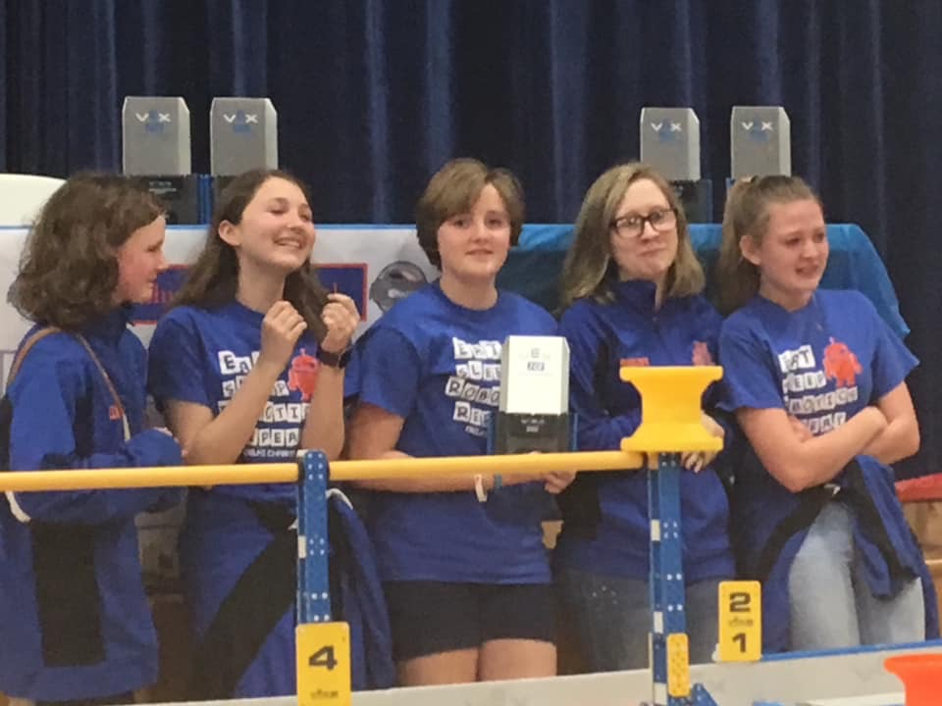
This picture sums up how amazing it is to be on a girl-powered robotics team. This picture was taken when we realized that we had qualified for the VEX IQ Worlds Robotics Competition. It had been a very stressful day, and we had trouble with our robot all day. We thought we had missed our chance to win any awards. But in the end we won the Design Award. We were all ecstatic and crying and just couldn’t believe that we were going to Worlds! It was an amazing day!

