

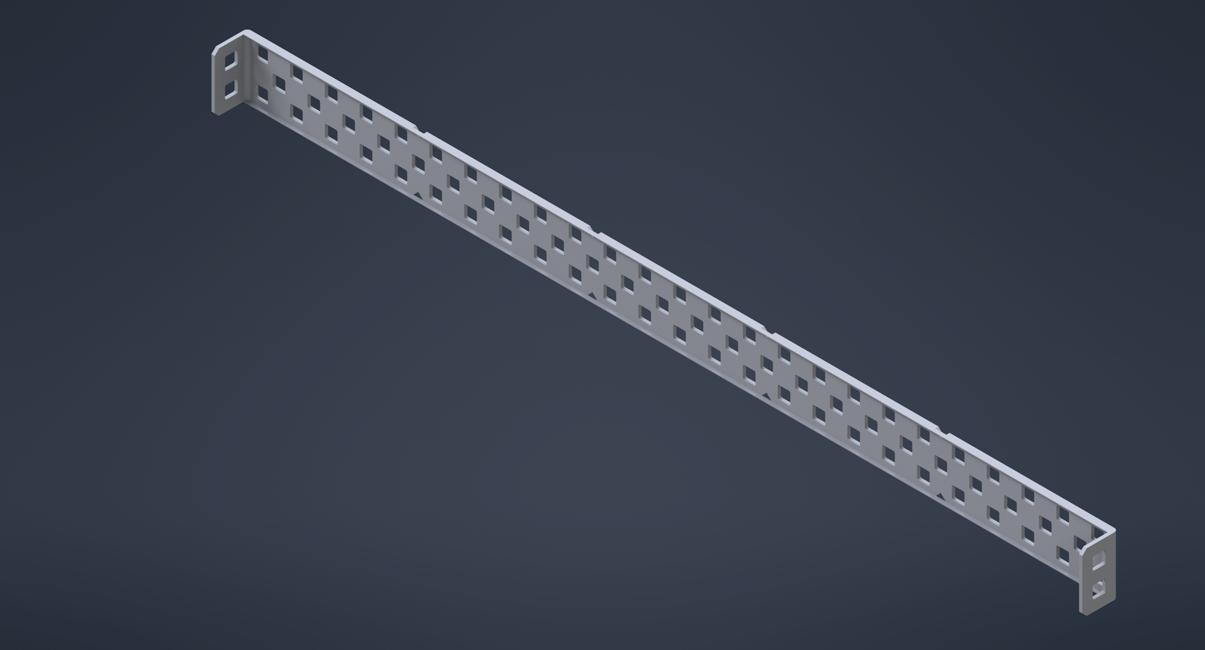

**Completed E-Channel**

Autodesk Making it Real Design Challenge

“E - Channel”

Team Number: #1155A

Team Name: Avengineers

School: Amador Valley High School

Contributors:

Daniel Ryder, Xavier Callait, Christina Taft

The part we created was a modified version of a C-Channel, called the E-Channel. We wanted to have the thinnest base possible for the robot as we wanted more space for the internal components. The C-Channels we used, however, have extrusions on the long sides; this meant the wheel assembly was wide due to the railings extending over the axle. The wheel assembly needed to expand so the metal would not interfere with the wheels while spinning.

We decided that if we had a part that didn’t have railings on the long side of the C-Channel, but rather on the shorter side of the C-Channel, the base of our robot would be thinner. Besides, having the railing on the shorter side would provide a shield for the wheel so parts lost during the matches would not block the wheels. The applications of our new part could also be incorporated into the structure itself. Without the railing on the long side, we would be able to attach other large parts on both sides of the metal piece, and it would fit into smaller spaces as it is much thinner. The added railing to the short side would allow for attaching the piece to other ones. Specifically, you can stand it on top of another perpendicular C-channel without them parallel to each other.

To model our new part, we used Autodesk Inventor Pro 2021 in tandem with Fusion360. Before modeling, we took the dimensions of the original C-Channels to find the thickness, width, and length of the body, along with the size of the holes. Once done, we created a sketch of a rectangle the size of the C-Channel and then extruded it to the same thickness as the original. Next, we added the railings along the length of the piece and rounded the edges to match the C-Channels. To make the holes, we first dimensioned a circle with the diameter of the height, then created 4 tangent perpendicular lines to form a square. From there, we filleted the holes to give them an authentic VEX appearance; finally, we used the mirror and rectangular pattern commands to efficiently deliver them across our piece. For the little markers every five holes, we used points strategically placed at important indicative positions, then obtaining dimensions that were recorded and re-used on our piece. This was the hardest part for us as the shape is irregular and on the edges of the piece. Despite this challenge, we used this opportunity to help introduce 3D modeling to the new members of our club. This software aided our team in the creation and design of the robot without having to build it in person, saving us time and effort.

Fusion360 was especially important --and new to us-- due to restrictions caused by the virus when we are unable to meet to build the robot. Without a doubt, many of us will use this kind of software in our future professions. It is essential for engineers of most disciplines to understand the modeling process. Modeling allows engineers to develop and conceptualize products without having to physically create a prototype. Moreover, it’s easier to find problems in the design, owing to this, fixing and tweaking the product before sending it to manufacturers is now much more effective. Using the visuals offered by the software, engineers are also able to see how their product will work once a tangible object is eventually produced. By doing so, engineers can save resources and time because before they fabricate anything, they already have a working digital device. Regardless of whether or not we utilize modeling programs in the future, they still augment the importance of planning and designing a product ahead of constructing it.

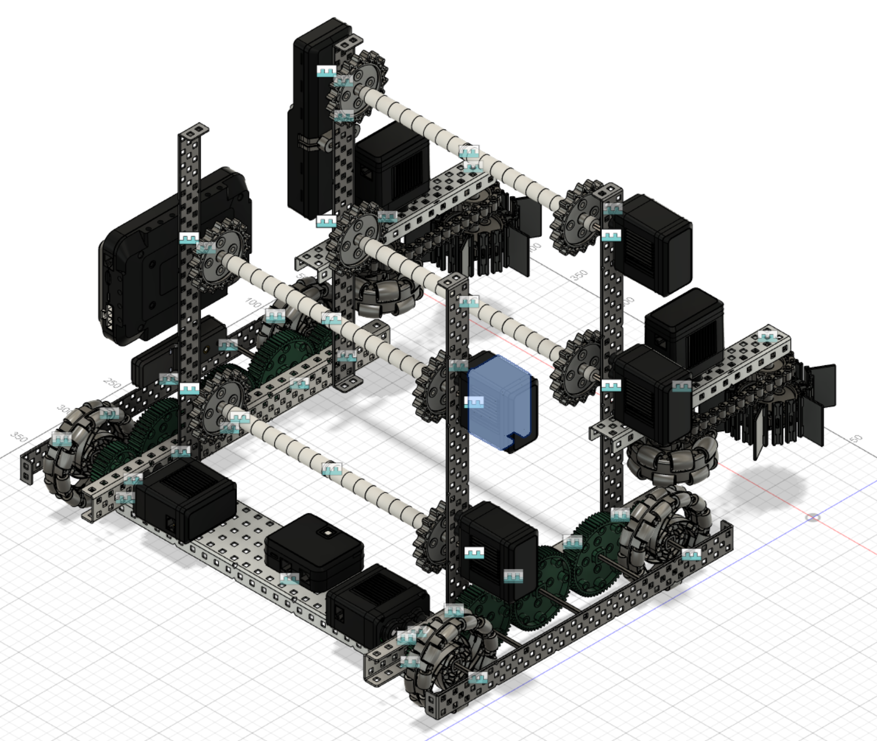

**Completed Robot with new E-Channels**

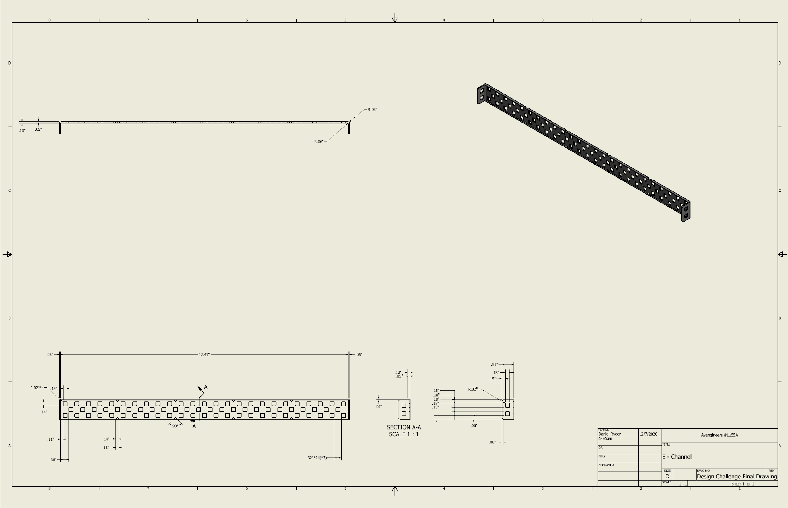

**Completed Drawing of the E-Channel**