Omni-Directional Gear

**Introduction**

In most robots I have seen, I have noticed a very heavy reliance on gears. In particular, a reliance on gears for the movement of parts that involve carrying or pushing an external object such as a ball or ring using the robot. I thought it would be more helpful for teams if they had a component that was capable of doing more than what a gear could do with less space and time consumed for many purposes. Hence, I have created the Omni-Directional Gear- a component that can move other VEX parts in a multitude of directions.

Front View

The component on the left was created using Fusion 360 version 2.0.9313. The shiny outer section is intended to be made of aluminium for weight and stability.

The Omni-Directional Gear


Back View

The smaller squares at the back are where the component is connected to other components via fastenings.

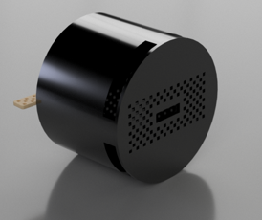

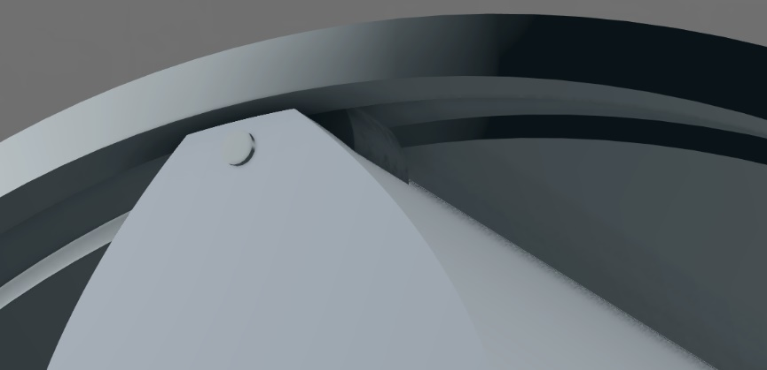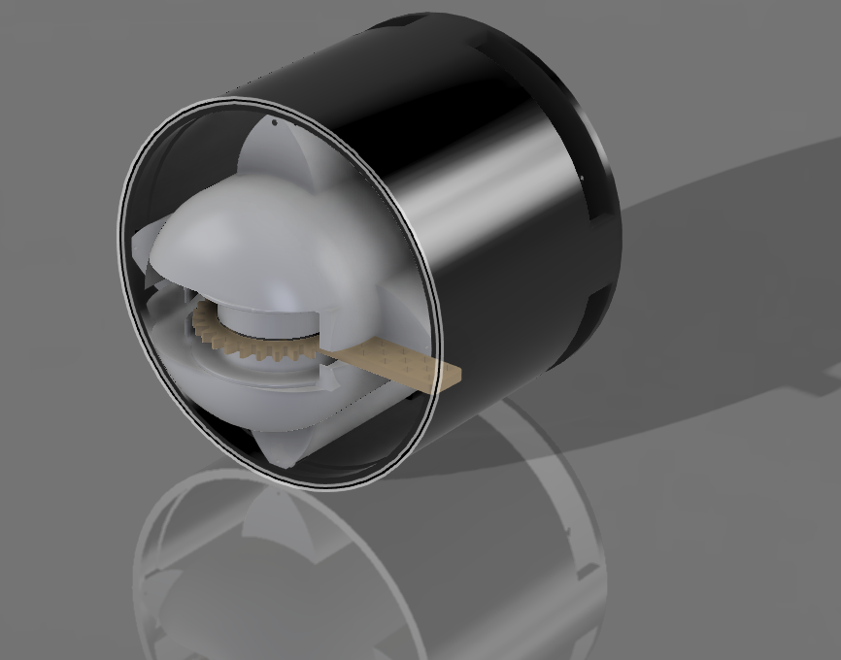**How it Works**

Lastly, the ability to change the orientation of the gear without physically removing the gear from where it is fitted. There are two tracks like these: 1 at the front of the outer casing and one at the back of the casing. 2 wheels , 1 for each track, are connected to each spoke of the design (shown underneath) via an axle. These wheels run along the tracks to be able to spin the rest of the component so it can change orientation easily.

When the aforementioned wire is pulled, this bar will swing to the opposite side. The extent that this bar swings to the other side can be controlled by changing the force applied to the component moving the wire. Once there is no force being exerted on the wire, the gears revert to their original position.

Firstly, a thin flexible wire will come out from here, which can be tied or stuck to any other gear, winch, or motor that can pull this wire backwards.

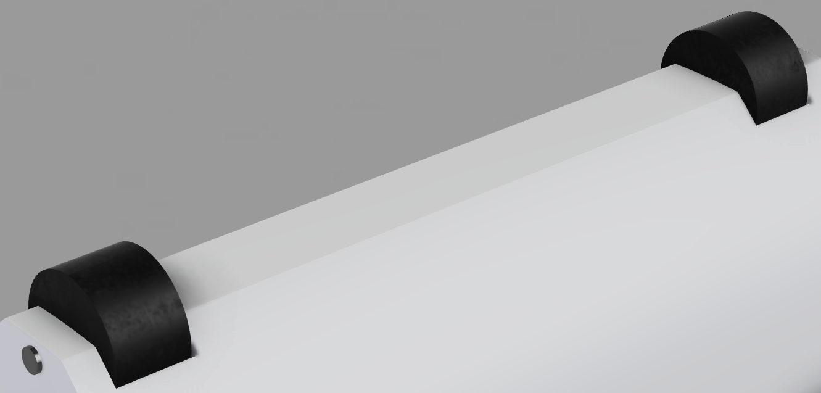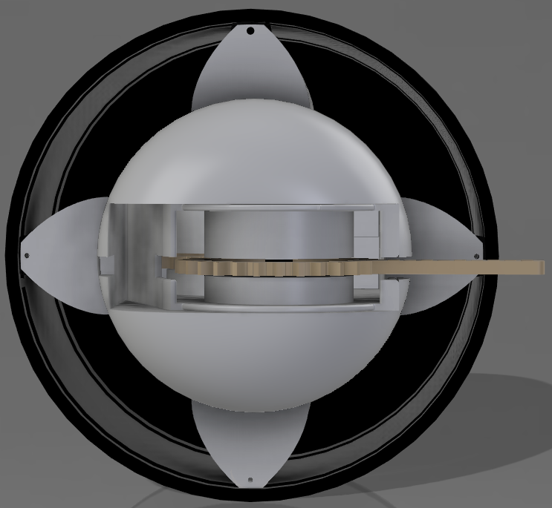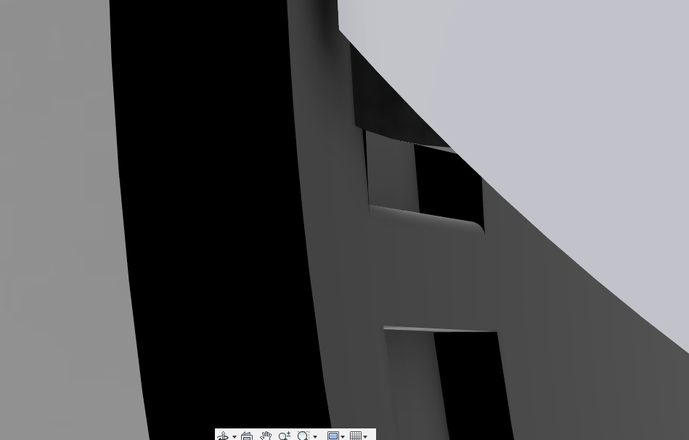

These are the 2 wheels that are in line with the tracks, and are connected to one of the spokes. The other 3 spokes are identical.

Image shows 4 spokes, that each have a visible hole in which the axle is fitted so the wheels can move freely.

Lastly, in order to make sure that the gear stays in position without spinning when in use, there are multiple wedges like these. These wedges are to be connected separately and have a spring underneath that can get pushed down from the wheel once it turns. This means that when no force is exerted to turn, it will remain in place, but when someone turns it to change its position, it will require minimal force to turn to another position. There are 8 positions with intervals of 45 degrees that the gear can turn to, and 2 sets of wedges for each position (one on each side of the wheel the wedges are securing the position of). This is repeated in the second track of wheels for stability.

**How it Was Made**

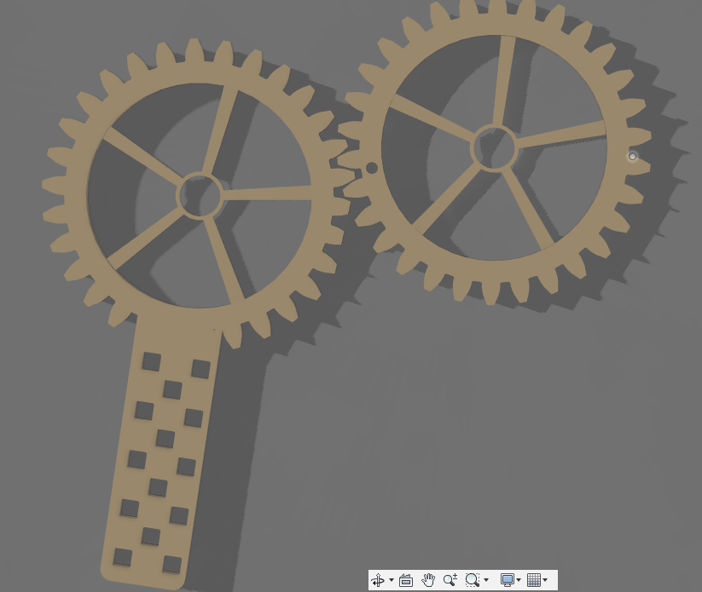At the core of the model there are two gears, one of which has an extension that can connect to other vex parts. A flexible wire will be tied to this hole, and the other side is left untied, but open to be tied to another movable component. This means that when the gear turns and pulls the string, it will turn the other gears so the component at the front that moves the connecting bar will turn to the right. These gears were also made by using the ‘Spur Gear’ add in in Fusion 360.

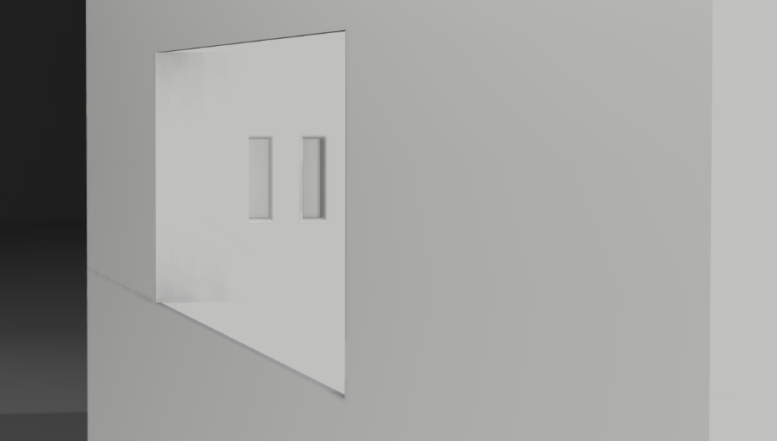However, after the gear gets pulled to one side via wire, the gear will remain in it is changed position upon being pulled to the right. So that the gear is able to revert to its original position after it turn turned, I will use an elastic string that has one side attached permanently to the first gear and one side tied permanently to another part of the component (below).

Here is where 1 part of the elastic will be attached- a section in the interior casing. I created this using 3 extrudes and sketches, then filleting some edges so the elastic does not accidentally snap while it moves and pulls the gear.

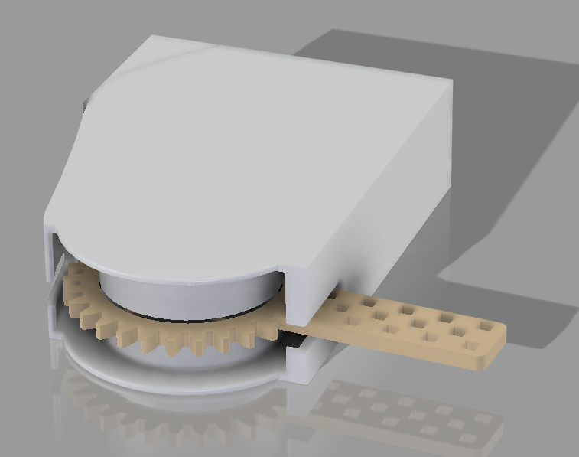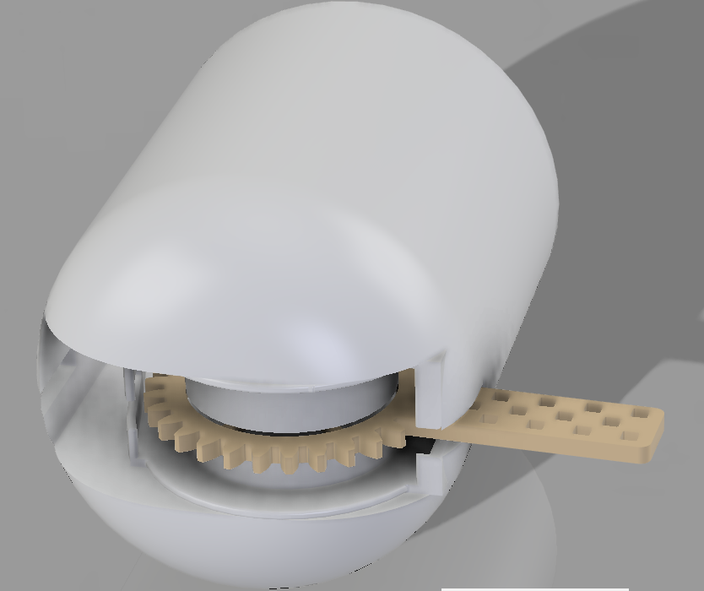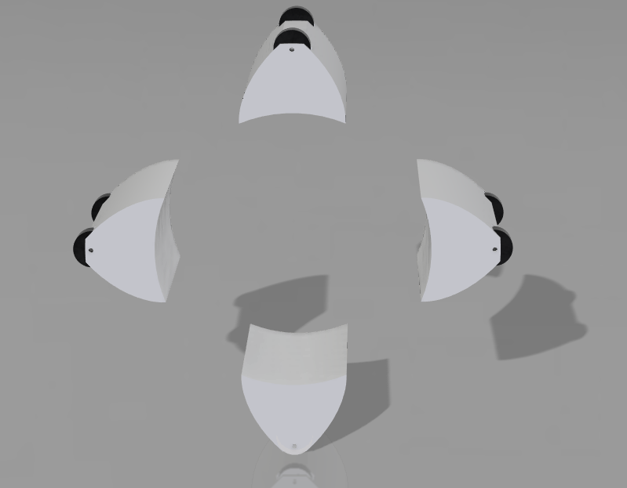

The rest of the interior casing, which included axles for these gears as well as risers so the gears so not shift too far away from each other and misalign, was just created through sketches and extrusion. Everything up to this point except the elastic and wire would be made of LDPE plastic due to its weight being easy to move without a hassle.

Because the current casing would be hard to continue working with, I created a more even shape to surround this first casing. I sketched a circle and the extruded it across the component. I used fillet to make the front of the cylinder look more appealing, and used extruded cut to clear more space for the gears.

To create the spokes, I created another spur gear with 4 spokes, then used extruded cut to clear all material until the spokes were left. I created the wheels on the design by using extruded cut to clear area for the wheels, then sketching and extruded wheels from this space.

Lastly, I created the outermost shell through extrusion, then extruded cut for the tracks, holes for bolts, and hole for the thread.

**Conclusion**

In this project, I learned the use of the ‘project’ tool and ‘circular pattern’ tool in Fusion 360. This furthered my interest in CAD overall. I realised through the difficulties in this project that by using this in my robotics team to help simulate how the real robot would look be built, I can identify possible errors in the build of the robot before we actually build it, reducing the time and resources wasted on failed builds. If I choose to continue with product design further in my career, this will be useful for the same reason.