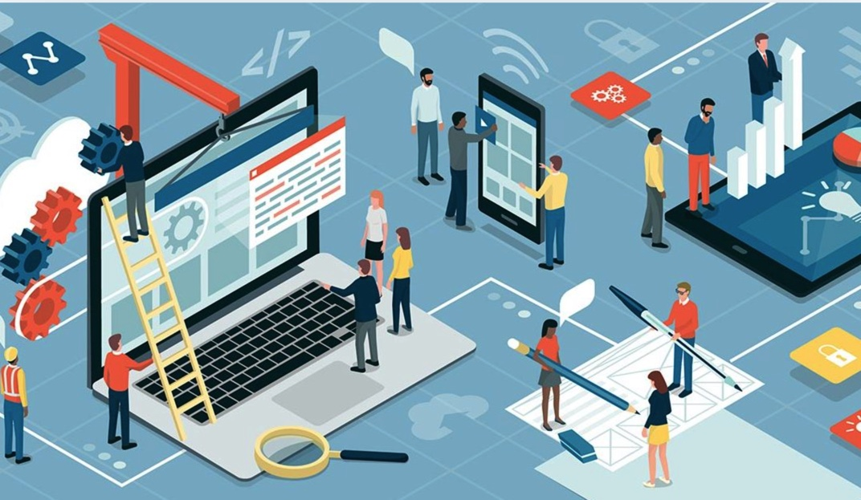

When I get older and go to college I would like to be in IT (Information Technology), because as a kid I always thought that electronics, technology, and new software are fascinating. Everyday there is something new, apple MacBook, or the new apple iPhone. IT can be used to find how the data on the computer works or how I can program the computer. Also, I can look at many different devices, and see how the device functions. The SECME experience let me understand why modern technology is made day-to-day and how is it used.

