While taking apart the Xbox controller, we took several notes and four different pictures of different areas inside of the controller. In order to take apart the controller, we needed a Torx T8 and Y10 screwdriver, a spudger. and a pair of tweezers.
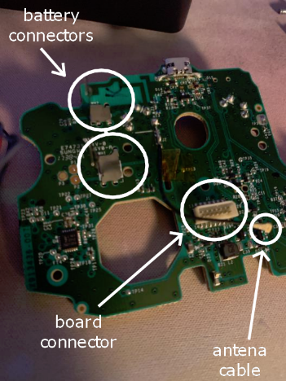
In the first picture, we are able to see one of the two main mother boards. The different objects that we pointed out in this photo were the battery connectors, the antenna cable, and the board connectors. The battery connectors are what holds and allows the batteries power to flow through the controller. The connector snaps the two motherboards together and allows the current to continue to flow through the controller, all while holding the boards in place. The antenna cable is used to connect the Bluetooth wireless module onto the second motherboard, which can be seen in the third photograph.
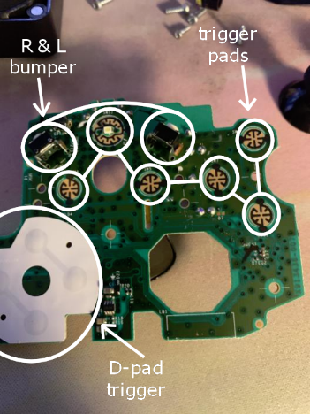
In the second picture, you begin to see more sensors for the controller. There are six visible trigger pads which are used when pressing buttons like menu, start, etc. There is also a D-pad trigger, which is the AYBX buttons on the controller. The final thing to see in this picture are the right and left bumpers. These are located at the back of the controller and are used very often in different video games, meaning that these would have to be easily accessible to the player.
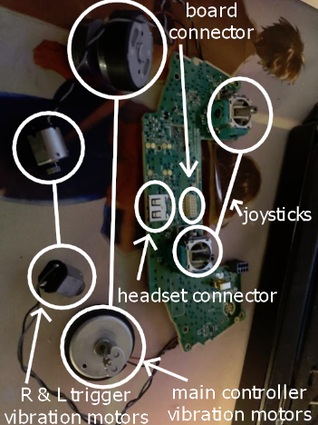
In the third picture, the most visible thing here is the second motherboard. We are now able to see how the vibrations in the controller are made. Each area that would vibrate has its own motor. We also see the two joysticks that are in the middle right and top left. Another very interesting thing about this photo is that we see where the headset connector is. This will tell the game if the user has a pair of headphones plugged in and hence where to send the sound.
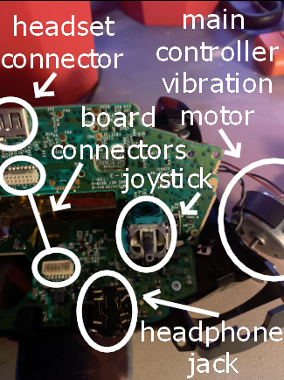
The last picture that we took was of all the boards (mostly) together before we took it apart. Here, you can see everything from how the board connectors clip on to each other and how the trigger pads will react when some one pushes one of the buttons. We also see the headphone jack where you plug in the headphones themselves.

