Connor M.
12/7/2020
Centennial High
7983D
Vex Robotics “Make It Real” CAD Engineering Challenge
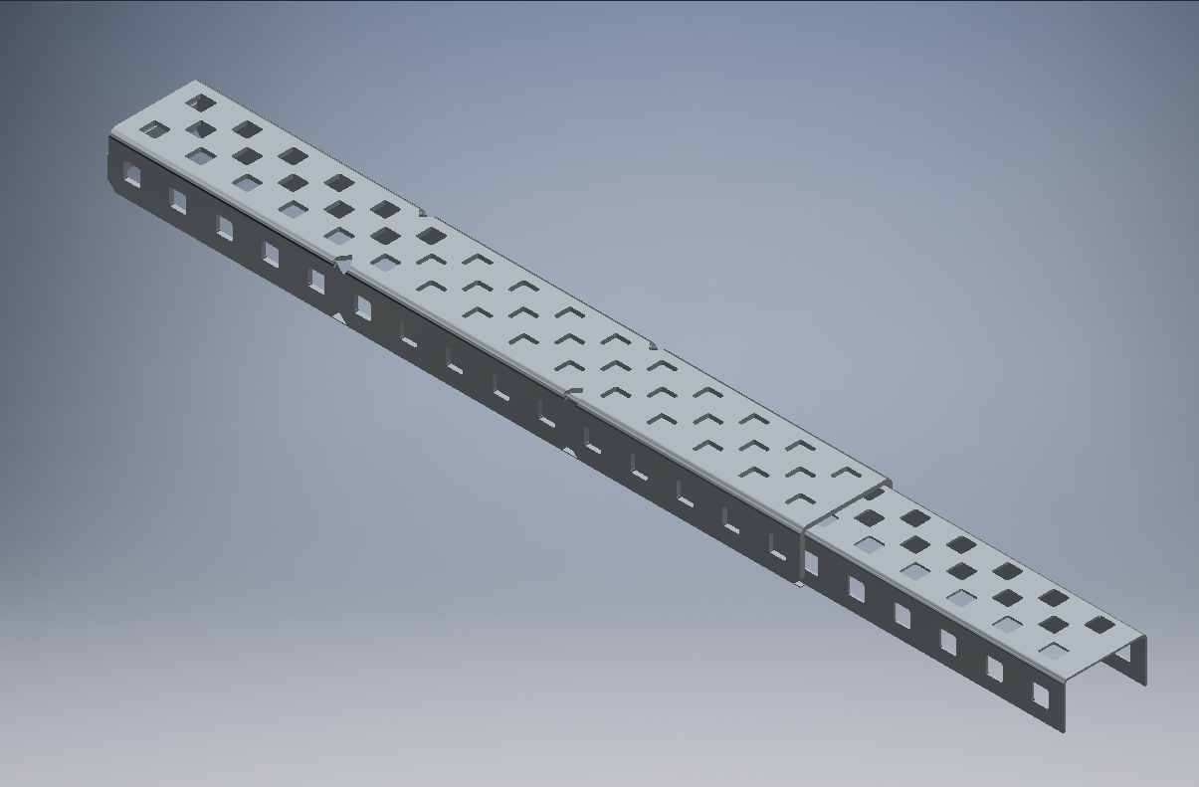
We are team 7983D of Centennial High, and our team decided to create an extendable C-channel as our part. It is a very simple design that allows for more flexibility with certain designs and allows for parts to be more reusable, instead of cutting a c-channel into a specific length for one singular year’s bot, then to never be used again as the size is unnecessary for newer bots. This specific piece that was modeled is a size 15x2 C-channel. It simply takes the C channel and splits it in half, so that the smaller side is able to move freely inside the outer part of the c-channel, with walls behind and underneath the part that slides to prevent it from coming out. To model this piece, we used Autodesk Inventor Professional 2021, as I had much experience with Inventor from various classes dating back to middle school using this program.
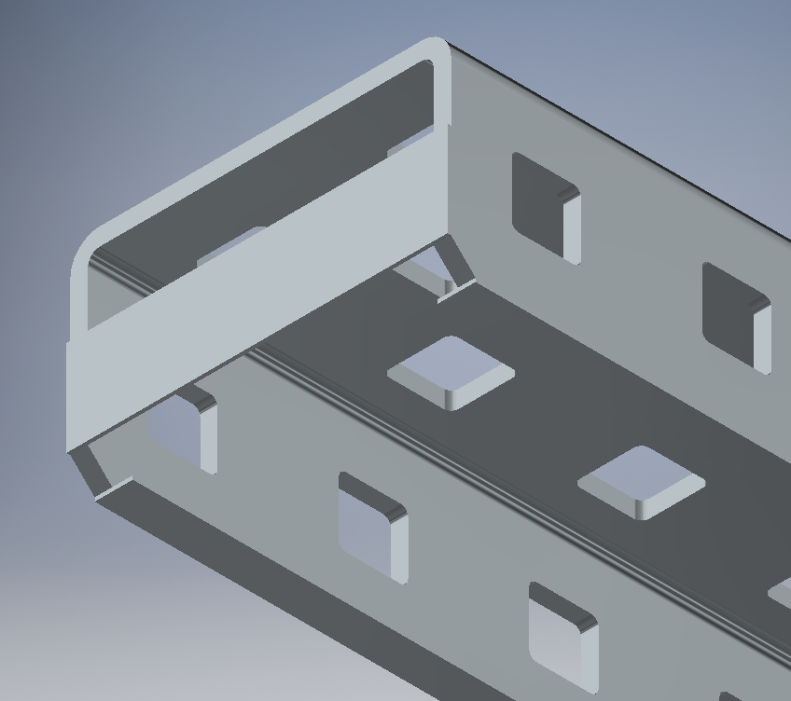
Overall, I learned how useful these programs are for modeling small parts for bigger sets, like a robot. I was able to have a basic idea of a part I designed and by working on it came up with more ideas and made the part more practical the longer I modeled it. I really enjoyed the process and definitely intend to use my educational license on Autodesk to its fullest potential and model anything that sounds fun, or use it for school. We can use this program on a robotics team to analyze certain parts far better than we could looking at them in person, and it allows the full team to look at and analyze the bot if modeled in an online format like what we are stuck in today. Learning 3D design software will definitely help me personally in the future and in my career. I enjoy using programs like Inventor and Revit a lot, and intend to find a career where I can use these programs often and to their full potential.

