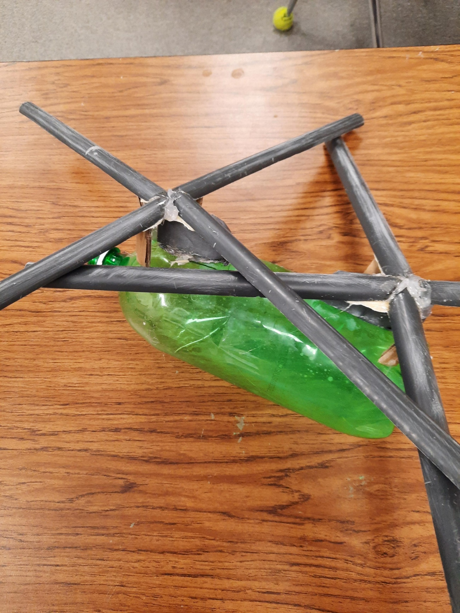Noah and I's project was a recycle bot of a chinook helicopter we were thinking about other thinks like: a military plane, cargo truck, a tank, and a cargo plane They were all great ideas but the idea we stuck with is the helicopter because it seemed the coolest. *The tools and tools needed to do this are as follows: Plastic pop bottle (2 liter), 2 pbc pipes (¾ inch), Cardboard thin and thick layers, duct tape, hot glue + hot glue gun, gorilla glue (does not work well), table saw, and vice grips.* The time we think it would take if you were seriously dedicated with no breaks. Put cardboard under the propellers to keep straight. The instructions are as follows First: we got a bottle and cleaned it out. Second, we cut some cardboard chunks for the lower rotor parts then we made the engine out of thin cardboard third after attaching the cardboard with the vice grip we cut the pbc pipes into strips with the table saw fourth we attached the blades aka pbc pipes to the lower rotor parts. Optional things (in own opinion): gorilla glue is optional to attaching the parts. Vice grip is also optional (we just had troubles attaching lower rotor). You should also add a piece of cardboard to hold the roader up. The reason is because the blades weigh too much, so they end up breaking the glue there was Mutiple attempts to make it work. Also make sure to add texture like we sanded the rotors, so it had some texture tom it also it was sanded to cut of the marks we used to cut the rotors. The rotors should be about nine and ¼ inches length attached and cut the outer end the inter image will be inserted. Also, you can spray paint it if you feel like it any color you want is ok. Also do not go light on the hot glue use a decent amount of it this is needed mainly because it can come of easy with little glue you will also be destined to fail if you use little glue. Also add a nosecone made pf cardboard we just did not have the time to do one on our version of it. Also, it is easier and better to sand the blades before you put them on the lower rotor parts. Also, there are certain types of glue that did not work for us: gorilla glue, rubber cement, and Elmers glue, JB weld works well for this too make sure to give the glue time to dry we did not do this so we failed many times on this. Also, you should sand the inner part of the blades to get the glue on better onto the lower rotor and inner blade parts. Also, you can cut out little parts of something to make the wheels to make it look more realistic we also did not have the time or had no idea what to do for this part, so we had to skip it unfortunately but, in the end, we thought this project was fun to do and that the time we did on it was worth all of it to do

