The Germ Free Robo-Hand, Team #61811A

Sheridan Hills Elementary School, Hollywood, Florida

My Robo-Hand was made to pick up trash. It was made using cardboard, straws, and yarn. The Robo-Hand functions by pulling the strings, it's as easy as that, when the strings are pulled the fingers begin to close in. The Robo-Hand can do anything from picking up seeds, picking up dirt, picking up trash and picking up mostly anything you could imagine. Its purpose is to pick up trash because our environment needs help and it can be helped by us people living on this earth, by picking up the things other people once littered. I'd like the Robo-Hand to inspire people to recycle things into something cool and new like this-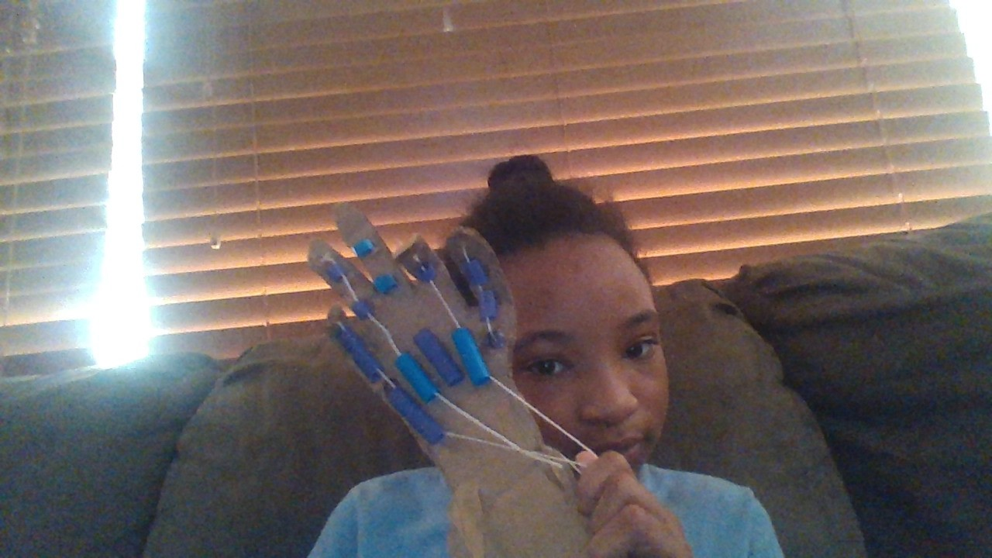Don’t just waste it and throw it away. This hand was made by me and only me and no help was used. I was provided some materials from my parents. The hand functions just fine and there are barely any flaws in it. I have only encountered a few flaws such as the fact that the middle finger doesn't move, and the thumb is just a little hard to move, but it does work. This hand can prevent your hands from getting dirty. The Robo-Hand was made by me, Cara Ignacio-Suarez I am in 5th grade and am interested in engineering and technology. I want to become a game maker or engineer when I’m older and the robo-hand helps me express my love for technology. I have entered in many Stem projects. The robo-hand could be a big help throughout coronavirus right now, as people don’t want to touch many things because of germs. Germs can be a big problem but with the robo-hand its no problem at all. Imagine just pulling strings to be able to clean up our earth and stay safe from germs. It sounds unbelievable. Using more cardboard you could make the robo-hand better by wrapping it around the wrist part or using rubber bands and glue it to the robo-hand to be able to pull the strings easier. You could also add a string to the middle finger so it would be able to move. This could make the robo-hand better and repair my mistakes. The robo-hand was made by cutting out the shape of my hand on a piece of cardboard and gluing shortened straws to the middle of the hand under each finger. I then pulled strings in between each straw and glued the string to the top of the finger. The thumb was just a bit more complicated but worked the same as the rest of the fingers. My friends supported me while I made my robo-hand and deserve some credit for being supportive of the robo-hand. My technology teacher was also a huge help and inspired me to make the robo-hand and enter it into this Stem project even more. This was the Robo-hand creator 11-year-old Cara Ignacio-Suarez, hope you like my concept. Have a great day.