Mandarin Lakes K-8 Academy
Miami, Fl
Recycle Robot Challenge

By:
Geoni Wells
Henry Hernandez
Emily Perez
Jason Alexandre
Sam Calixte
Kennari Shorter
Izaquel Mendez
Semaj Favors
Angie Librado
Javoni Lopez-Rodriguez
Kevin Diaz
Alaijah Grant
Delia Timot
Glennaejah Madison
Adrienne Payuyo

- As we look around in our classrooms and homes, we see materials and supplies that can be recycled.​

The challenge for this project was to create a robot using only recycled materials. As we look around in our classrooms and home, we see materials and supplies that can be recycled. We had to use our creative, design, construction and artistic abilities to create a Recycle-Bot. In other words, we decided to learn about recycling, collection of recycled materials and the importance of recycling. The robot we built out of recycled materials has a purpose. The robot's purpose is to show the community how coming together as a team and recycling can be a useful way to make the environment better. In robotics class, we learned how to build our robot out of recycled materials. We saw in a documentary that there is 8 millions tons of plastic on the ocean. Since there is so much plastic circling in the world, recycling is something that benefits everyone and we all must do. We want our robot to get the community excited. By seeing our robot can hopefully get them to recycle and work as a team which makes it fun to do.

We started this challenge by bringing in recyclable goods to class. We even worked with the school principal to make an announcement before the end of school so that other students in our school could drop off some recycled good. We kept a list of all materials collected and used and recycled everything that we could and did not use. The materials we used for our final robot was:
- 12 Water bottles
- 2 Milk Gallon Bottles
- 8 small boxes
- 3 large boxes
- Hot glue gun
- Hot glue sticks
- Scissors
- Red, black, white, and green Paint
- 1 Soda can
- Yarn
- Piece of fabric
- Paper
- Tape
- 3 Disinfectant Wipe Containers
- Pencils and Paintbrushes
- Moving Square Dolly

Our teachers always tell us that planning is important because failure to plan is the same as planning to fail. When we first started, we were sitting around looking at all of the stuff that we brought in with no idea what to do. We were almost planning to fail until one of our teammates came up with this amazing rough draft of something we could design for our robot. Later on, we would have to adjust the drawing to the size and scale of real items.

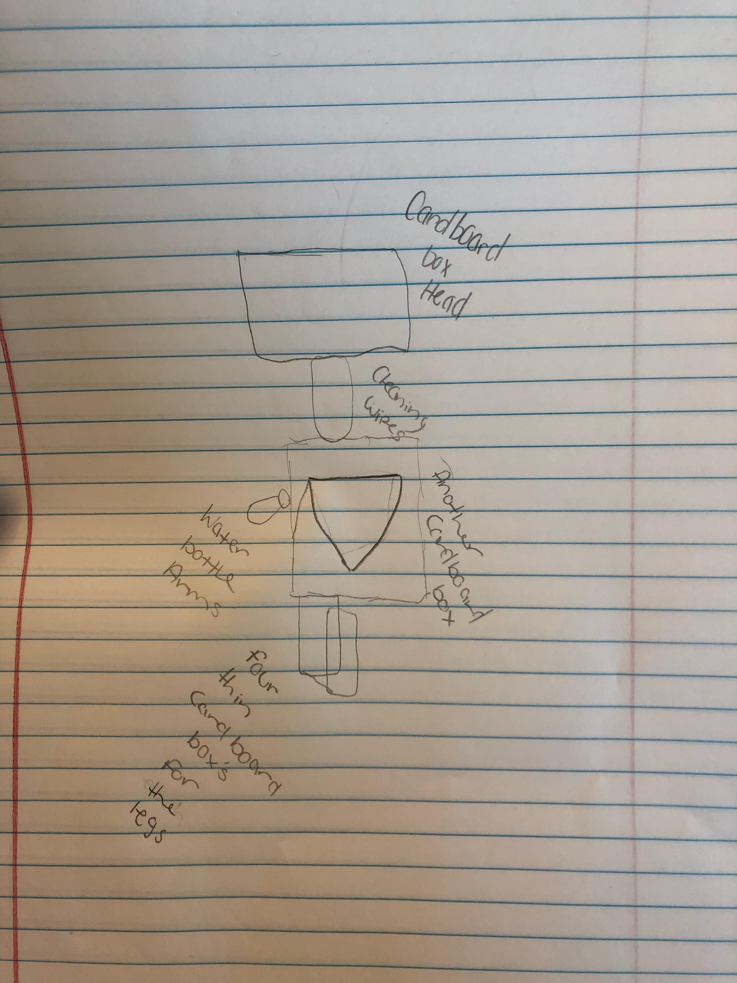

We began to shape the boxes that would later become the parts for the robot. First we used tape, a lot of tape, to hold the boxes together. That didn’t help because you cant paint on top of tape. Also, tape is not as strong when holing the weight of the boxes together. Then one of our teammates wanted the robot to be taller than him so we made changes to the original plan. Then, the Arms were not quite right. They were way to small for the robot. We had to change the materials to more bottles and gallons, so we had to change the design again. From here, it was off to paint. We gave everyone in class a different piece to paint so it would make the painting process faster. We created the correct shades to pain our robot. It was a challenge because every day we were painting we had to create the colors again and all the colors had to match, like it was done all in one day.
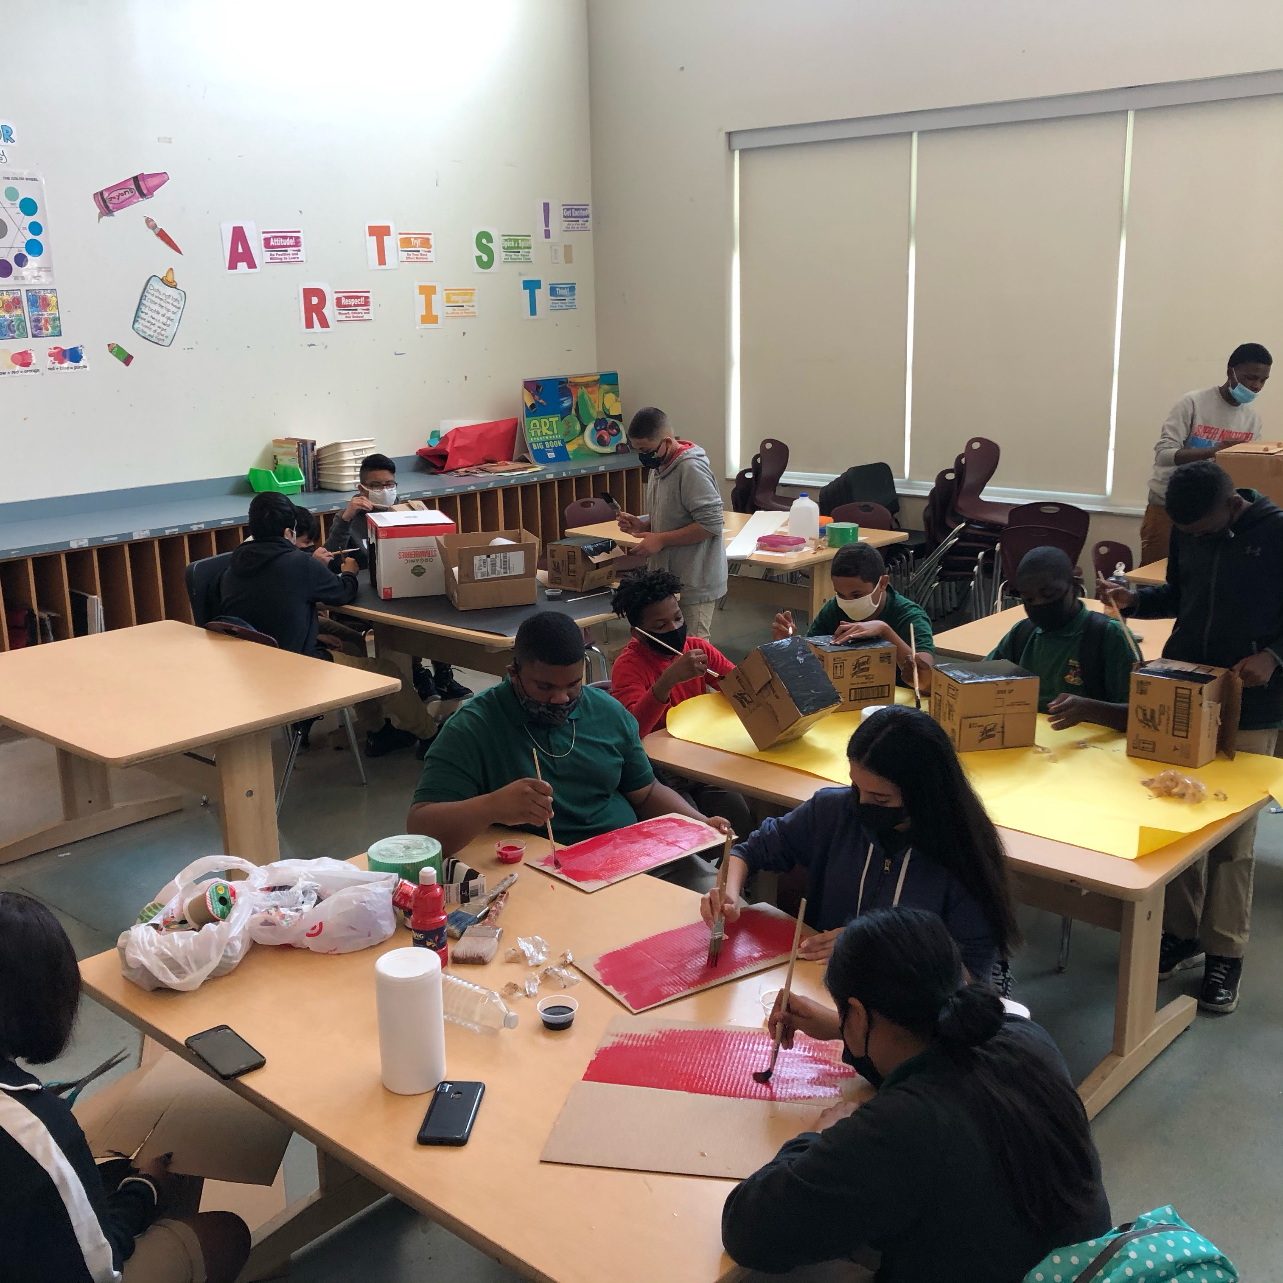

After all the painting was done, we had to put things together. We used hot glue and stiffer cardboard pieces to make some parts stronger because certain parts like the head and water bottle arms would fall off too easy since our robot is over 6 feet and 5 inches tall. We also learned that hot glue would not stick that well to plastic, so we would have to attach the plastic to a stiff piece of cardboard before attaching it to the main robot body. This fixed all the problems when the heavy pieces like the arms or head would fall off if we tried to move the robot. Another challenge that we encounter was making the robot strong enough to stand and stay standing for days. We had to make more changes to our design and add more boxes. To be most careful, we sat the robot on top of a moving square dolly to move the robot around the school to display when you enter the building. We learned many things when building this project, but most importantly we had FUN learning and creating. Thankfully, we did not do it alone since we had help from our classmates and helpful teachers.

When many of us first saw that we had robotics, we were scared because that was the first time many of us ever had robotics and we thought it was going to be really hard. We had seen the students from last year with all these projects and robots. We were overwhelmed and scared of all this challenges and competitions. But it wasn't hard at all and we actually understood what we were doing. We may not get along sometimes, but we're still classmates and we can say that we bonded while making this challenge. We worked together as a team and we were able to create a huge robot that’s over 6 feet and 5 inches tall. Teamwork plays a big role inside of robotics, because robotics wouldn’t be accomplished with only one single person.

