where the trash taker 2.0 can take you
TEAM 3581A, ENTRANT: Marianna Duarte
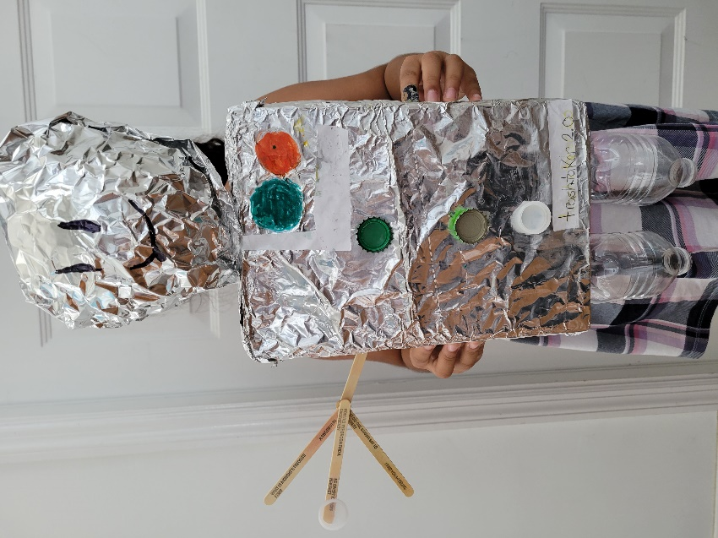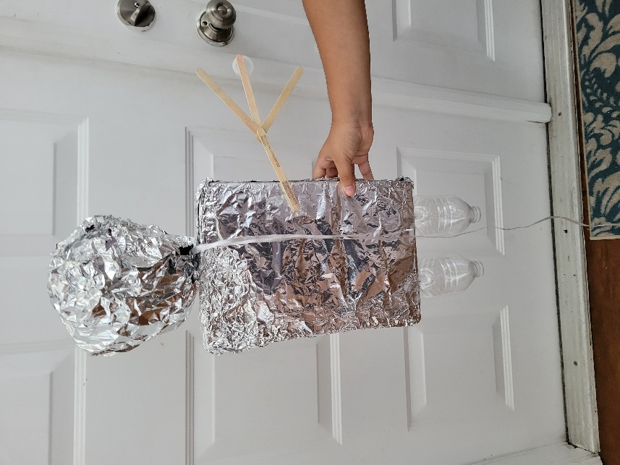
Have you ever wondered why my robot is called the Trash Taker 2.0? A lot of people asked that question. Well, it is because it picks up trash with a cardboard hand. If you keep reading, I will tell you how I came up with an epic creation that could revolutionize picking up trash.

Telling the Story of the Trash Taker 2.0
The Trash Taker 2.0 is a robot that is made to pick up trash with its one claw. How did I came up with this you may ask. How this idea came to mind was I was walking around my community and I noticed all the trash along the sidewalk. It was everywhere, and I thought to myself there must be a way to fix this problem. Then it came to me. The world is revolutionizing so I thought the best way to fix this in today’s world is to use robotics and then I thought I could make the Trash Taker 2.0.

What the Trash Taker is Made of (literally)
Not only is that an idiom but I will be talking about what the Trash Taker is made of. So, the Trash Taker is mostly made of cardboard. Its body is a cereal box that is covered in aluminum foil. Its legs are plastic water bottles. Its buttons are different types of bottle caps. But the most important part of the Trash Taker is the claw it uses to pick things up which is made from popsicle sticks (to be clear 4 popsicle sticks) and its head is a balloon covered in aluminum foil.

The Trash Taker’s Troubles
The Trash Taker was a great opportunity for me to show how creative I am and how hard I work but It was not all fun and games. I had lot of times when it was very hard and frustrating. For example, when I was covering the body in aluminum foil, I had to add another layer. Also, when I was gluing the claw to the body, the sticks kept falling apart. But I solved it by putting them on top of each other.

The Trash Taker’s Meaning
The Trash Taker was made to pick up trash and keep this world from being a mess. I am very creative and do things like this all the time but this time it is different because this time my robot has a purpose. It one day could be made a real robot that helps change the world. And I hope I can continue to make things like this that exercise my brain.

The Trash Taker’s Termination
In conclusion, this recycled bot may have had its twists and turns and ups and downs and it's been hard but I believe truly the Trash Taker one day will be a good robot that can help us revolutionize into a better world. The Trash Taker’s job is to pick up trash. It took me a while to come up with this and it took me a lot of hard work, but that hard work paid off and I created something that I truly believe in.

