By: Gianna, Kayla, Tristan, Aviana, Bryan, Daniel

Girl Powered.

Bob Graham Education Center
15901 NW 79th Ave, Miami Lakes, FL 33016

Team number:
38298R

Coach:
Marilyn Dieppa
209341@dadeschools.net

Women work together in many ways, to finding cures to diseases, to as simple as helping a patient feel better. Women like this, help children become a successful person. This causes a diverse population. In 1948, workplaces started becoming a diverse place, this encouraged many people to work together. Girls are powerful people that can do many things. So, in this picture essay we will talk about girl power, and how girls work together to accomplish things.

This picture shows a powerful woman who is climbing a mountain. She signifies the message that women and girls can be fearless leaders that really show how powerful the term “girl power” can really be. They can change the word with their talents and remarkable ideas. Even though their overlooked by men, girls can help just as much as men or even help more than men as they have strong leadership qualities.
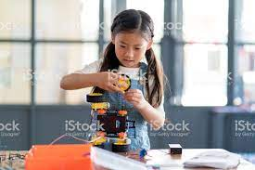
The teams’ approach to robotics is to show how girls would take the lead and have their turn to shine in many ways, such as coding, driving, building the robot, and being a strong leader overall. Girls can prove others wrong when they use their amazing skills to work during any situation. We all agree that when girls work hard and set their minds on something, they’re most likely to succeed.

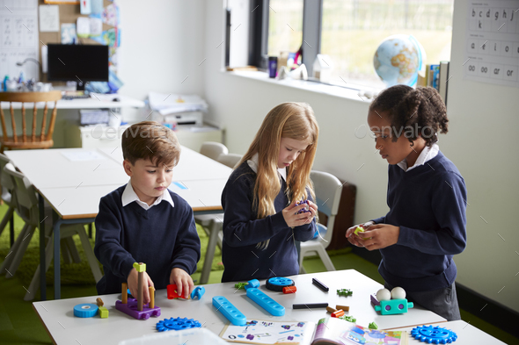
In this picture, it shows a diverse group of students working together as a team. We hope that in the future when our team works together on our robot or projects, we can inspire others from different cultures to do the same. We also want people to know that when any group of students come together, anything can get done no matter what culture they come from or gender they are.

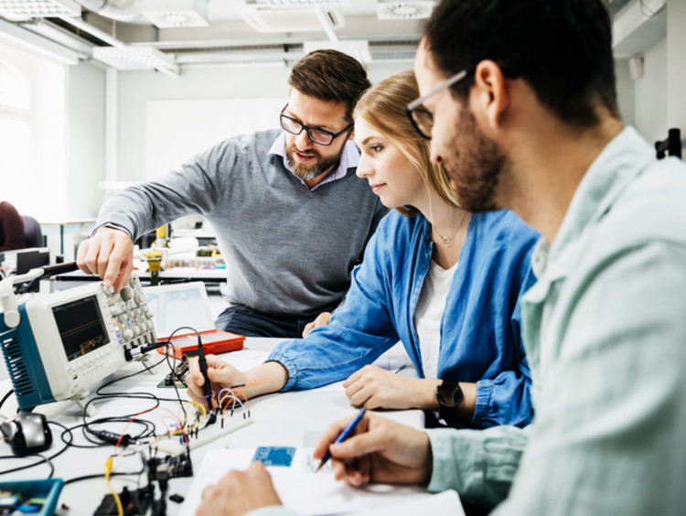
On our team, we all have our own roles that we use to make our robot and team projects. Some of these roles are driving, coding, building, and writing just to name a few. Some of us even do multiple at a time. We all learn new skills and responsibilities for the future from these jobs. Knowing our places on the team will be helpful for the future when we will have to make important decisions.

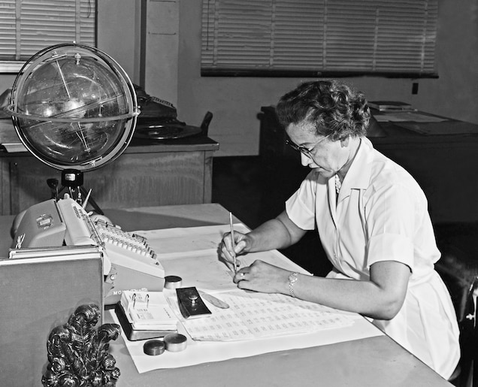
This is Katherine Johnson. She helped do the math for the moon landing in 1969. She is our role model in our STEM Vex IQ team. This is because she mainly inspires all the girls not in our team only, but in the whole world as it showed that girls can do anything if they set their mind to it, even back then when girls were discriminated just for being female. She inspires us to have a more inclusive team as it shows us that girls can be included in the team as much as her, and that she can help the team just as much as the boys.

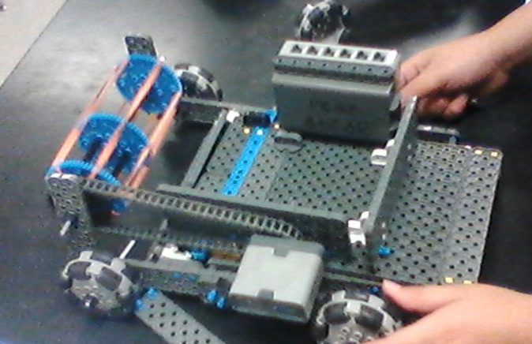
This picture shows our robot that our team worked on together. Each part of this robot was built by different members on our team. From day one of being In the SECME program, we have all learned valuable information that can improve our skills in the future. Over time we have learned to be responsible, crafty, and creative with our ideas and engages us to try something new.

To conclude this essay, when people from different genders or backgrounds work together, they will most likely succeed, especially women. It is important to know that when working together as a team anyone can get the job done.

