Ti Reverse Engineering
Ahlrich Baldivas and Faith Baldivas

We chose a toy car and controller because it is simple to disassemble and reassemble. There are lots of sections in the inner workings of the toy car and controller. For example the signal between the remote controller and the car, the wheels and spring, the battery, and the joysticks on the controller.
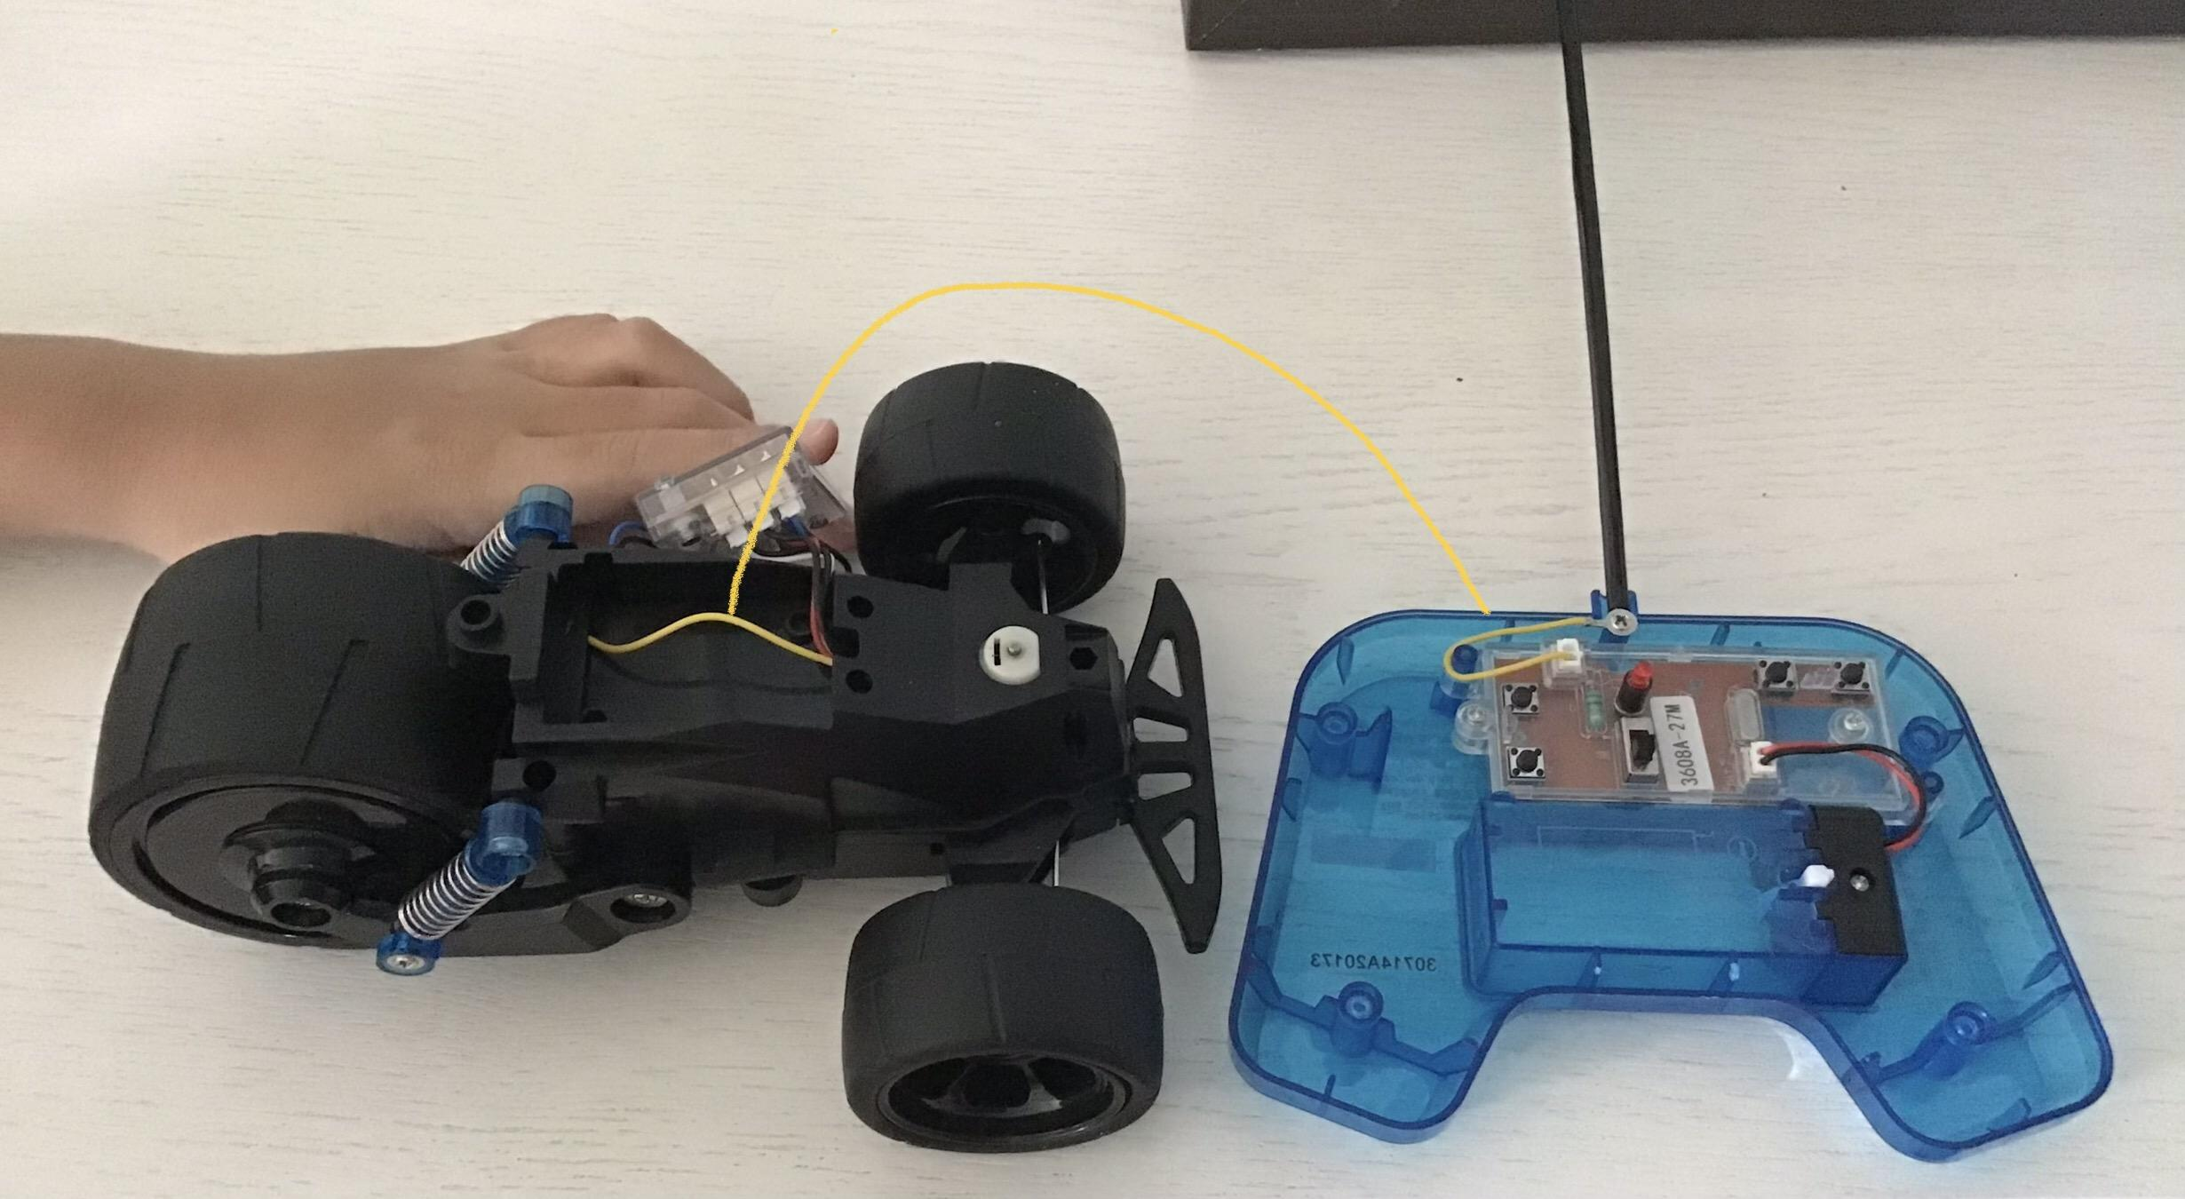 The 2 yellow wires make a signal to connect the toy car and the controler.

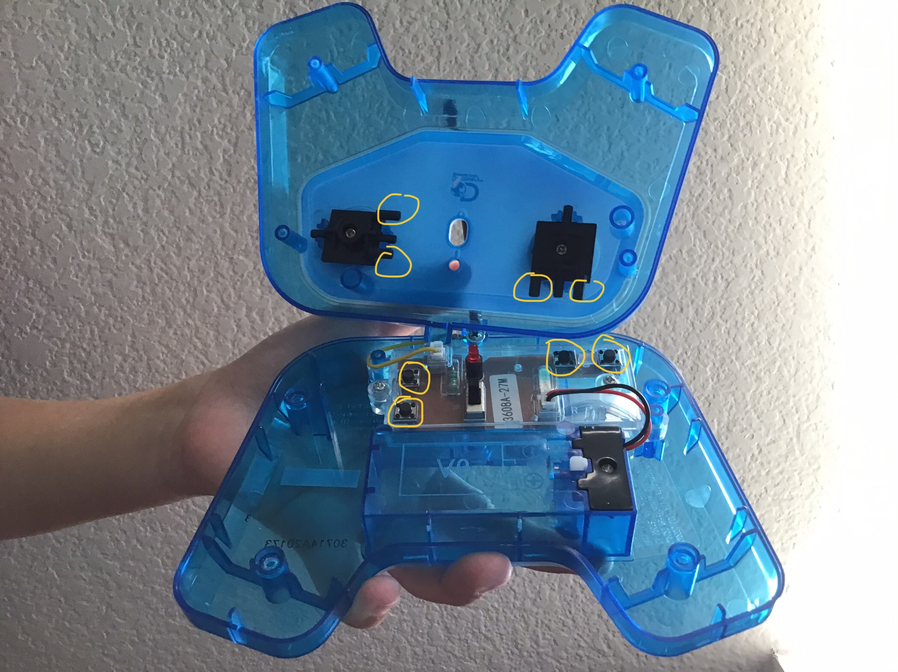
The two black rods at the back of the joysticks, hit the two buttons on the circuit board whenever the joystick moves left or right or, up or down.

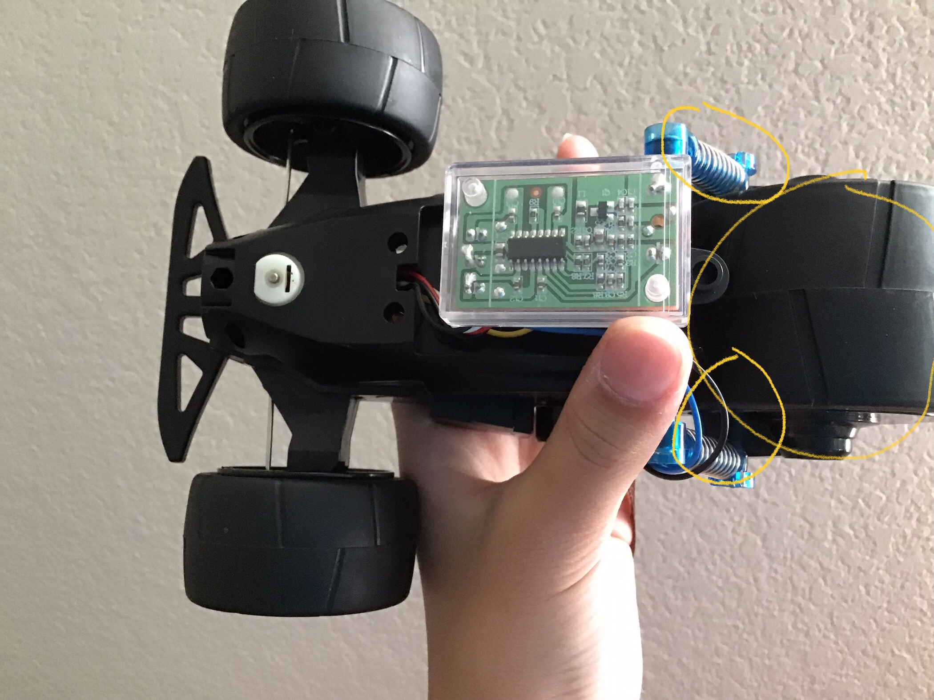
When
the black wire is activated by the 2 black buttons; it triggers the springs to turn the wheels.

The battery powers all of the wires etc.

I have learned that most parts aren’t on the outside but it works on the inside.

