Sebastian Zelaya
Report Global Challenge “Reverse Engineering Challenge”
I am going to carefully deconstruct an electronic device and document the parts I find inside of the device and identify the roles or those parts. I have been deciding on what to take apart and I’m thinking it might be an old iphone.

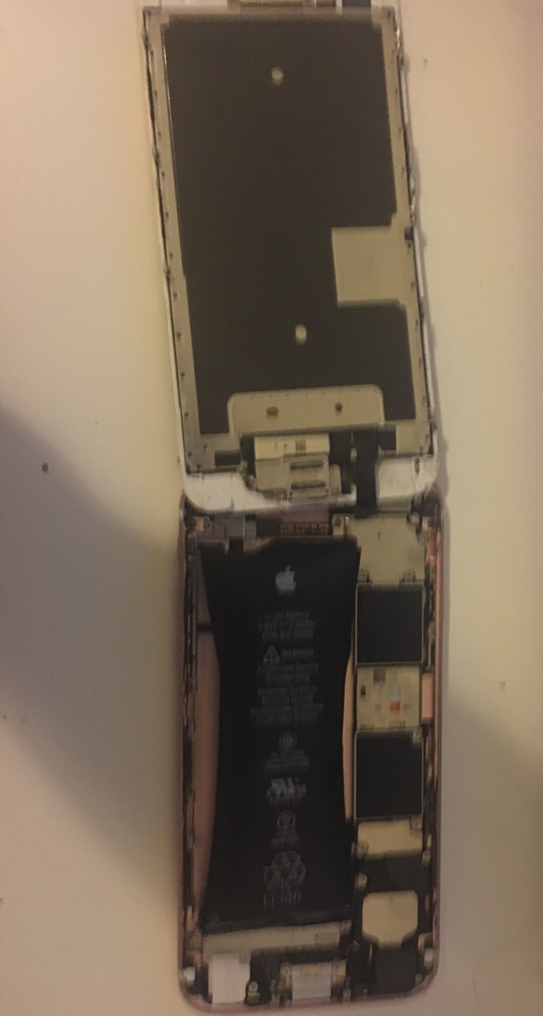
I opened an Iphone 6s and reviewed some of the parts I noticed the taptic engine and the battery, then I saw the camera and home screen button with the fingerprint scanning system
after unscrewing a few things and looking more, I found the sim card input and the back camera, and the light along with the audio speakers on the front and bottom of the phone
I managed to take off the battery and unscrew the Taptic Engine

