Vex Robotics Career Readiness Challenge.

By : Simon Smerk 4073A

Location: Joe Walker Middle School, Quartz Hill

Date: 1/14/22 Due Date: 1/18/22

The STEM career that I selected was the Zoologist and I chose the Zoologist because I would really enjoy studying animals and what they do, and also getting to know how animals live in the wild. I also chose the Zoologist because one day if being a Doctor doesn’t work out for me, then I would be a Zoologist, and this is a perfect way for me to learn how to be a Zoologist in an exciting way.
The resource that I found to learn about professional Zoologists in this career was an article online called “How To Design a Zoo Exhibit In Four Steps,” by Katya Vines. The four steps in designing a Zoo Exhibit are understanding the criteria and constraints, choosing your animals, designing a natural habitat, and the last step is to open your exhibit.
Professionals in this career apply the engineering design process by using the criteria and constraints to research what the animal needs for a habitat. If we use a penguin, they would test the penguin and if it breaks its habitat then they would need to make the walls stronger. They chose their animals by making an enclosure first, then seeing how much square feet the animal needs, and what wall strength they need. Once they check that, they narrow down the animals until they find one they like to put in their zoo. After finding their animal, they research the animal to see what they live in. If the animal lives in a jungle, they will put jungle trees with vines and water and will make a natural habitat to make sure the animal feels like they are not in a zoo. The last step in the engineering design process that Zoologists use would be to open the exhibit. When opening the exhibit, Zoologists make sure that the animal is happy, and that the animal cannot escape. Also make sure the glass is strong enough so that way no guests are injured. After that, your exhibit is ready.
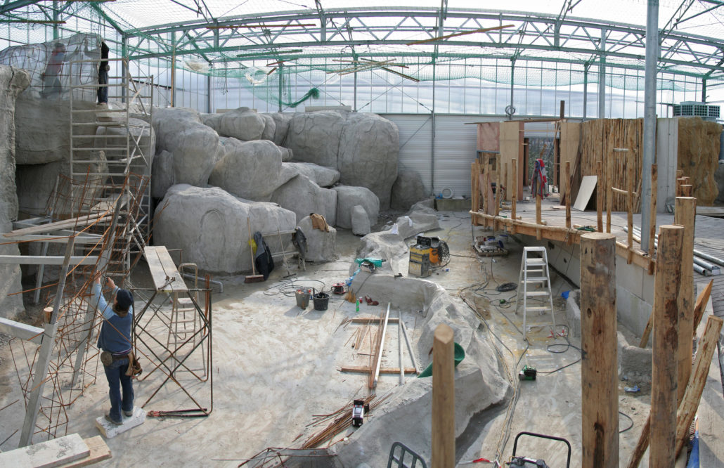
(Gallery Construction projects of Houthoff Zoo Design)
In the engineering design process for Zoologists, it differs and matches with our team. Certain parts of the engineering design process for Zoologists differ from our team, and other parts match with our team. The first step, criteria and constraints, matches with our team because we need to see what works with the robot and what doesn’t. The next step in the engineering design process, choosing your animals, differs from our team. It differs because we do not need to choose anything. The builders decide what to put on the robot, inventors build the robot from autodesk inventor, engineering notebook writers write what they do, and programmers program for the robot. So we don’t choose, we follow the instructions from the builders. In a Zoologist’s job, they just choose an animal to adopt and make a habitat for it. For the third step, designing a natural habitat, it differs from the Zoologist side but we do have to do the research which is the same with the Zoologists. It differs with our team because we research pictures of robots and find the best creation for our team. Then, we recreate that piece the best that we can. For Zoologists, they have to research what the animal needs, how much space they need, what biome they live in, etc. It matches our team because both of us need to research the best for the robot/animal. The last step, opening your exhibit, differs from our team as well. It differs because for us, when our robot is ready, we just get into tournaments and compete. For Zoologists, they just move the animal into the exhibit and then let the public see the animal.
Participation in Vex robotics has prepared me for a future career by helping me learn programming and also preparing me for unexpected challenges. For example, before Vex, I didn't even know what programming was. And when I programmed, sometimes I would make an error and have an unexpected challenge to fix that error. Also in tournaments, we might have a wheel fall off, and we would have to fix that wheel before our next match. It has also taught me teamwork. Before, I would not really think about how to use teamwork, but now I have learned that teamwork really helps a lot when working on something more complicated. Vex has also taught me to be more creative. Before Vex, I was definitely not creative at all. But now, I realize that creativity does not need instructions, like lego. I can now make programs without someone helping me, and I don’t need instructions to make a robot. Participation in Vex has really prepared me for a future career, and I hope I keep these skills for a long time.

