Reverse Engineering a Nokia by 21549D

This is the front of a Nokia. There are cut-outs for the buttons, microphone and speaker. In the centre is a glass or plastic screen cover. The front of the Nokia is made out of poly carbonate just like the back.

Speaker

Microphone

On the back of the keypad is little sticks. The purpose of them is to hit the electrical buttons.

This is the keypad of the Nokia. It is very soft and is easily scrunch able. It has several holes some for better grip to other pieces and others for air to escape. The hole in centre is for the microphone.

This is the microphone of the Nokia. It is made out of a magnetic material and it is soldered onto the motherboard

This is the micro usb charging port for the Nokia. It is very small and delicate. It has no excess solder on the back. It is made out of metal. It is directly connected to the CPU and battery.

This is the headphone jack. It like the charging port is soldered onto the Nokia and it has no excess solder on the other side.

This connects to the speaker

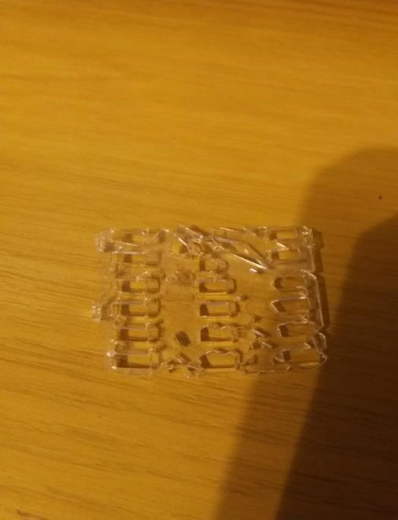

This is a piece of clear plastic. Its function is to make sure that the right buttons are pressed as it filters the sticks to make sure that they touch the right button. It has little legs on the side to clip onto the Nokia’s keypad

Leg