Title Page:
  - Tile of submission: VEX Recruitment Poster
Names of students who participated (using first names only is acceptable)
Vincent Cheng, Royall Lau, Hugo Zheng
  - Team number : 3168X
  - Location of team: Half Moon Bay, Auckland, New Zealand

Explanation Our Design:
Our design is to mainly inspire mentors and children to join VEX Robotics. I wrote the breath-taking points and the many benefits of VEX Robotics. I was thinking about blending the fun of VEX into a poster so people would be inspired to join VEX!
Our poster revealed that we work as a team and to create robots and imagine ideas that would work to succeed in the robots, so this inspired us to never give up on ideas or to stop thinking or solve problems.
The parts we involved in the poster include building and teamwork, so we think it is the most important parts of STEM as it is what (I think) VEX Robotics wants us to improve on.

This was our poster plan | This was our final design
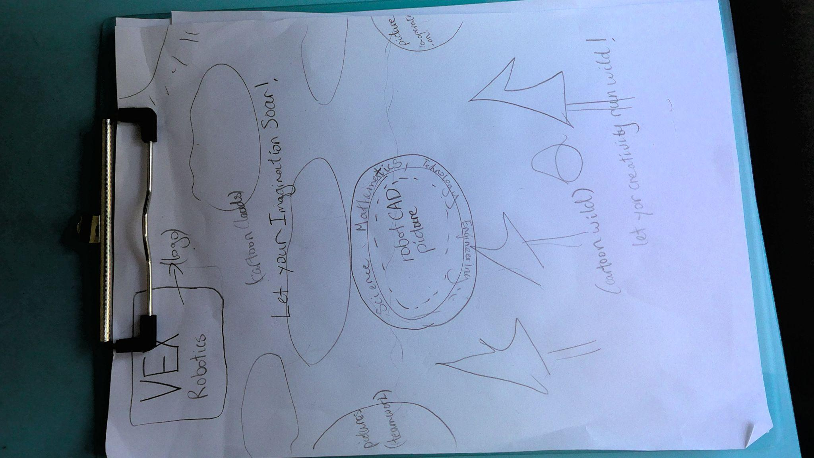 | 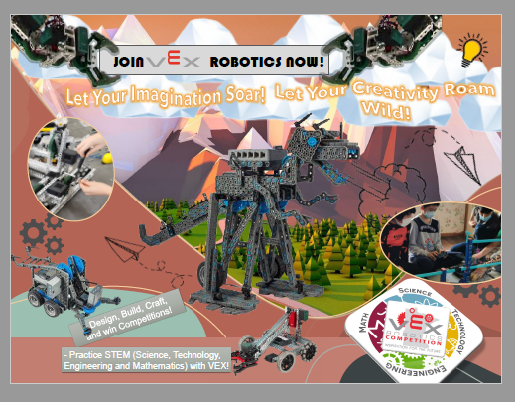
We Finished the plan on 10/12/21 | We Finished it on 14/1/22

By Vincent Cheng

