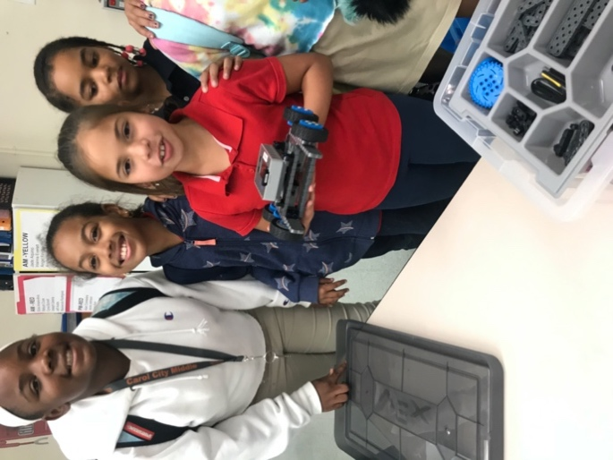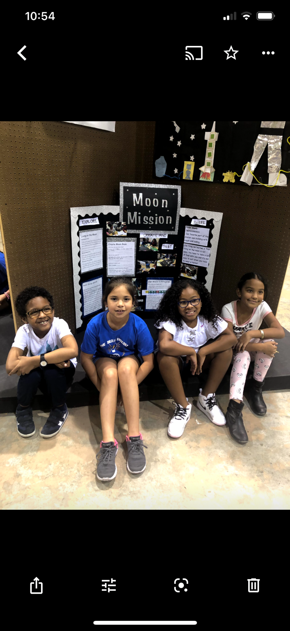

Girl Powered by Vex IQ

My name is Alina Ramirez and I’ve been in robotics since 2nd grade. In the pictures above you can see my team and I at the Dade County Youth Fair and also building our first Vex robot. Our team was mostly powered by girls and we worked together to make our robot come to life with coding. I love when my team and I work together. We shared the responsibility equally. What comes in mind when I think about girl power is that girls can be leaders and they can use their ideas to help people out. The girls in our team weren’t afraid to take the lead as we were guided by our teacher, Ms. Farley who is also a girl.

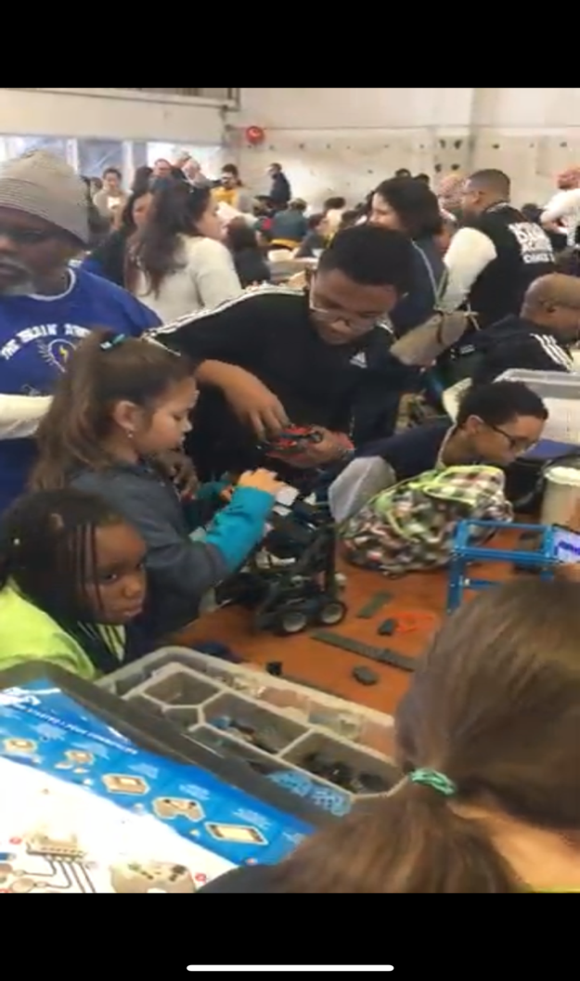

Here I was, finally, in another vex competition and I was excited! I have heard people say that girls can’t code, but I proved them wrong. I was one of the coders for the VEX autonomous runs. I also helped in the building of our robot and the design of the program. Our team that year was mostly new students to VEX and we didn’t get many points, but we still competed, worked as a team and had fun. Our coach taught us that having fun and learning new strategies were more important than winning. In school, during our after-school program we have an area to practice driving the robots and we can make upgrades and changes when things do not work out. There is a mix of boys and girls on the team and the boys sometimes try to take over, but Ms. Farley is good at making sure that we all get a chance to practice and code by rotating us.

Our First VEX Competition

When I first got into vex, I was in 3rd grade. Mrs. Farley, the robotics STEM teacher, was always helping me. Since I was new, I was just learning to code and really did not get to do too much. However, I still felt that I was an important part of the team. My older sister was on the VEX Competition team and I remember always being around her and watching the team work together. She was using her girl power to motivate and encourage me.

During this competition I was coding the robot for the autonomous run and I was also one of the drivers for the team competition. As you can see, I was the only girl in my round, and I was proud of myself. Building and coding robots is not just for boys, girls can do it too, and we are good at it. I was one of the only girls to program the robot and Ms. Farley really helped me think about the program and what changes needed to be made. She is my STEM role model! She is always fair and she does a good job of making us think. Ms. Farley inspires me because she always includes everyone, she helps everyone out when they need it, she gives us advice about how to build the robot and always pushes us to our limits so we can be better. Participation in Vex has taught me how to work in a team and how to use my girl power to help my team.

3rd Grade

Our team has changes over the years and all our hard work paid off. During the VEX IQ Rise above our team made it to the VEX IQ world Challenge. We were so excited. Our all-girl team have made it to the world competition, and we were also a little nervous. In the middle of the Covid pandemic, our team kept working on our robot and coding. Sometimes our classes were quarantined. Sometimes we worked in person and sometimes we worked virtually. But we kept going and it paid off. Working on an all-girl team is very challenging. We have very strong opinions and sometimes we get upset at each other. In one of our virtual challenges, we got so upset and we were disqualified. But we learned from that experience. We learned to listen to each other and use our ideas to make changes to the robot. When we made changes, we tested the robot to see what worked best. Being on a team is like being in a family. There are going to be times when we don’t agree but we find ways to work out our differences and become stronger as a team.

After many changes to our robot we were rewarded with the Think Award. We were happy to get this award because our team really thought about how to build this robot. Coding it also made us do a lot of thinking so we felt like we earned it.

I am now in fifth grade and our team is participating in the Pitching In competition. We are excited about this year’s competition and our team has won 1st place in a district coding challenge so far. From 2nd grade to now, all that I have learned and the encouragement I get from Ms. Farley has made me feel confident that girls can build and program robots and I hope that I can continue building on what I’ve learned through middle school and beyond.

VEX World Challenge