This is the VRC Girl Powered entry for the team “39702F.” Coming from the team captain’s perspective, Aubri Stacy. Aubri is the main writer, and Ava and Savannah (teammates) will take part in it. The way our team interprets the term “girl powered” would be accomplishing goals with a team of solely women.

Even though each team member has a designated role on the team, each member is encouraged to try different roles. For example, each member allows others to see from a different perspective.

If we won the spot at worlds, we would use it to make a difference. We would show that girls can do it all. It is highly likely that we won’t win anything, but if somebody knows what we’re doing, that’s our goal, completed.

(Aubri) Katherine Johnson made traveling to space possible. She inspires me, personally because she was a woman. That’s not the only reason, as how could just being a woman inspire somebody, other than the blatantly obvious.

Other reasons that she inspires me as a woman is that she overcame challenges that I find amazing. She got the first men to the moon! Katherine would be a great role model to many because she overcame difficult challenges. Including segregational, and sexism. They even made an entire movie about her, titled “Hidden Figures”.

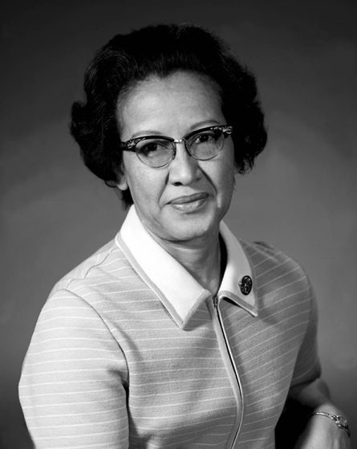

(Ava) In many ways, Tu Youyou was inspiring. Personally, she was inspiring to me because she found a way to cure an almost, uncurable disease. Malaria. Very serious, and often fatal. She was invited, by the government, to find the cure. And not too long later, found it. She accomplished her goal, and later received a Nobel Prize.

A good reason that Tu Youyou would be a good role model is because she was very persistent, and never gave up. She continued to follow her dreams, even when her attempts did not get her very far.
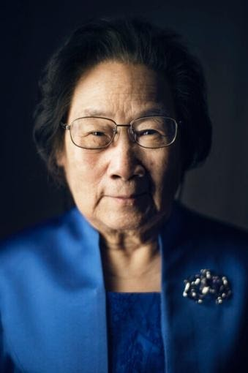

(Savannah) Jemison was the first ever African American woman to go to space. After graduating from Stanford University, she continued to get her medical degree. Jemison applied to NASA and was one out of the 15 people who were accepted. She was the science mission specialist on the STS-47 Spacelab-J flight in 1992. Where experiments were carried out as the crew orbited Earth.

Later Jemison decided to leave NASA. She is now leading the US government funded 100 Year Starship project, which is a project that aims to help develop all the technology needed to reach the goal of interstellar space flight.

One of Jemison’s goals is to make sure that science and technology are accessible to everyone. She also wants to empower young women to encourage with STEM and pursue careers involved with STEM.

Jemison has truly been an inspiration for everyone to try their hardest to achieve their dreams, no matter what the obstacle is, which is why Savannah’s STEM role model is Mae Jemison.

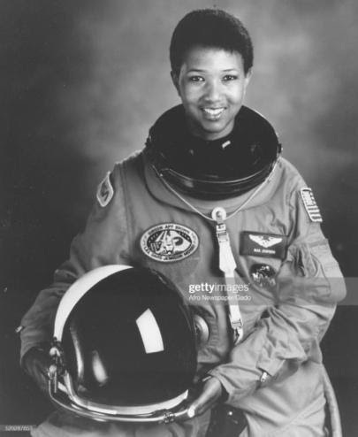
In conclusion, our team has different opinions and different perspectives. But these differences make our team great.

