Deconstructing a Lenovo laptop with Goulburn High!
Lucas with 11123A from Goulburn High School, Goulburn NSW Australia

The 2013 Lenovo ThinkPad was designed for business and was used a school laptop before it was deconstructed. We deconstructed it as the school found no use for them and it was already decommissioned. As well the laptop allowed us to go through and see the parts of a computer before more advanced technology came into place.

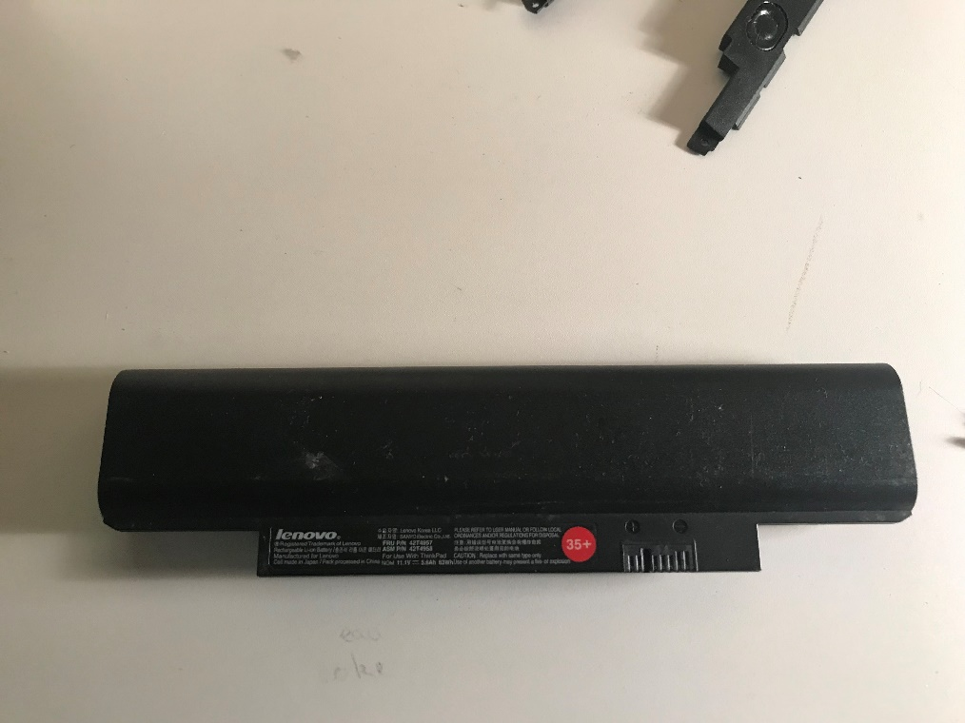 | Rechargeable battery  The number of charge/discharge cycles a battery may go through before its capacity drops below a certain point is known as cycle life. The total "health" of the battery is determined by the combination of cycles and capacity. During charge and discharge cycles, all lithium-polymer batteries experience some swelling. Swelling that causes the battery pack or your system to bulge outward is abnormal.
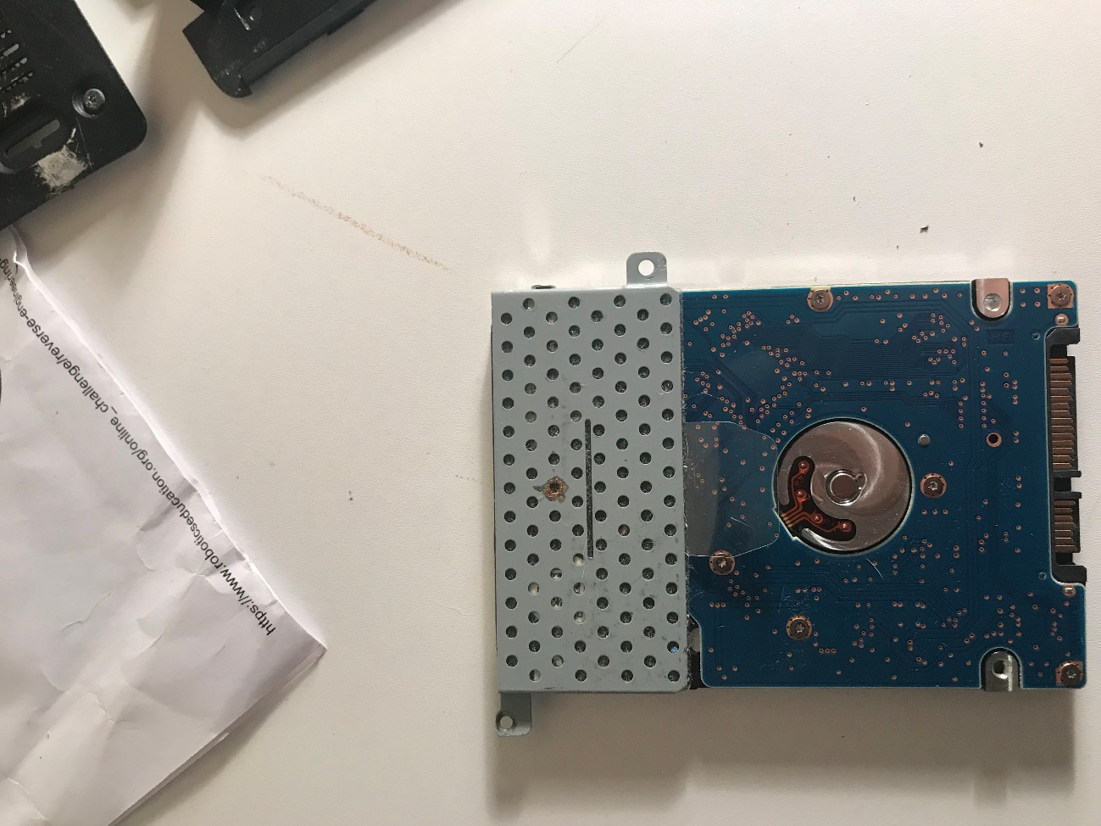 | Hard drive  The hard drive is where a computer's data is stored for the long term, including all of the code needed for the operating system, the framework used by browsers to access the internet, drivers for accessories, and everything else. Every hard drive has a certain amount of storage capacity. Some of that space is taken up by the operating system and backup software. The remaining, on the other hand, can be filled with data you download and save, such as a new app or a humorous cat photo someone posted.
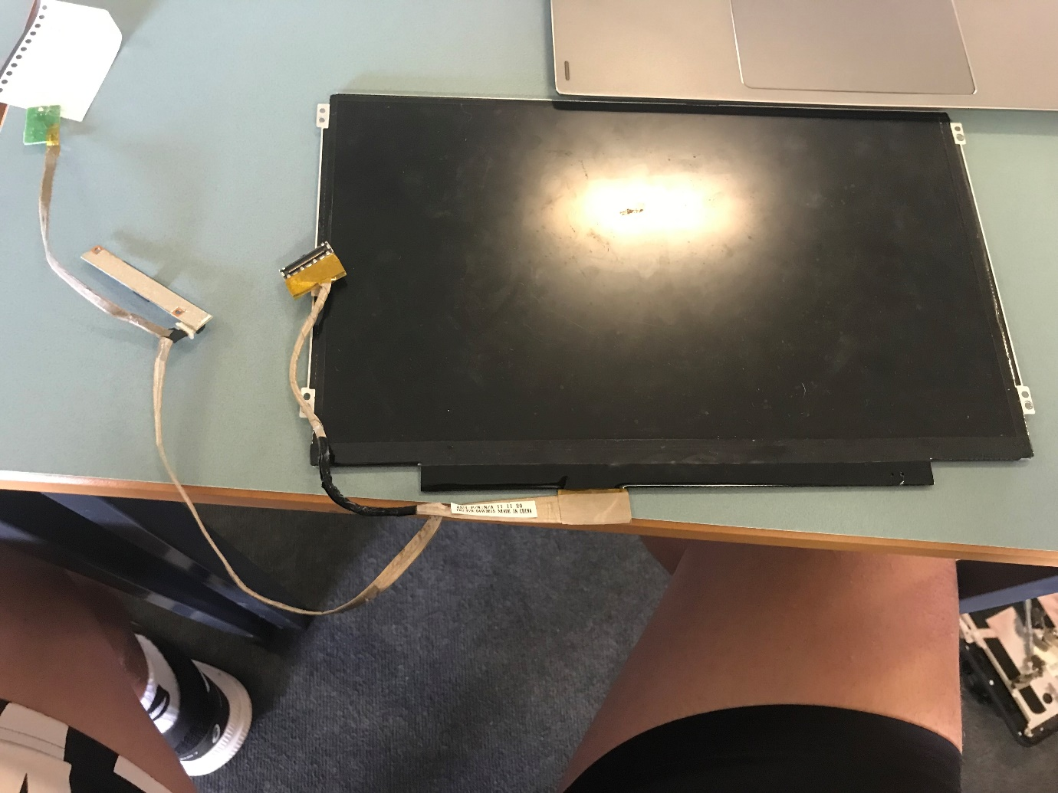 | Display screen  Liquid crystal displays work by obstructing light. An LCD is made up of two pieces of polarised glass (also known as substrate) with a liquid crystal material sandwiched between them. The light from a backlight travels through the first substrate. Active matrix technology is used in the majority of LCD displays. On the display's glass, a thin film transistor (TFT) organises small transistors and capacitors in a matrix. Passive matrix is the other sort of LCD technology. Each pixel in this LCD panel is charged by a grid of conductive metal.
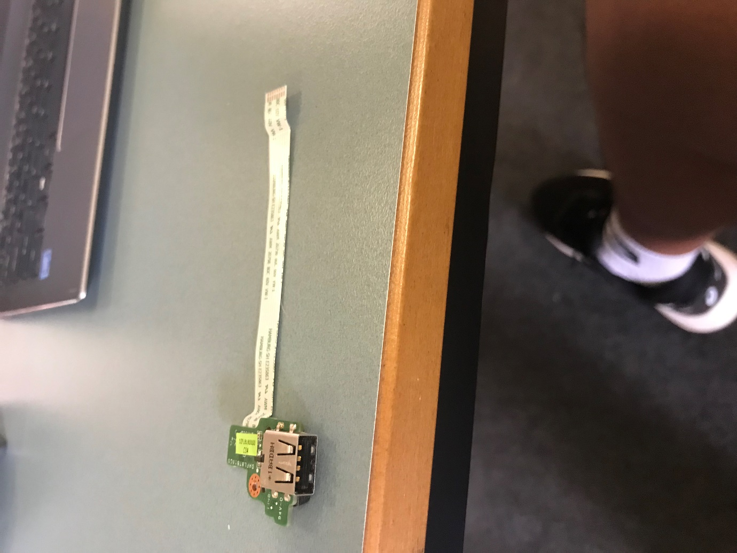 | USB port board  A USB port is a common cable connection interface for computers and other consumer electronics. You can connect USB drives to your computer or electronic device via the USB connector and then transfer digital files. Furthermore, the USB port can be utilised to provide electric power to USB devices that require it via a USB connection.
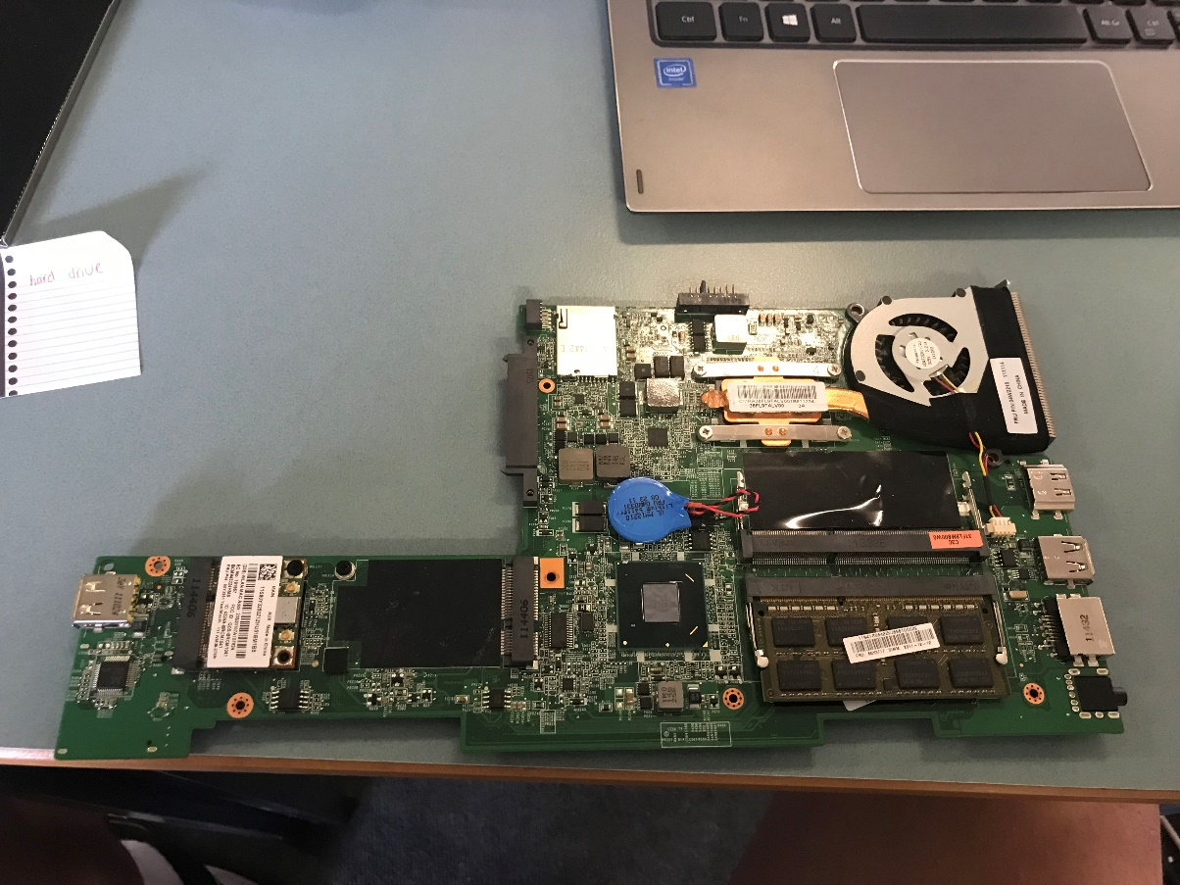 | Motherboard  A motherboard connects the computer's hardware components, such as the processor (CPU), memory (RAM), hard drive, and graphics card. Motherboards come in a variety of shapes and sizes to fit different types and sizes of computers. Each type of motherboard is designed to function with specific processors and memory, therefore not all CPUs and memory types are compatible. Hard drives, on the other hand, are usually ubiquitous and function with almost all motherboards, regardless of type or manufacturer.

Taking the laptop apart and seeing all the components inside gave me more insights on how a laptop is built. Then learning about what some of the parts do to a laptop and help people use a laptop was very interesting.

Article title: | Battery Q&A - Lenovo Support AU
Website title: | Support.lenovo.com
URL: | https://support.lenovo.com/au/en/solutions/ht509084-battery-qa

Author | HowStuffWorks
Article title: | How Computer Monitors Work
Website title: | HowStuffWorks
URL: | https://computer.howstuffworks.com/monitor5.htm

Author | Data Tips
Article title: | If Your USB Port Not Working, These Solutions Are Available
Website title: | MiniTool
URL: | https://www.minitool.com/data-recovery/usb-port-not-working.html

Article title: | What Is a Hard Drive? | Digital Trends
Website title: | Digital Trends
URL: | https://www.digitaltrends.com/computing/what-is-a-hard-drive-your-guide-to-computer-storage/

Author | M Definitions
Article title: | What is a Motherboard?
Website title: | Computerhope.com
URL: | https://www.computerhope.com/jargon/m/mothboar.htm

