VRC 2021-2022

Make It Real CAD Invention
AT. Shaft Collar

1. Introduction

We are team 98709X for Dayspring Academy in Greenbrier, TN. We are a high school division team in VEX VRC.

We asked the several teams around us what they would like to improve about VEX robotics. One of the ideas that came up was a better shaft collar.The shaft collars are hard to put on and loosen. We needed to find a way to make the shaft collar an easier piece to use.

2. Problems and Solution

We needed to fix several problems in this build:
- The metal shaft collar would come loose.
- The rubber shaft collar was not secure enough.
- The metal shaft collar screws would come out and get lost.
- The metal shaft collar screws are harder to adjust.

We designed a simple solution that could fix almost all of these problems. A mixture of the rubber shaft collars and the metal shaft collars, working together to become a stronger shaft collar. We lined the inside of the metal shaft collar with rubber and a small jagged hole (similar to the one in the original rubber shaft collar) so that it could securely hold the shaft. We kept the screw hole, although it will still be a little difficult to adjust the screw, it will be harder for it to pop out and get lost somewhere.

We used Fusion 360 as our software to construct 3D pieces of the AT Shaft Collar.

3. Design

First we took the measurements of both the metal shaft collar and rubber shaft collar. We then started to make the metal parts of the shaft collar, later adding in the rubber parts. The metal was the outside of the shaft collar with the rubber lining the inside of the metal. We extruded the piece then added the hole with the measurements from the original shaft collar, plus some modified measurements we used. We also made sure that we had the holes extruded through the whole piece.

OUR BUILD:

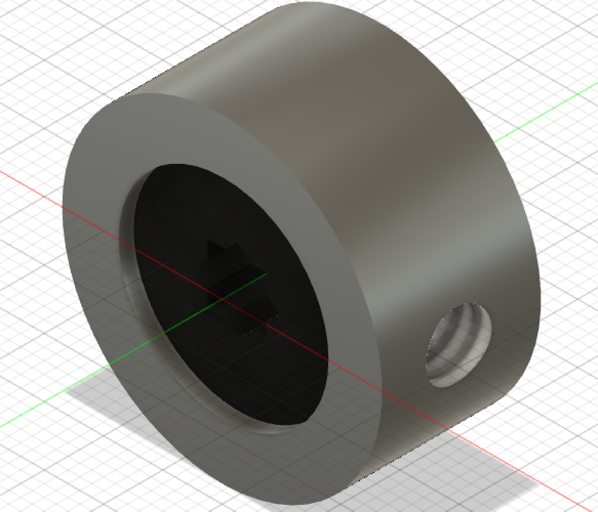
Metal Shaft Collar:
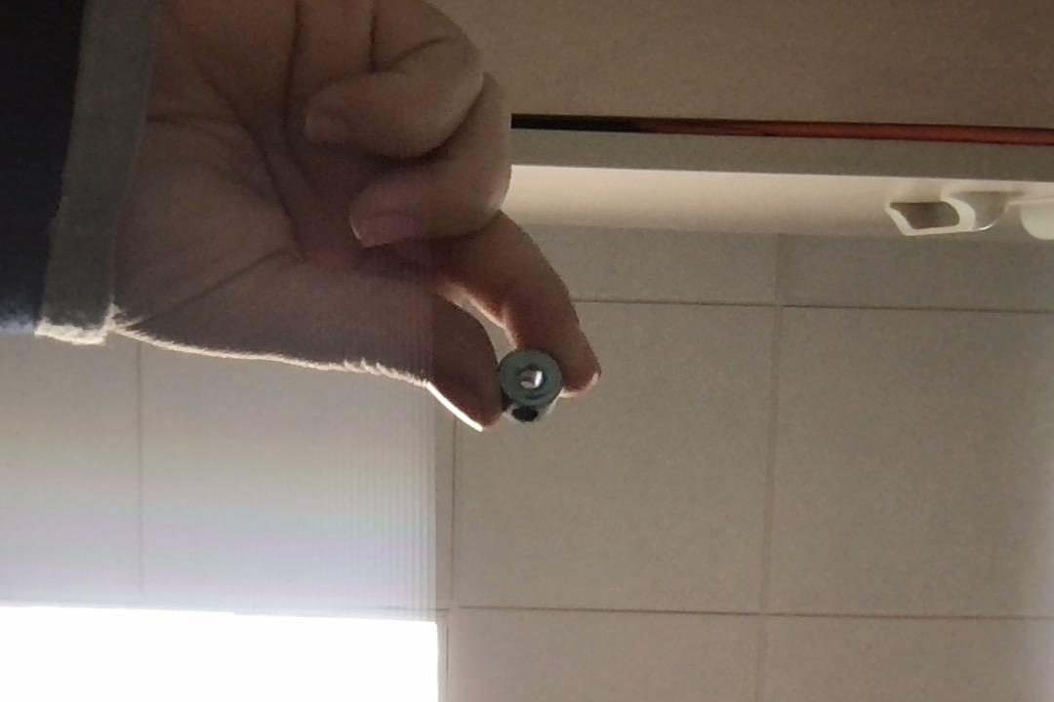
Rubber Shaft Collars Pieces:

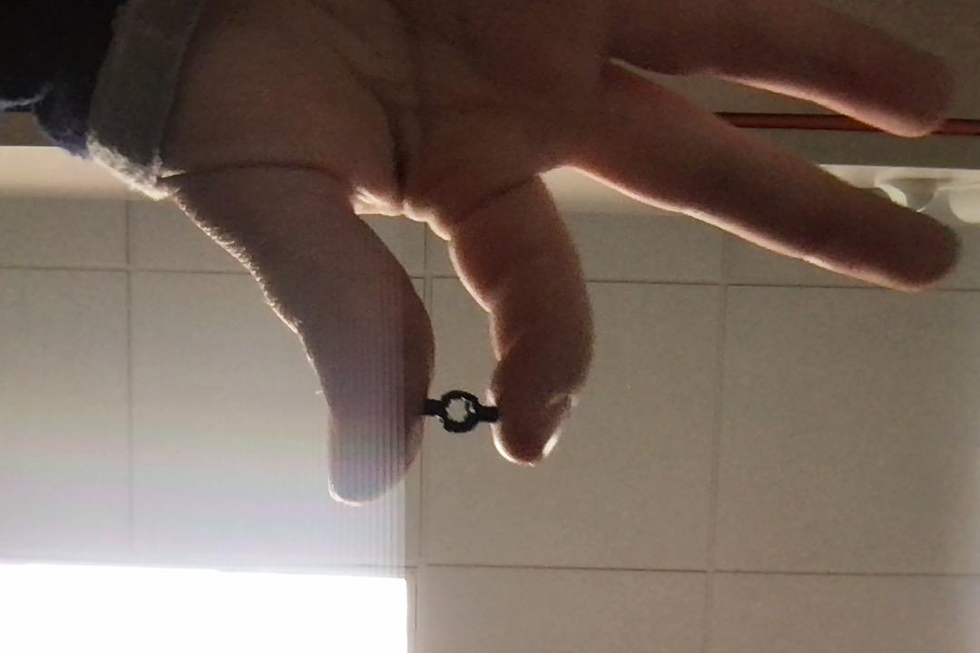

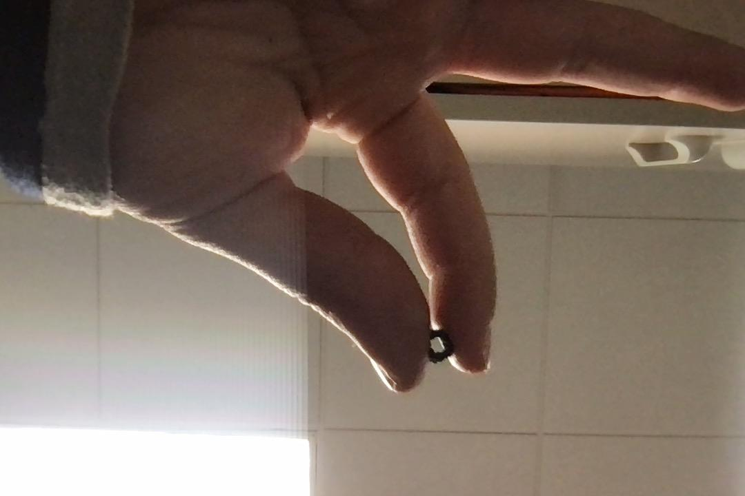

One of the prototypes with and without a shaft inside: 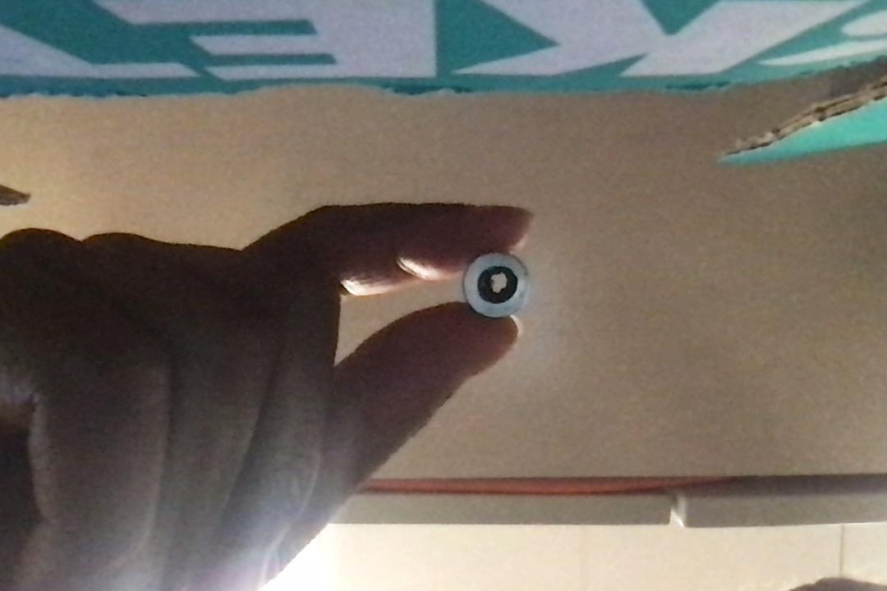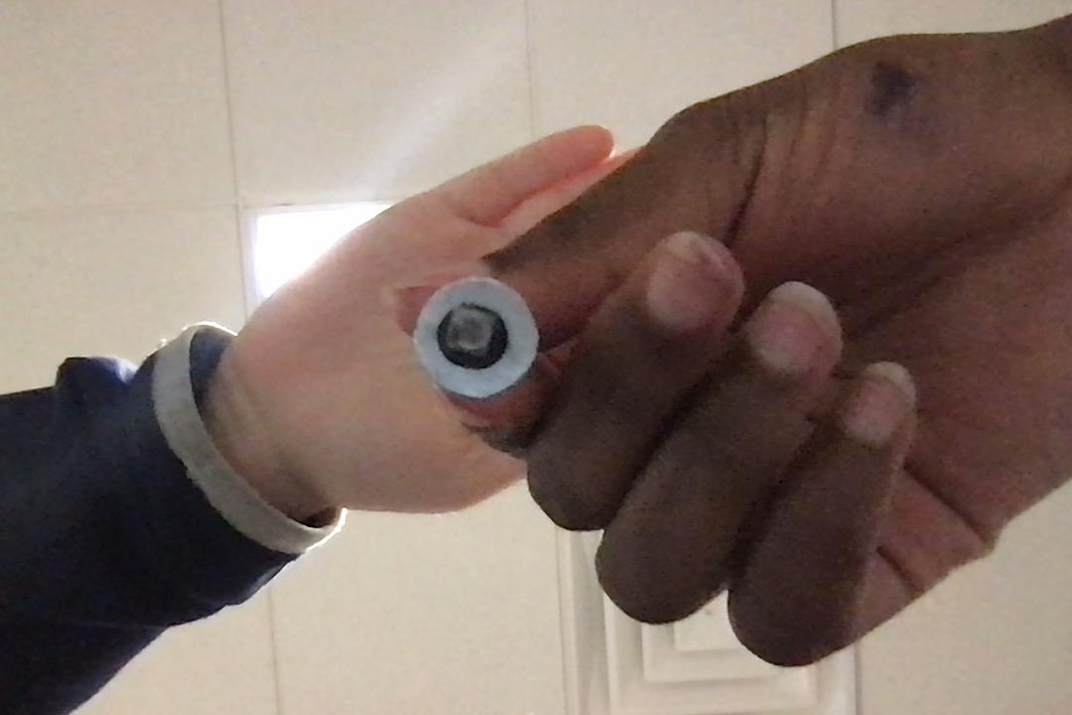
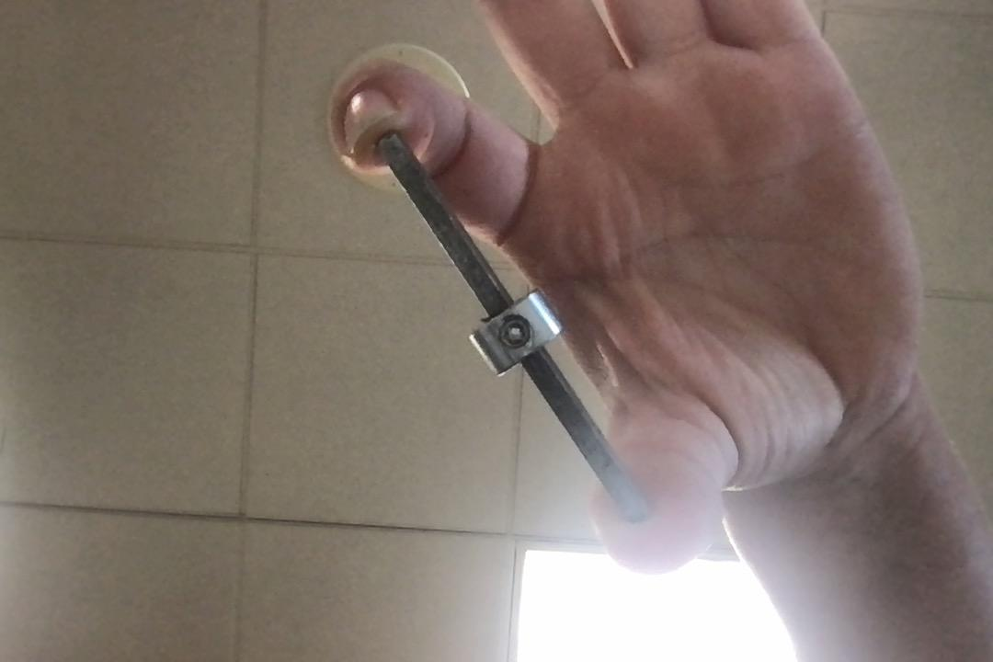
3D Printed Prototype
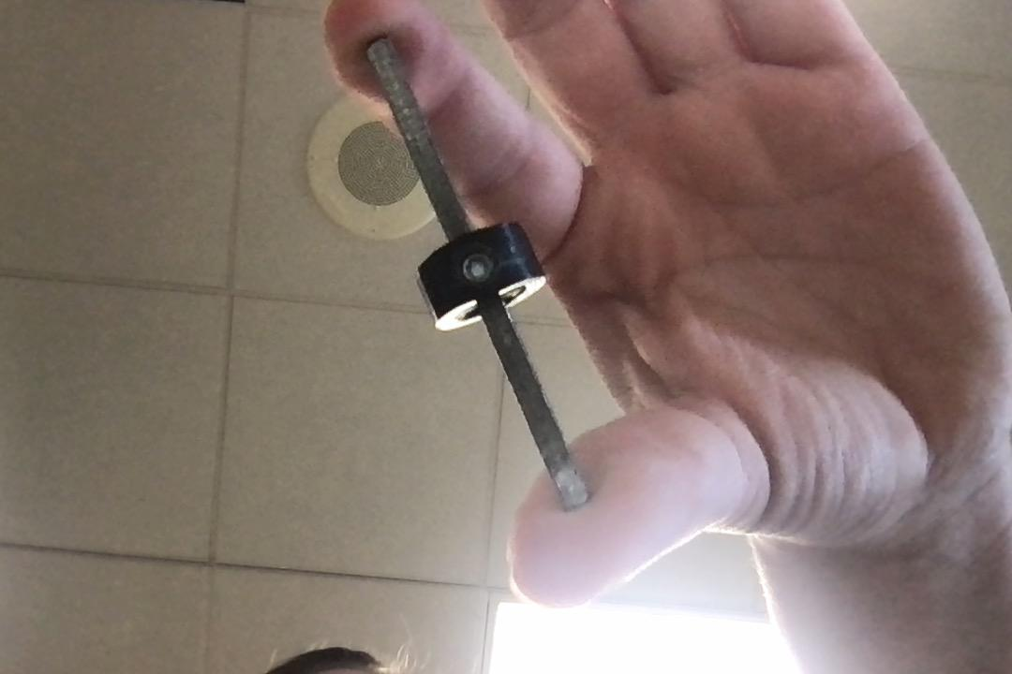
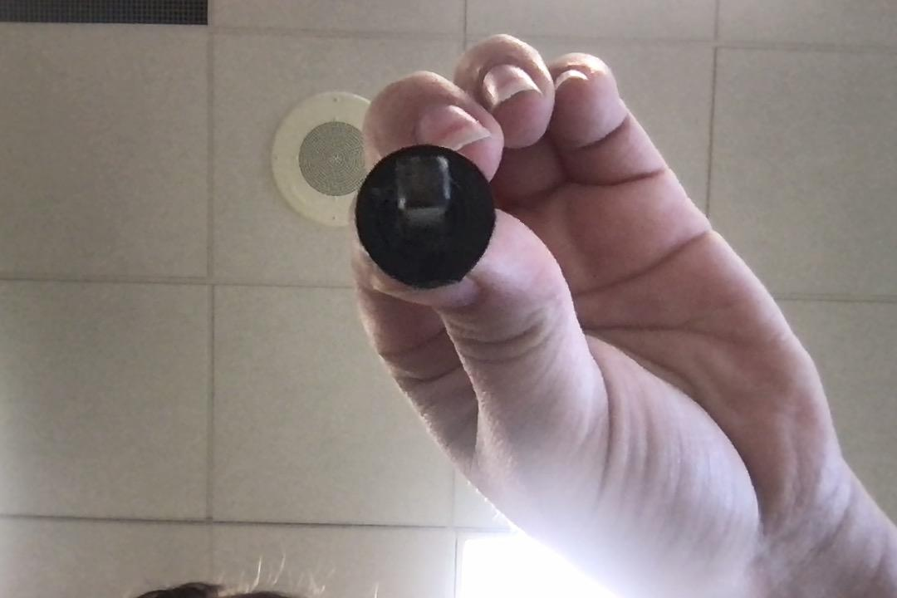
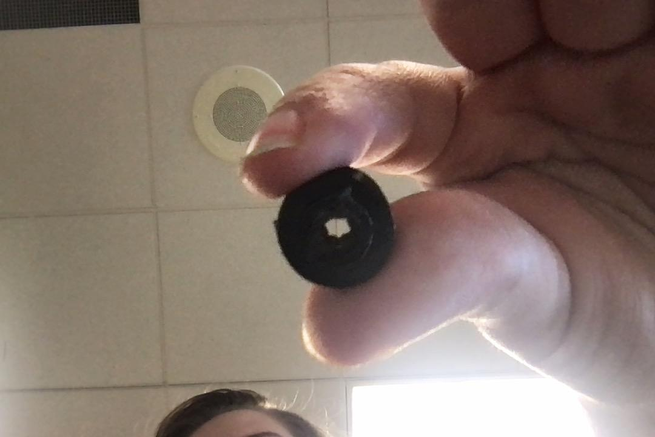
4. Original Dimensions

Metal Shaft Collar
- Length: .532in
- Hight: .264in
- Hole: .350in
- Depth: .249in
Set Screw
- Piece: 0.122in
- Hole: 0.132in

Rubber Shaft Collar
- Length: 0.426in
- Hight: 0.346in
- Hole: 0.262in
- Depth: 0.384in

5. Our Dimensions

Metal Outside
- Length: 1.671in
- Width: 0.264
- Radius: 0.266in
- Diameter: 0.532in

Rubber Inside
- Length: 1.096in
- Width: 0.236in
- Radius: 0.175in
- Diameter: 0.349in

Inner Rubber Hole
- Dictance: 0.14in
Set Screw Hole
- Distance: 0.172in

Prototype while testing:
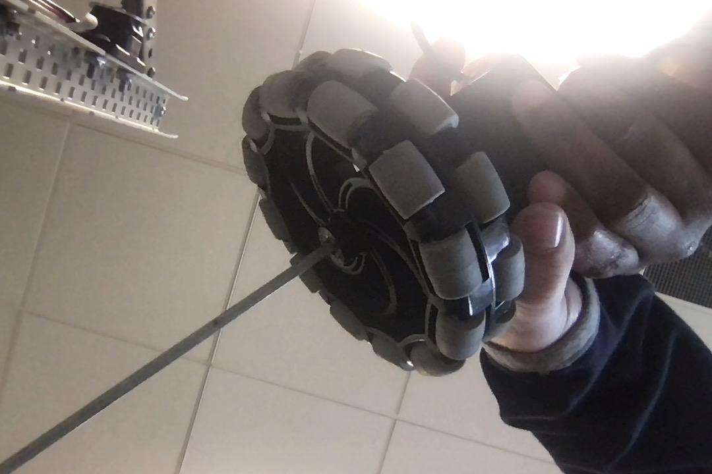
5. Conclusion

After testing with a motor and wheel, we found that our 3D printed prototype could hold onto the shaft. It worked really well and it was easier to take off and on the shaft. Even with a little wiggle room the shaft still stayed pretty tight on the shaft. There are some things we could have changed in our design to make it better, but we are really proud of the outcome of this project. We could have had knobs on the rubber piece and locked it in with the metal, like they had on the original rubber shaft collar. We also should have made modifications to the set screw hole dimensions, so that we could fit the screw in without so much work having to be done to the piece. Other than that the AT shaft collar worked really well and we are very proud of the designs and prototypes.

