Build a chariot and compete in the games for a chance to win Athena’s Blessing!

As a time traveler, you and a friend decide to travel back in time to visit Ancient Athens. You both enter the Panathenaic Stadium, where you soon learn that the Panathenaic Games worshiping Goddess Athena are currently being held. You both realize that you are just in time for the main event, and are soon whisked into the center of the stadium by other gladiators to hear the rules.

Each gladiator must design a chariot to play in the following game: A huge goblet is placed in the center of the playing field and is filled with wine. 22 golden grapes are scattered around the field in predetermined starting positions. In order to pass from one side of the field to another, your chariot needs to be able to fit under the lowest branch of the olive tree. You can score points in multiple ways: First, 2 points are awarded for every golden grape pushed under the goblet and out of sight from the gods above. Second, 6 points are awarded for every golden grape launched into the goblet of wine. Third, 5 points are given for clearing a corral, which is the 5 golden grapes lined along opposite sides of the field. Lastly, at the end of the match, 6 points are awarded for hanging on the low branch of the olive tree, and 10 points are awarded for hanging on the high branch of the olive tree.

There are 3 ways to play this game. First, you both and one other pair have 60 seconds to drive your chariot around the field. The first person, Driver A, can operate the chariot for the first 25-35 seconds, and then must switch with Driver B. At the end of the 60 seconds, the points from both pairs are added, and each team receives the same number of combined points. Second, in the driver skills match, a pair of teammates can drive their chariot around the field for 60 seconds (switching at the 25-35 second mark), to receive a number of points. Lastly in the programming skills matches, a pair of teammates can program their chariot to score points by itself on the field and are not allowed to drive it. The points earned from the Driving Skills matches will be combined with the points from the Programing Skills matches for one final score.

At the end of the day after all the matches, whichever team has the most number of points wins and is forever blessed by Goddess Athena and will be praised by all of Athens. She will also reward you with laurel wreaths as a symbol of her blessing.

Good luck, and safe building!

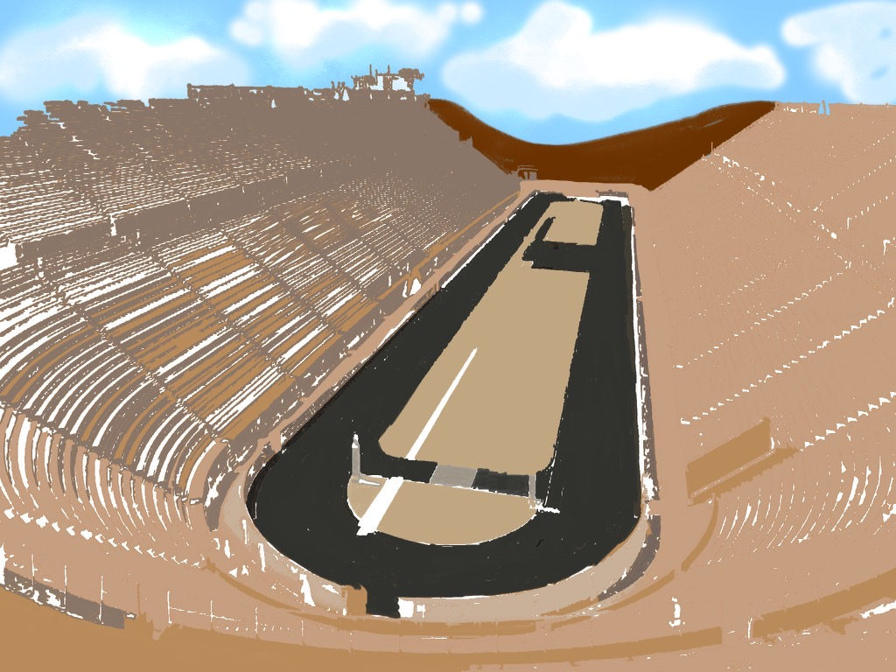

You are capable of time traveling and one day decide to bring your friend along to explore Ancient Athens. Once there, you both decide to visit the Panathenaic Stadium, where the Panathenaic Games held in honor of Goddess Athena are currently going on! You have both arrived just in time for the main event, and are brought to the center of the stadium to hear the rules along with hundreds of other gladiators.

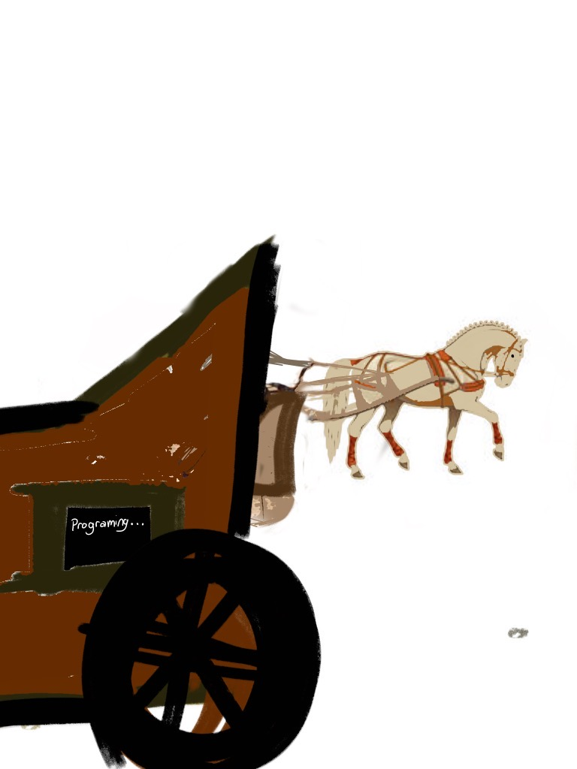

The rules are simple; Each team of two must design and construct a chariot equipped with functions that they think will allow them to score the most points in the game. A huge goblet is placed in the center of the playing field and is filled with wine. 22 golden grapes are scattered around the field in predetermined starting positions. In order to pass from one side of the field to another, your chariot needs to be able to fit under the lowest branch of the olive tree.

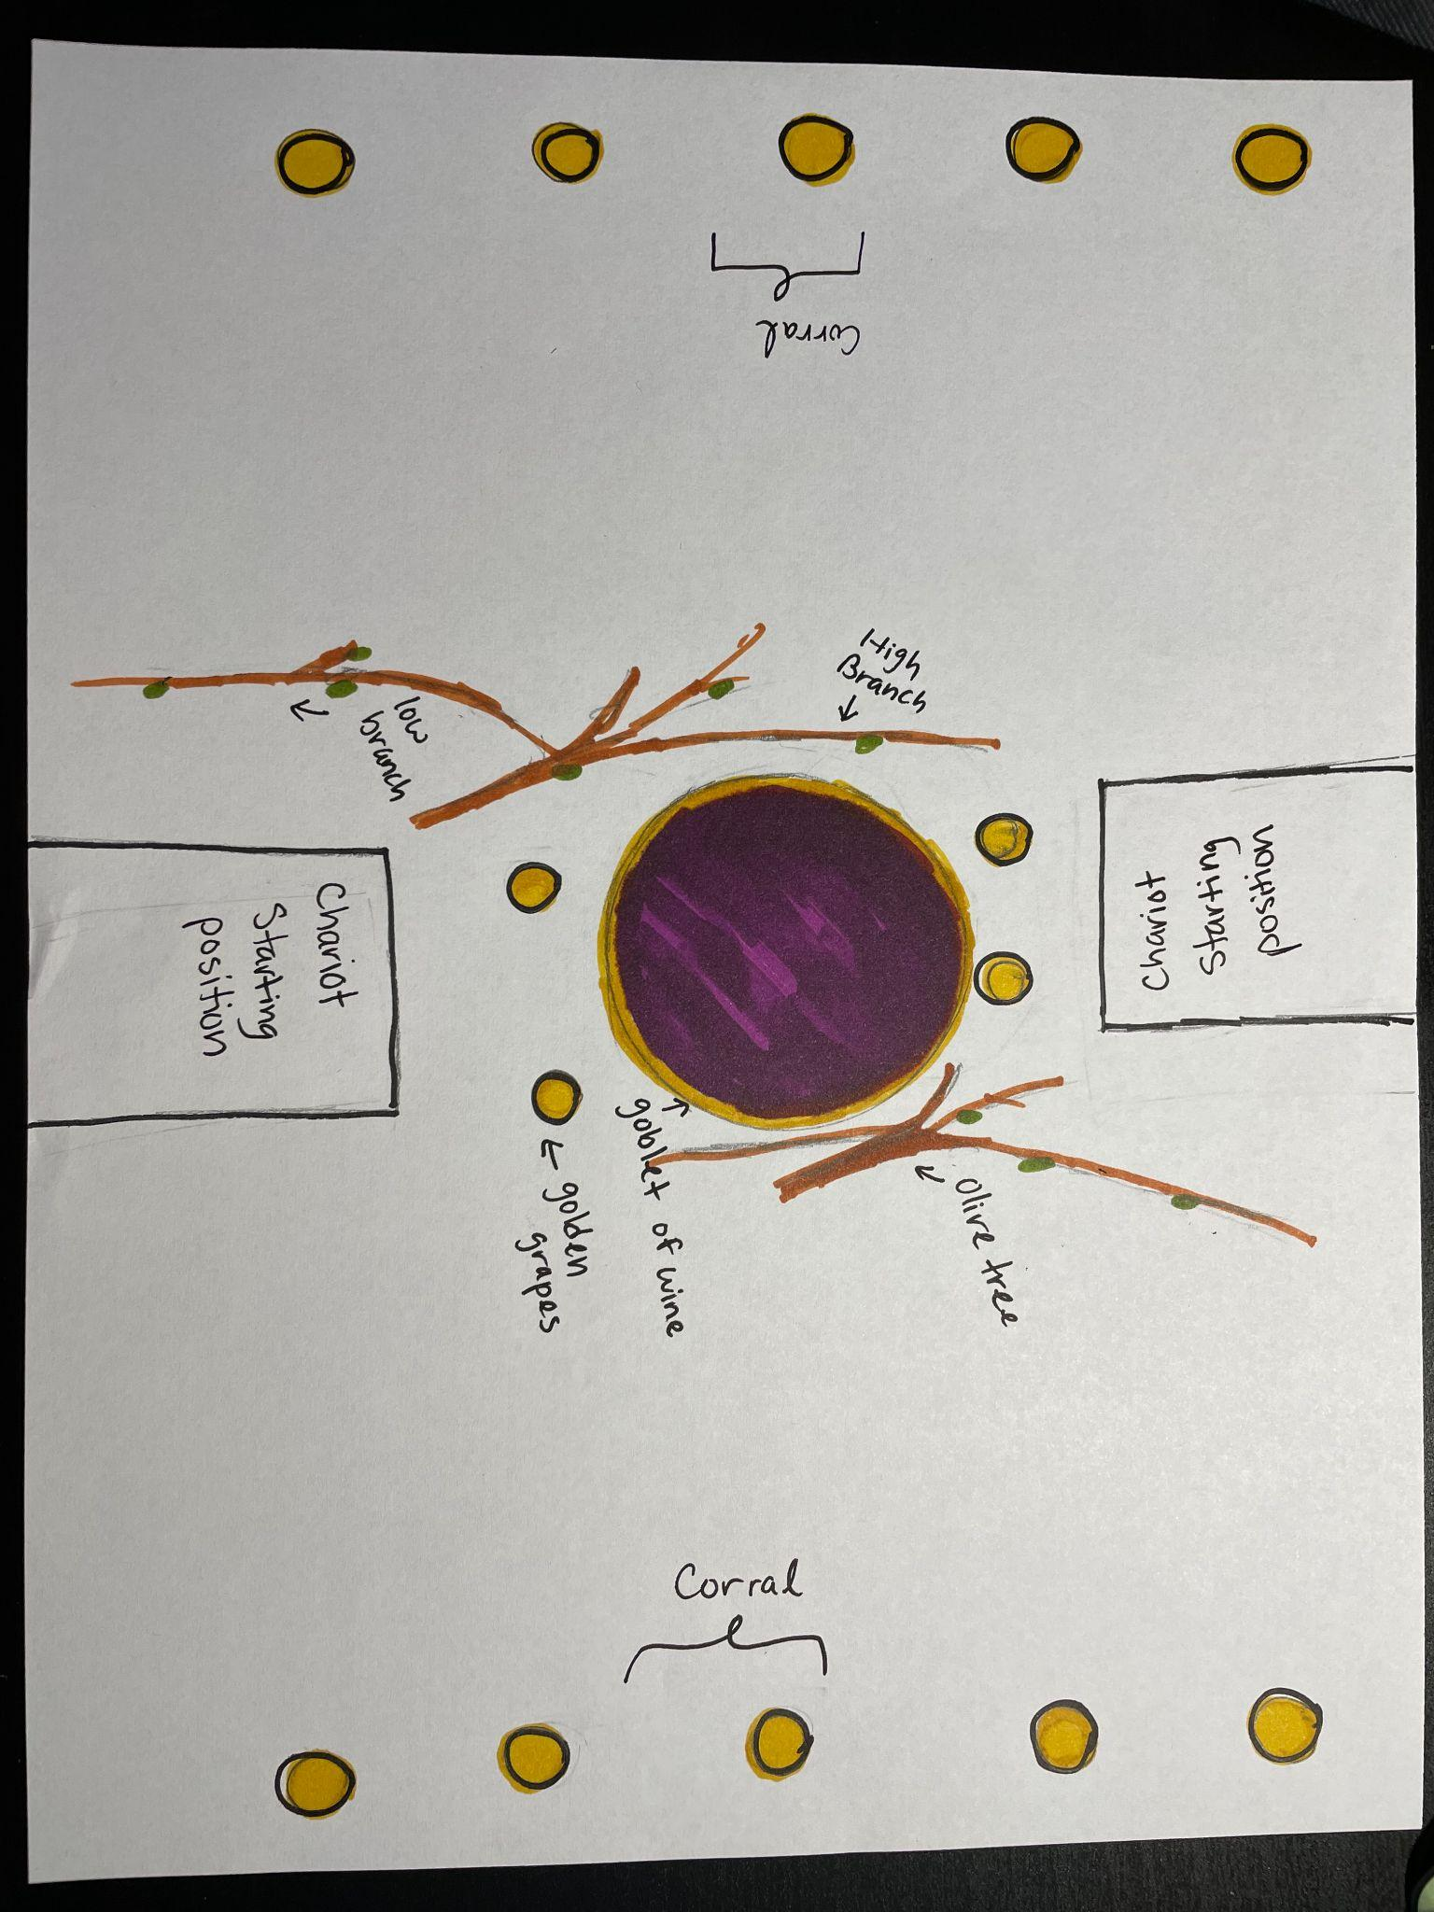

You can score points in multiple ways: First, 2 points are awarded for every golden grape pushed under the goblet and out of sight from the gods above. Second, 6 points are awarded for every golden grape launched into the goblet of wine. Third, 5 points are given for clearing a corral, which is the 5 golden grapes lined along opposite sides of the field. Lastly, at the end of the match, 6 points are awarded for hanging on the low branch of the olive tree, and 10 points are awarded for hanging on the high branch of the olive tree.

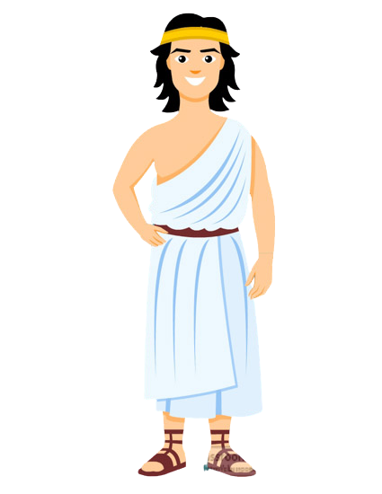

There are 3 ways to play this game. First, you both and one other pair have 60 seconds to drive your chariot around the field. The first person, Driver A, can operate the chariot for the first 25-35 seconds, and then must switch with Driver B. At the end of the 60 seconds, the points from both pairs are added, and each team receives the same number of combined points.

Driver A Driver B

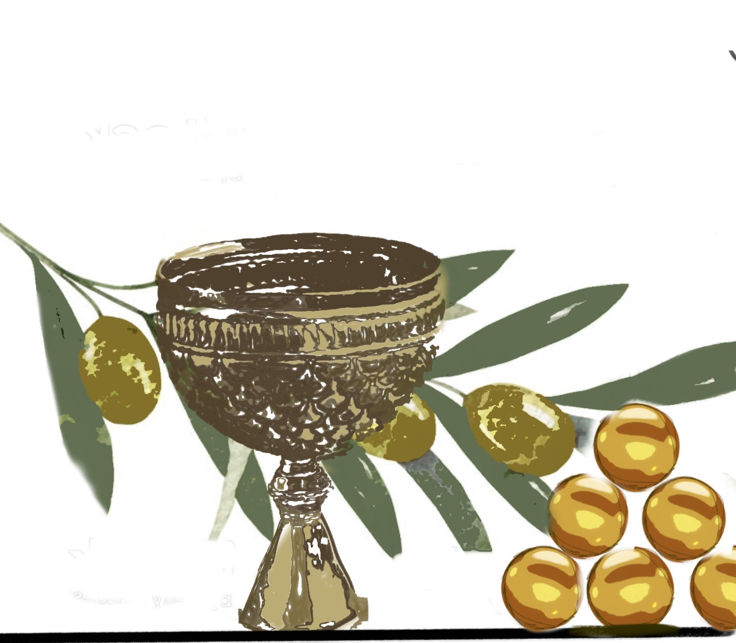

Second, in the driver skills match, a pair of teammates can drive their chariot around the field for 60 seconds (switching at the 25-35 second mark), to receive a number of points. Lastly in the programming skills matches, a pair of teammates can program their chariot to score points by itself on the field and are not allowed to drive it. The points earned from the Driving Skills matches will be combined with the points from the Programing Skills matches for one final score.



At the end of the day after all the matches, whichever team has the most number of points wins and is forever blessed by Goddess Athena and will be praised by all of Athens. She will also reward you with laurel wreaths as a symbol of her blessing! Good Luck, and Safe Building!

Credits:

Laurel Wreath - <https://www.pinclipart.com/downpngs/iTwJhmR_laurel-wreath-png-golden-laurel-wreath-png-clipart/>

Ancient Athenian Man - <https://classroomclipart.com/clipart-view/Clipart/Ancient_Greece/ancient-greek-man-wearing-tunic-sandals-clipart_jpg.htm>

Team 1715 A - Apex

Made by: Arshia.A, Arshia.T, Anaya.M, Kaesha.R, Kashvi.G, Ishana.K, Shruti.M, Sheethal.U

Hopkinton, MA