5327S’s Poster Submission
Team 5327S
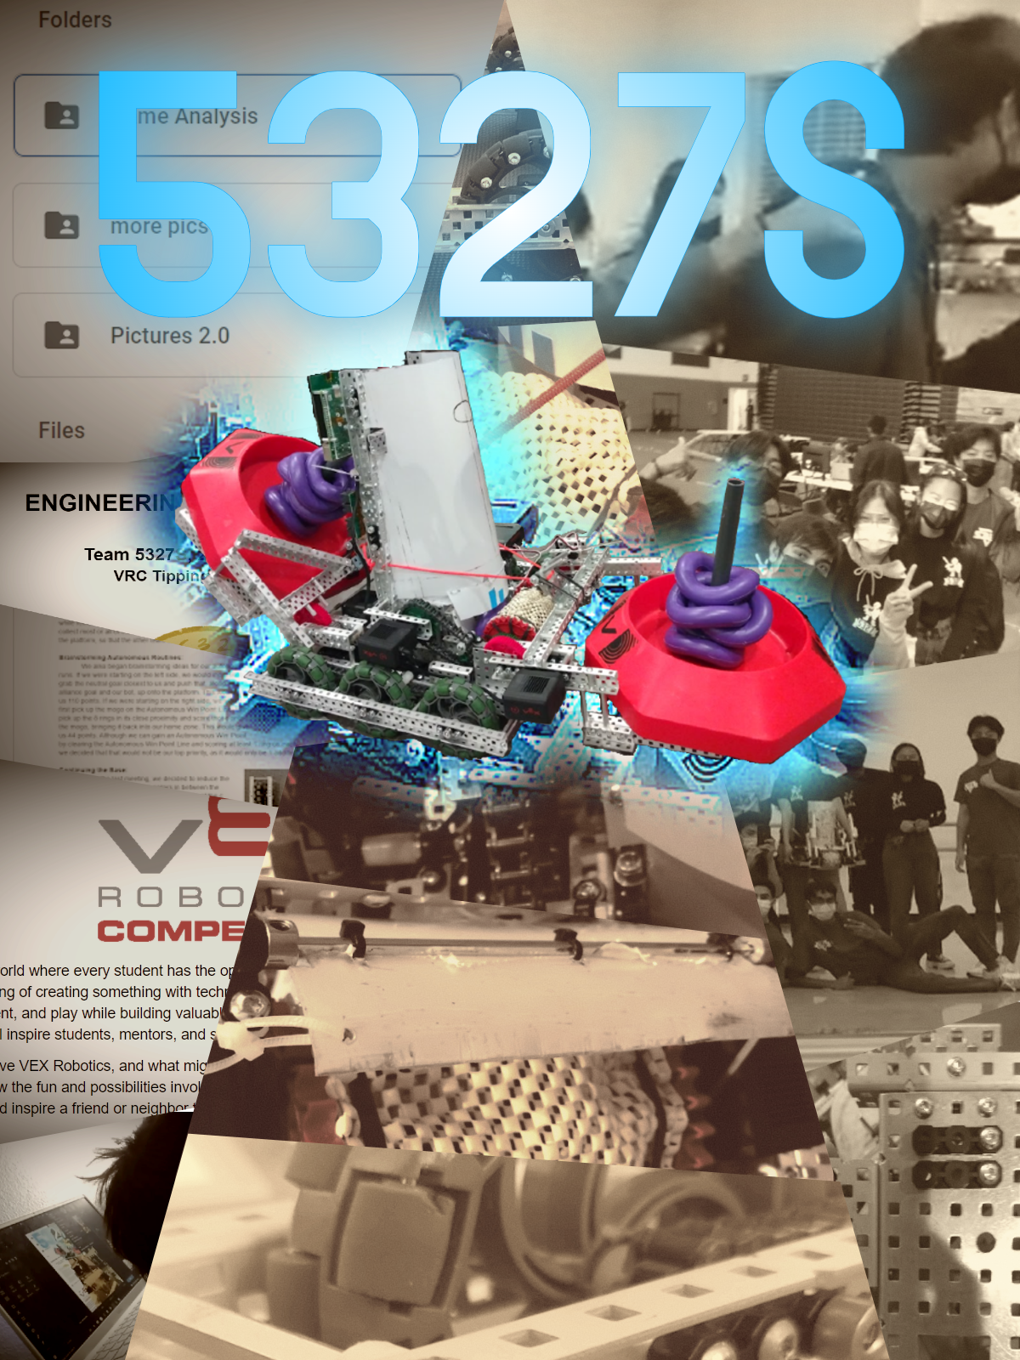
Team members involved - Anit Annadi, Sid Mathur, Jeia So, Edison Chan, Abhi Paranthanate, Dylan Wang
Dublin California

How Its Made
Our poster was made using an online image-editing tool called “Pixlr X”, through which we were able to take photos we had and stitch them together into our final product. The pictures in question are ones that were taken by ourselves, as we were putting together our bot, taking part in a competition, or simply having a good time. Using image cutting tools, we were able to make the unique patterns which can be seen across the poster, with the intent of breaking up the background to appear less boringly orderly. With the help of a recoloring tool, we could then make these images mesh together as a single color scheme. These tools were also used on the image of our robot being displayed at the front, which gives it its blue glow. As for formatting, in order to make the image fit within the given constraints, the dimensions have a ratio of 3:4, which.is respective of the required 18” x 24” poster requirement.

About the Poster
The goal of our poster was to display the most prominent aspects of the VEX robotics experience- tedious documentation, bot designing, team building, and competitions. Given that the name of the game is to make a poster, we designed ours with simplicity so that extra details will not take away from the soul of our poster- our bot. We wanted our submission to truly feel like a poster that could be put onto a wall, with a simple message of who our team is and what we do.

Our poster mainly utilizes colors- Blue and a faint Gold. Blue being the color that makes our bot and team name stand out, to emphasize what we might want someone seeing this poster to take away from it. Meanwhile, the faint gold is used to dampen the details of the background image to make the aforementioned details stand out even more, while bringing these highly contrasting background images together. On top of being a nice way to spiff up our images, these colors represent where we come from. Blue represents the blue Knight Mascot of the club which all Dublin High School Robotics Clubs are a part of- Gael Force Robotics. Meanwhile, the faint gold is reminiscent of our own team’s mascot, which is a gold coin.

In the poster, there is an easily evident divide into three parts. We used this to symbolize what we believed to be the three sort of “pillars” of VEX robotics for us. These being teamwork(right), robotics(middle), and documentation(left). We tried to make these three parts sort of bend towards our bot in the center, to symbolically show how each of these aspects are equally imperative in allowing us to get to where we are now.

