V.E.X.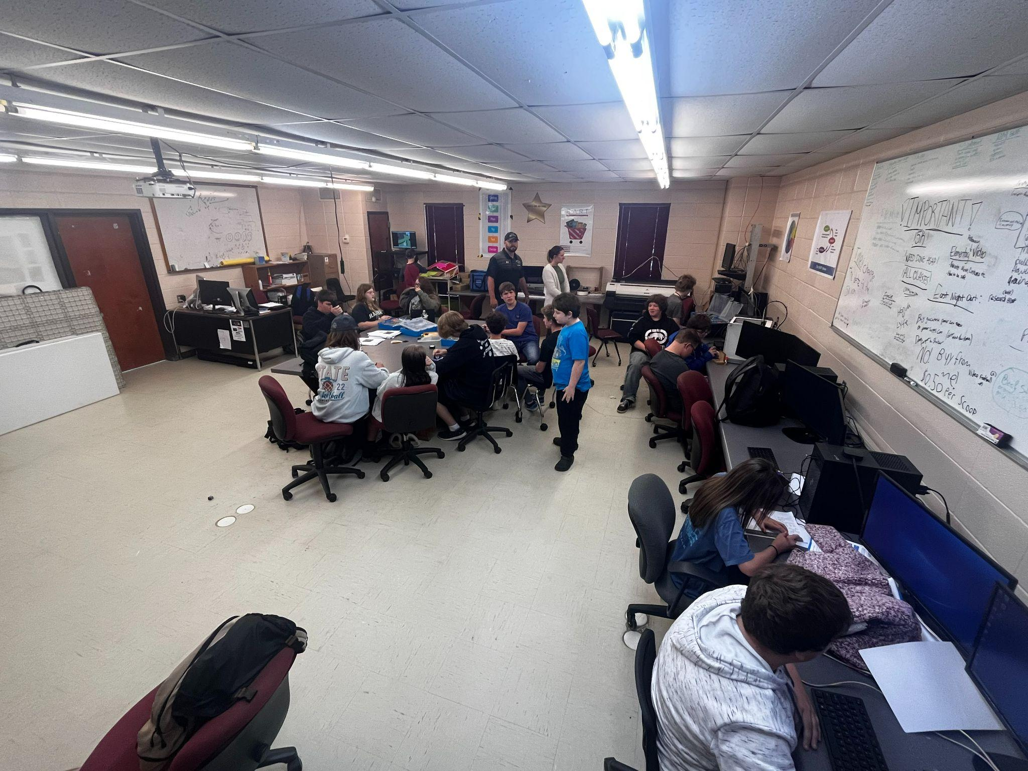

ROBOTICS

Why you SHOULD

Join ROBOTICS!

**~** **It’s fun!**

**~ You learn how to**

**Cope with large groups**

**of people.**

**~ You get to build**

**your own robot!**

**~ You can challenge yourself**

**and you can compete with other**

**schools and get money and**

**buy things to make your robots**

**cooler and stronger!**

**What is Robotics about?**

**~ Robotics is about building, designing, and constructing a robot that can complete tasks or challenges!**

**~ In Robotics you build a robot so that you can compete with other schools and if you win those challenges then you could win money and buy some more Robotics kits and make your robots better so that you can win!**

**~ It’s not all about winning though, it’s also about group projects! You have to have a helpful group that will help you get what you need!**