Vex Robotics

Hello my name is Alex Cook. My friend Ben and I make up the team 64145A also known as Botsteins located in St Cloud MN. From a young age I have loved to take apart and put back together various things. I have decided to use a pc to take apart for this challenge. There are three main parts that I am going to talk about today. The three parts are the fan, memory, and the battery.

The Fan is a cooling system that makes it so that the computer does not over heat and damage itself. Eventually if you did not have the Fan you would not be able to use your computer.

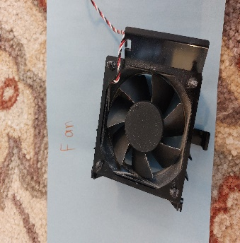

The Memory is what stores the data that you are downloading to your computer. If you did not have the Memory every time you would not be able to download anything.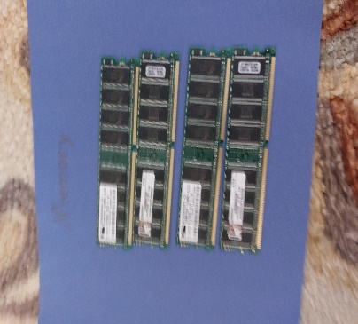

The Battery is what is used to power all of the parts inside. Without the Battery you would not be able to use the computer at all! The Battery is one of the most inportant parts of a computer.

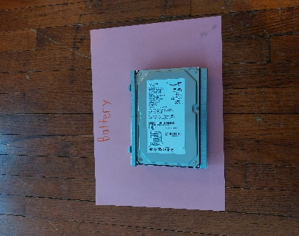

Over all this is what the computer looks like without any parts removed.

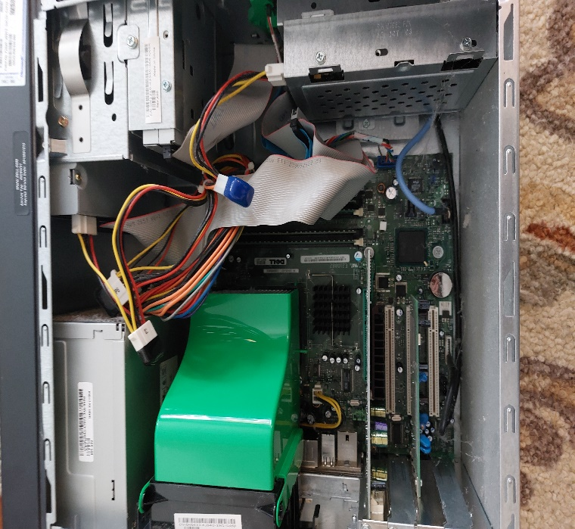

These two pictures show the inside of the computer with some parts removed. It looks like a big mess but all those parts play their own role. Without some of the parts this computer would not be able to run.

