**Reverse Engineering Online Challenge sponsored by Texas Instrument.**

Team Phoenix Colombia

As a team that loves technology and computers, we wanted to know how a computer Works, and understand its parts and how they work together, and also learn how to make a computer better.

We found the computer has different parts:

1. A processor
2. Motherboard
3. Ram memory
4. Hard drive
5. Graphic card
6. Mechanical disc
7. Mouse pad
8. Keyboard
9. Speakers
10. Connection ports

At the left of picture 1 we see Tomás who wonders which part of the computer allows it to “think”, which part converts information into action? While unarming he computer we saw something like a chip, our teacher taught us it was the CPU, the part of the computer that allows the correct functioning of all the parts of the computers which we will be mentioning, it is like the boss that directs all the functions.

In the Middle of picture 1, Maria Fernanda is showing a card that was connected to other elements like USB ports, HDMI port, keyboard, mousepad, connection ports. It is called mother board. As she saw how it connected different parts of the computer, we concluded it´s function is to connect al the parts together so they can “talk” with each other

At the right of picture 1, Jose Miguel is showing a card that looks like a Nintendo plaque. It is the RAM memory is like the brain of the computer, that remembers, finds and processes the information, just like our brain allow us to think. The processing speed depends of it.

We also found a metallic box, which is the mechanical disc, it is like other part of the computer´s brain, that saves or stores the computers information like pictures, music, videos, documents. It Has a motor that passes and verifies information until it finds what it needs, and gives it to the RAM memory for it to process it. Other computers have a solid stat which is faster.

Many computers have an element called GPU, which is the graphic card. It transforms information into images so it can be projected into the screen for us to see it

Other elements that we found were: the mouse pad, keyboard, screen, speakers, internet connection, that all connected form a computer

PHOTOGRAPHIC RECORD

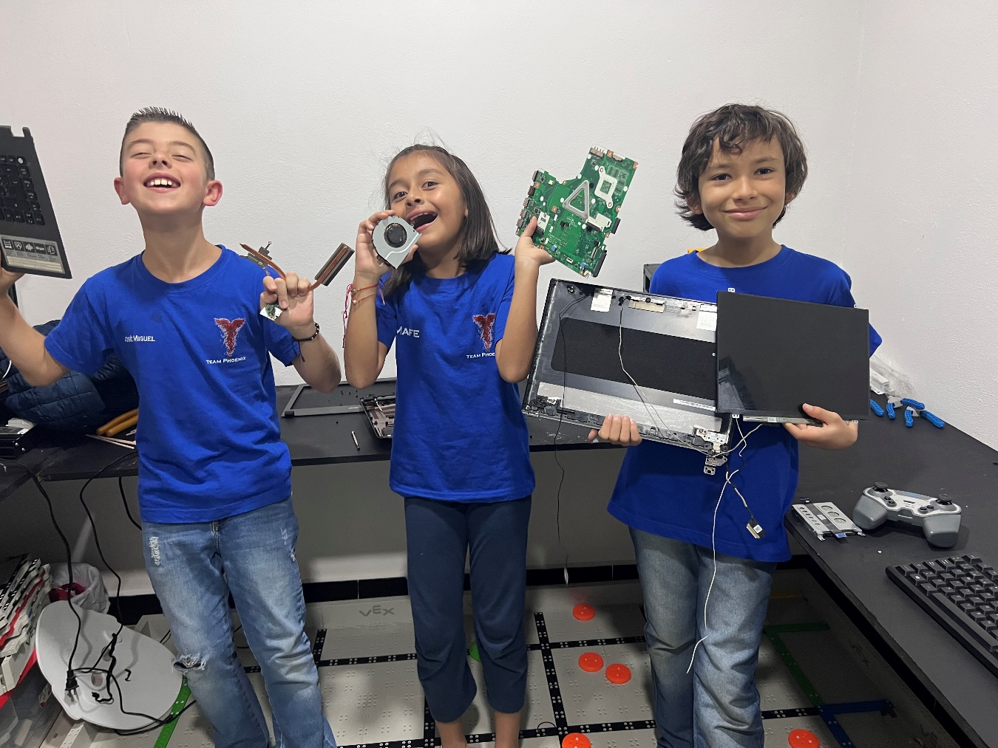picture 1.

**}**

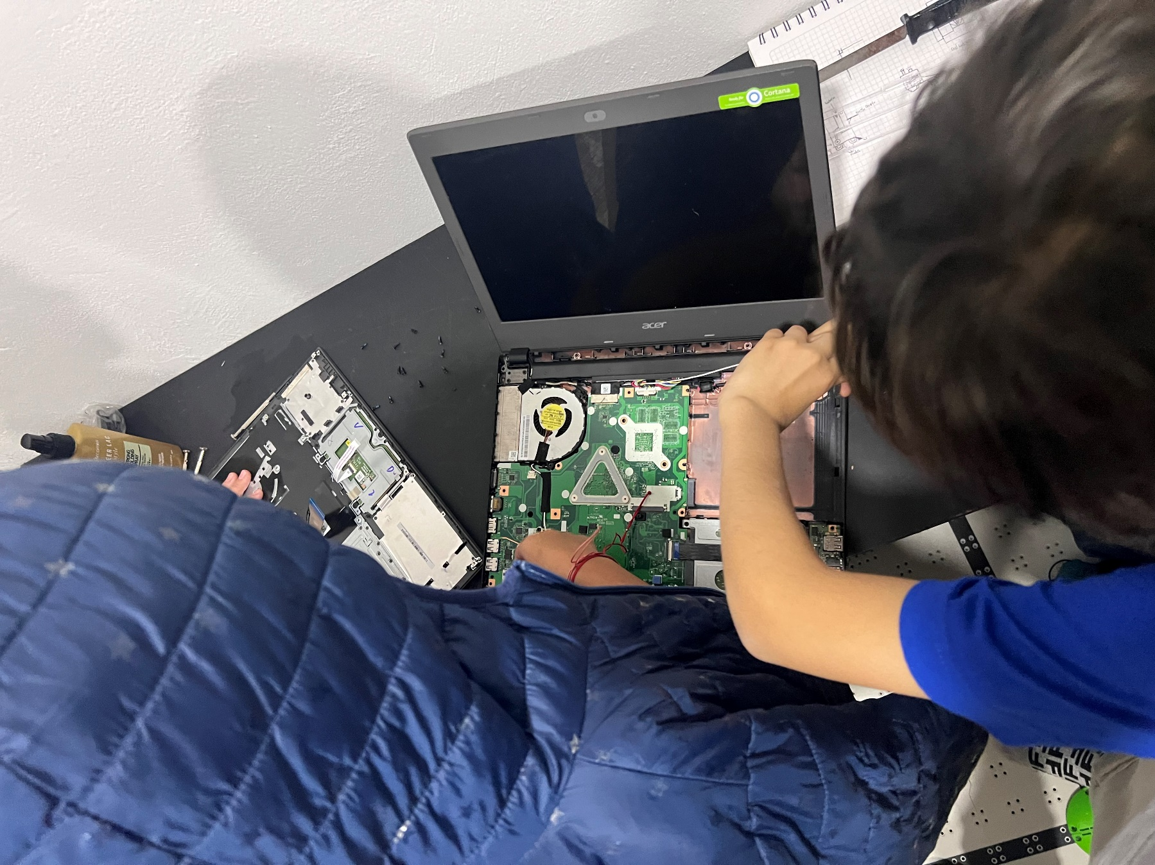

picture 2

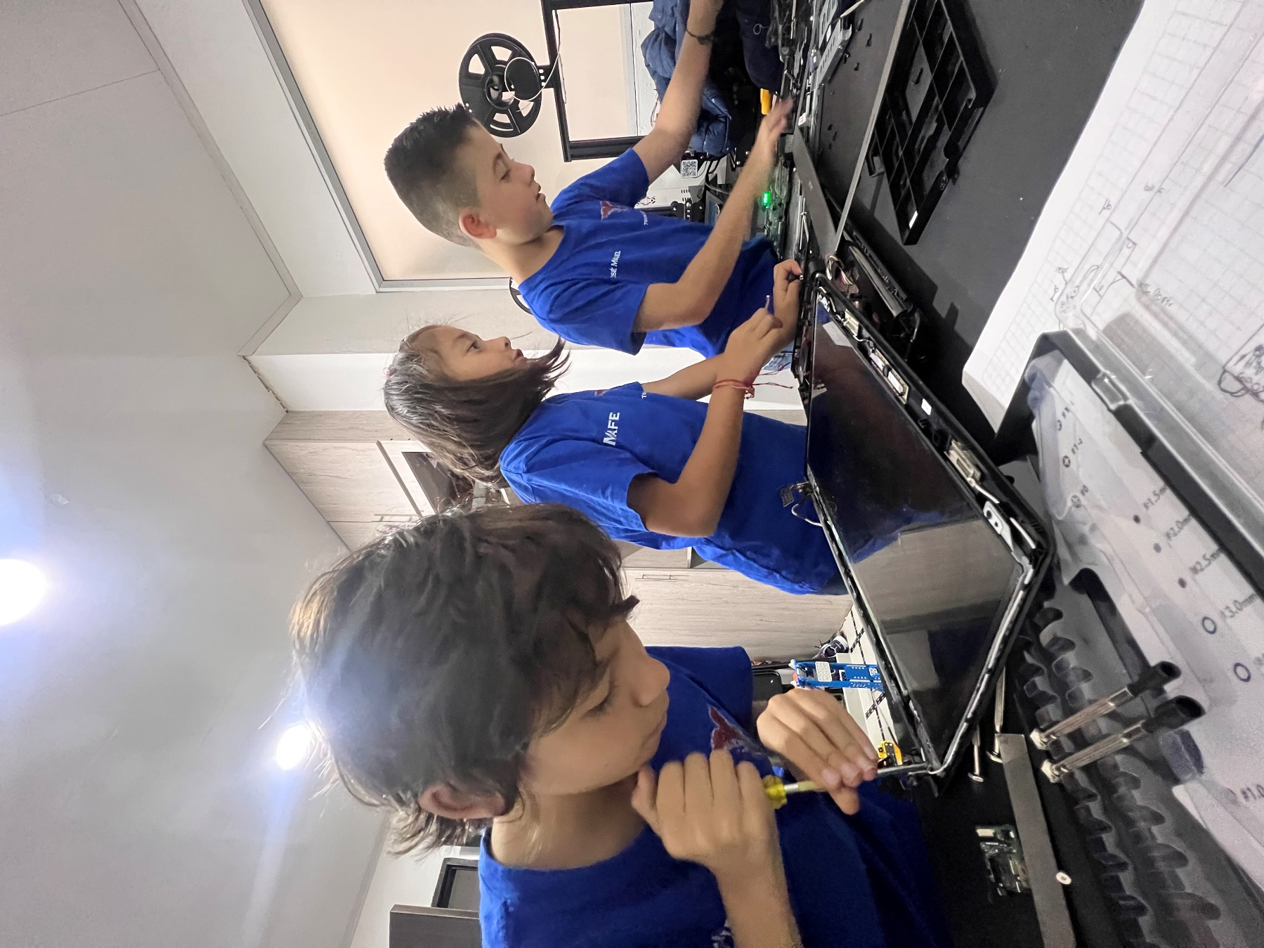

picture 3

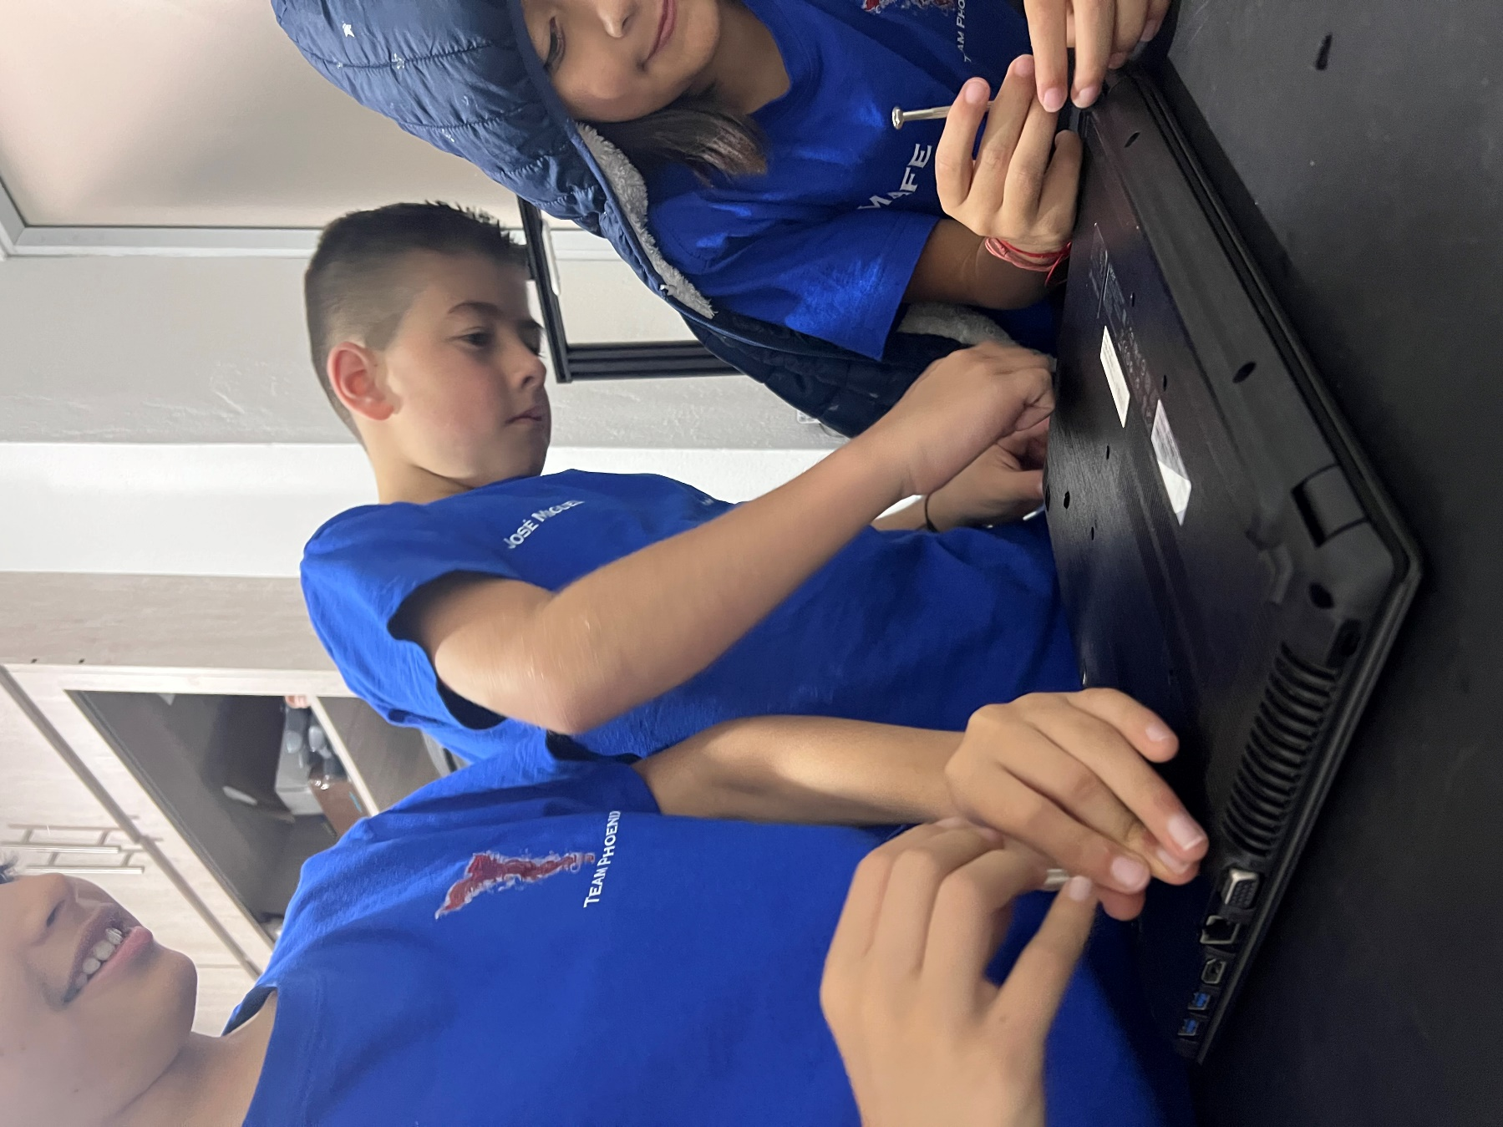

picture 4

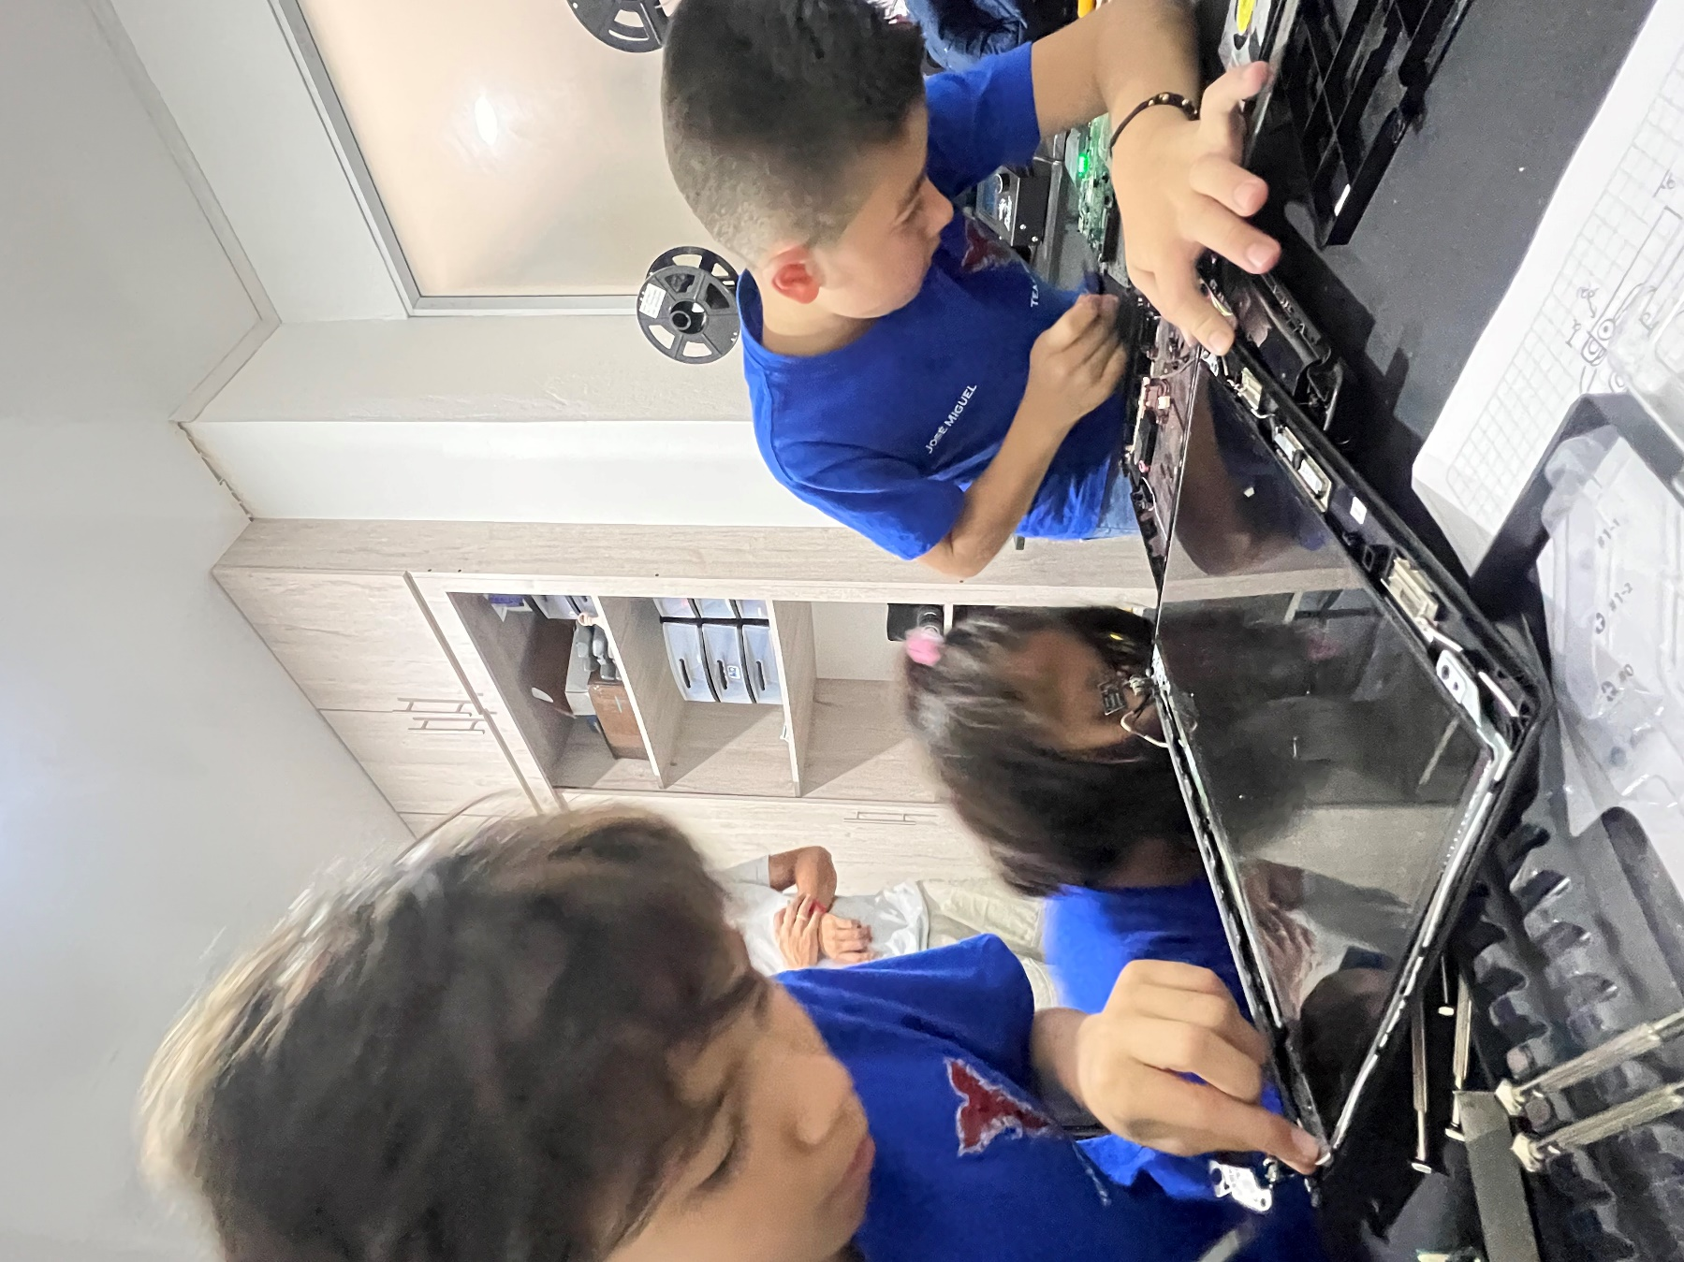

Picture 5

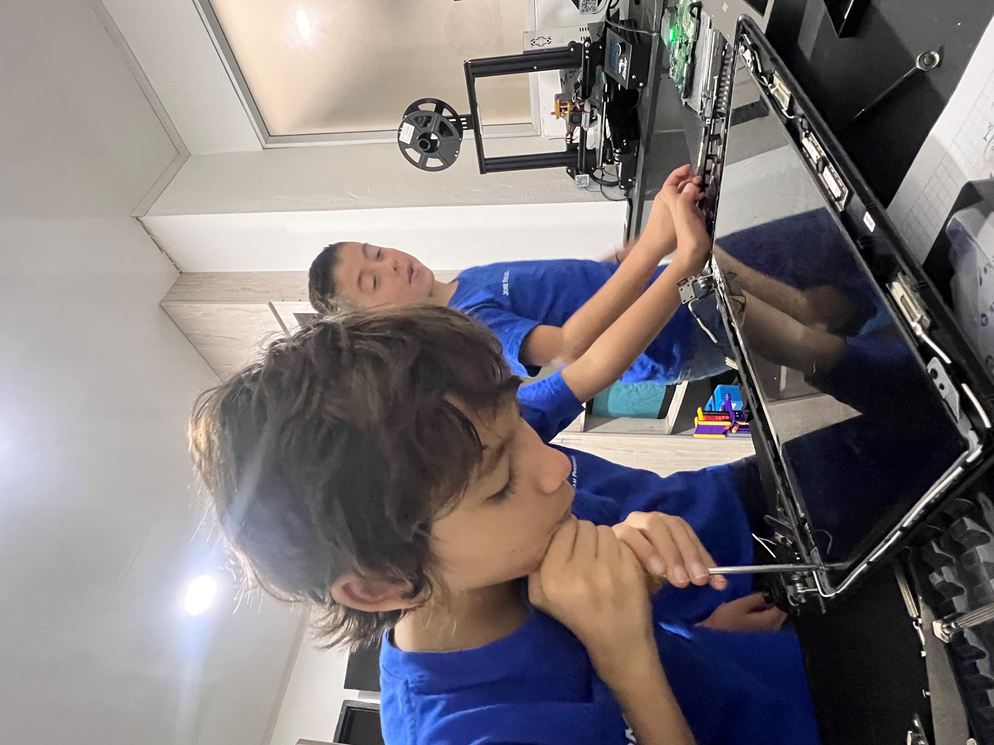

Picture 5

we thank Tomás's mom for helping us translate.