VEX RECRUITMENT POSTER

Student participation: Emily Chamberlain

Team #: 98709F

Location: Dayspring Academy, Greenbrier TN

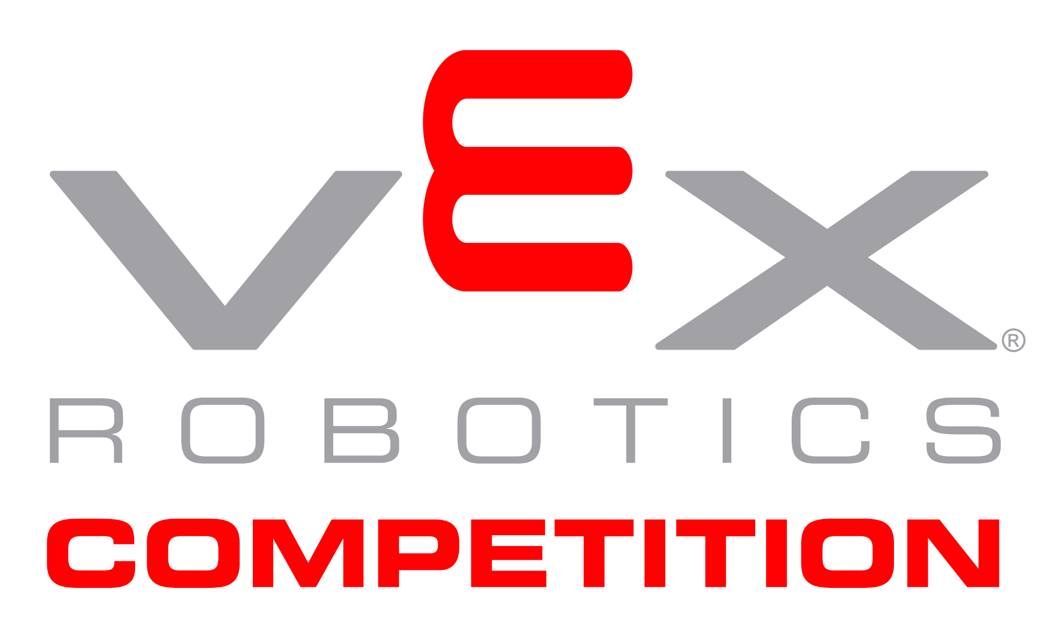

**My Design Process:**

The design process for my poster was quite simple. Whenever I was coming up with ideas I thought about what would get my sister to join a VEX robotics team. My sister,who is only 10 years old,knows she wants to be an engineer when she is grown up. I have encouraged her dream extensively especially considering how few women engineers there are. I think it’s important for women and girls to feel like they are included in a robotics environment the same way men do. I believe in equal rights and this poster firmly supports that message. I created my poster using Canva and I asked for input on my poster from my peers. After I got feedback I tweaked the poster until the message I wanted to portray was clear. That message is women and men alike can be engineers.