Teresa Pham

11108B Team Axle - Lotl

Mulholland William Middle School

17120 Vanowen Street

Lake Balboa, CA 91406

Southern California Region

Deconstructing A Logitech Mouse

A Logitech computer mouse. A simple gadget that is used by millions around the world to help simplify their lives, but no one ever stops to wonder what allows the mouse to work. How does it function? What is it made up of?

To the plain eye, the computer mouse holds a USB (Universal Serial Bus), which is used to 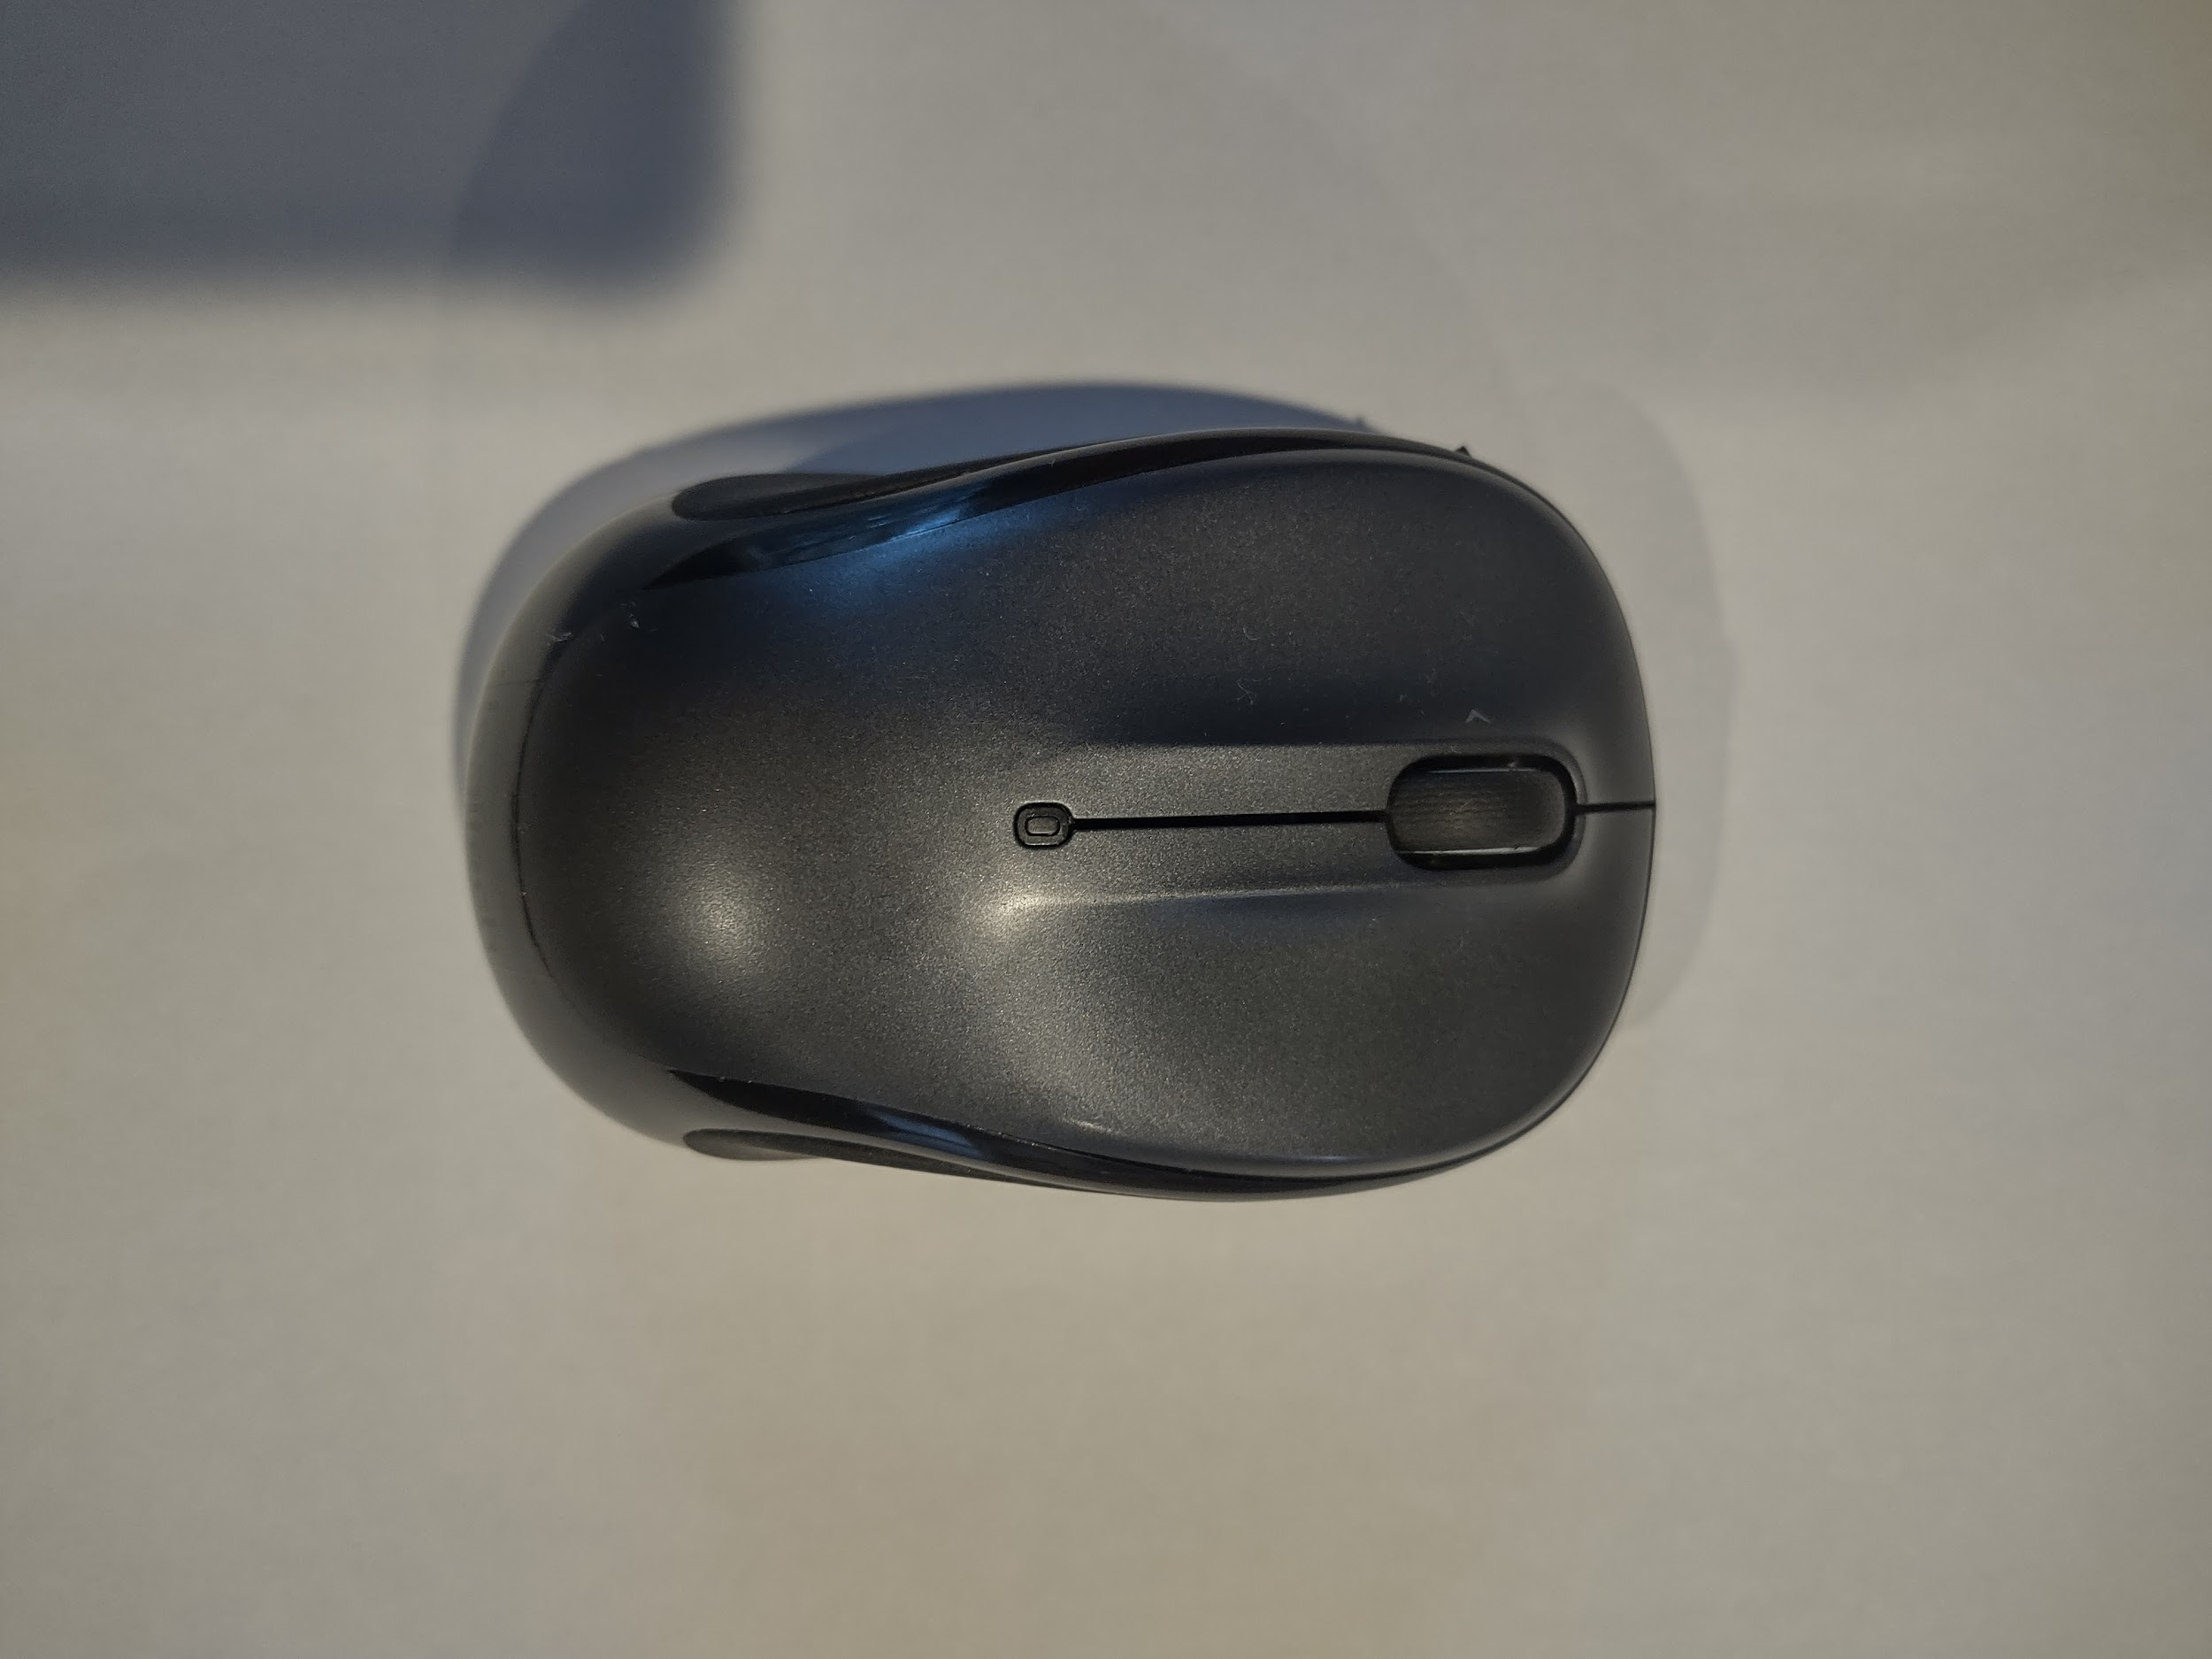connect the mouse to the desired device. The mouse also has a little compartment to put the USB and battery in. The mouse is designed to have its sides curved in order to prevent wrist strain. There also appear to be four circular ramps, at the bottom of the mouse, this is known as mouse skates. It’s to make the mobility of the mouse smoother. Lastly, there are two buttons, a 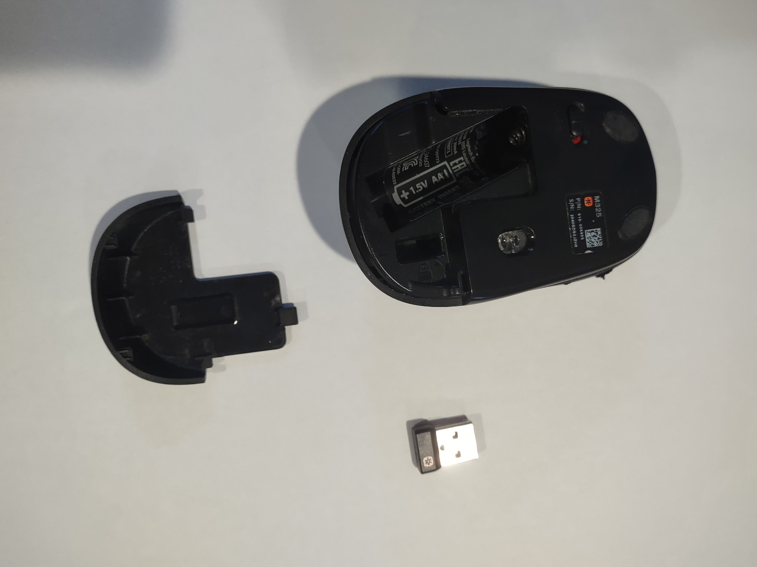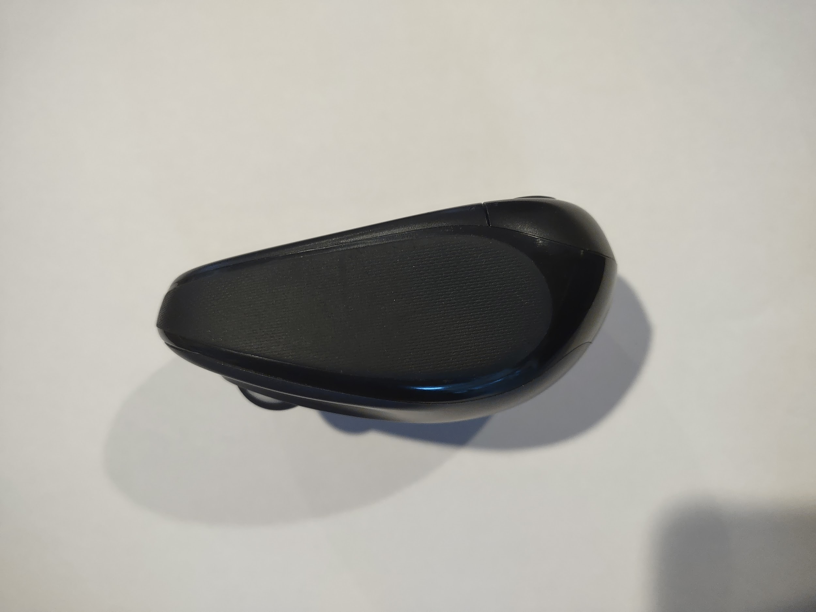

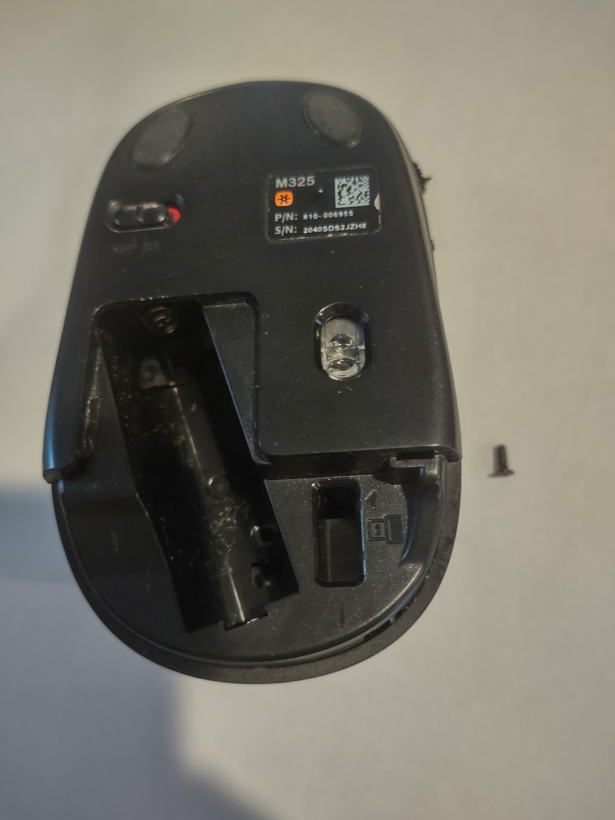right click, and a left click button located on the top.

To start the disassembly, we removed a black sticker that needed to be removed in order to unscrew all the main components together. When the parts were finally separated, the first thing that we looked into was the scroll wheel. The scroll wheel is used to scroll up and down on any online page. The second thing that was found was the mouse 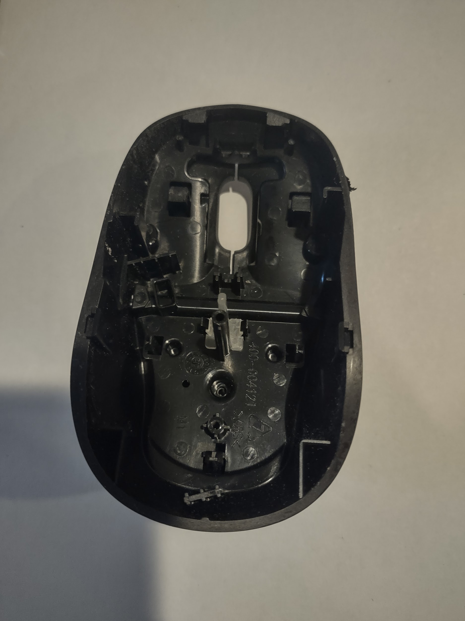shell/skin. It is the outer part of the mouse. It is used to protect the main inside components of the mouse. The third thing that was discovered is the circuit board (The Entirety of the Green Board). Its purpose is to send signals to other parts of the electronic device, it works just like the brain.

Furthermore, there are also a lot of main components that connect with the circuit board. This mouse is an optical mouse, which means it uses LED lights and light detectors to detect movement and surroundings. Moving on, the other main components are the prism/mirror, CMOS sensor, micro switch, and rotary encoder. Now, the functionality of the prism/mirror is reflecting and guiding the light (created by the LED light), to the bottom of the mouse. Equally important, the CMOS sensor works by detecting light. Once it detects the light, it also knows where you are moving the mouse (Ex. Up, Down, Right, Left). Next, the micro-switch is used to register clicks, it informs the device how many and when the clicks are received. Lastly, the rotary encoder functions by both sensing the speed and direction of the mouse wheel. 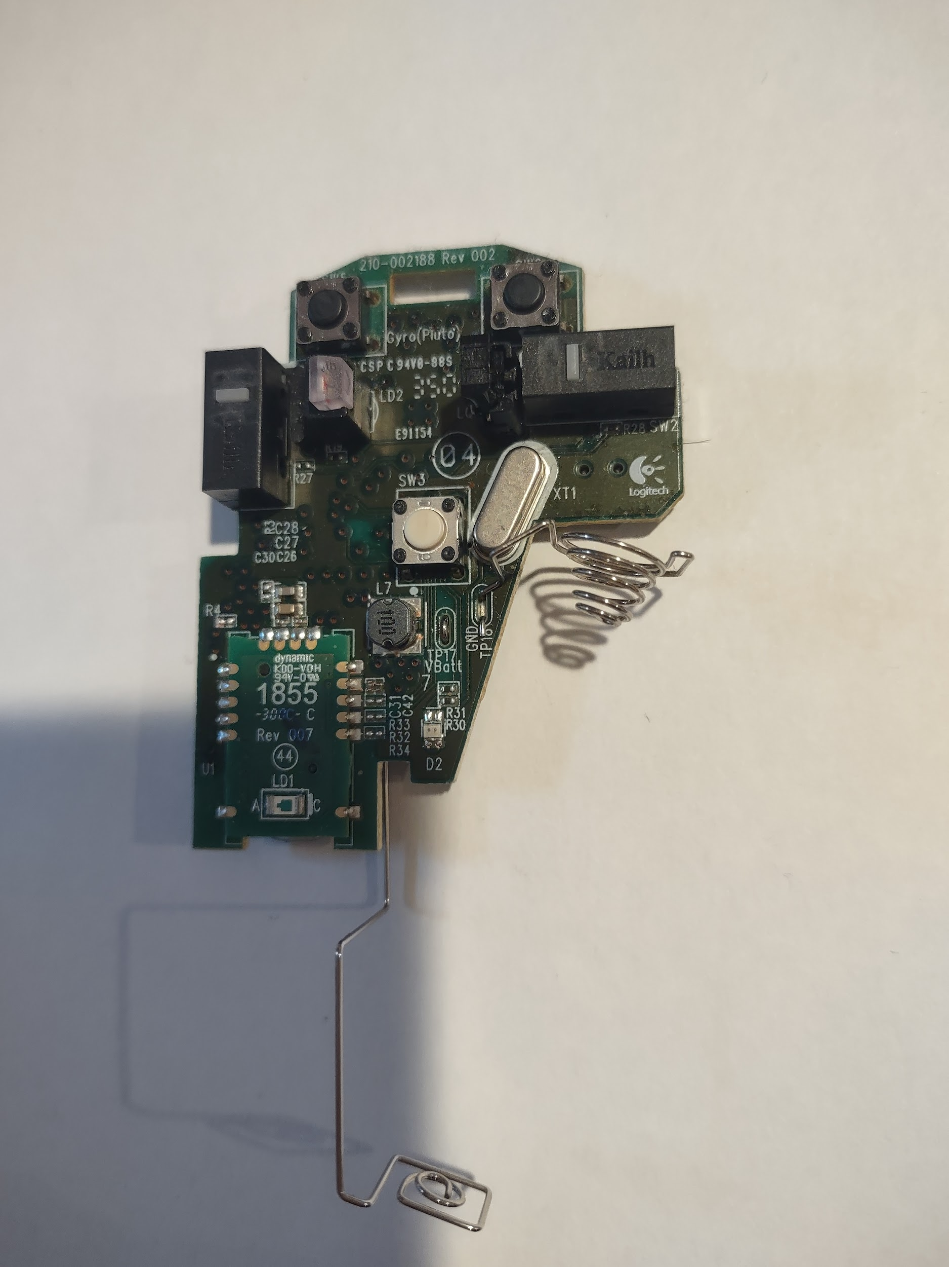

In conclusion, the process of disassembling a computer mouse really taught us a lot. We learned something that is regularly used in day-to-day life may seem more complex than the outer shell. If you have ever used any electronic device that seems very simple, and easy to use, always remember that the main components are located in the insides of those electronic devices, that is where all the main engineering goes.