***Microsoft’s Use of the Engineering Design Process; A Practical Approach***

Written by Chelsea M.

Team 11108A

Rubix Cube

Mulholland Middle School

17120 Vanowen Street

Lake Balboa, CA 91406

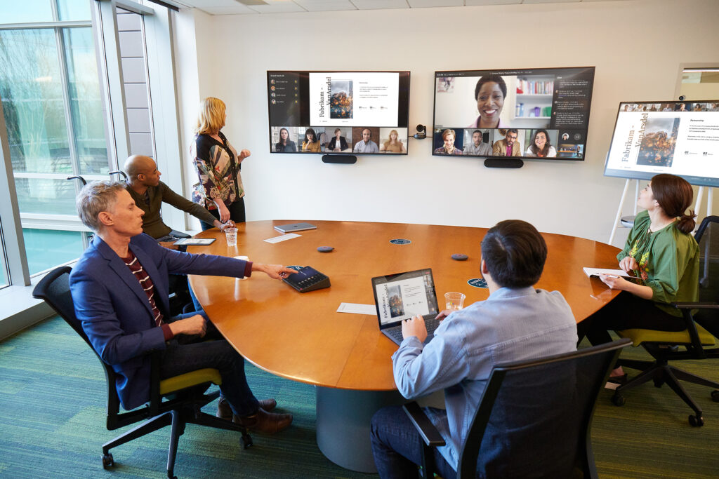

Microsoft is a computer software company that mainly focuses on the manufacturing and development of brand-new or significantly better technology products to be released to the public. It is widely known as the world’s largest vendor of computer software, changing the world with their products, and inspiring the newest generation to work in a similar fashion to them. Besides being globally known as the largest computer software company, Microsoft stands out because they often publicly admit to the mistakes made in their products or as a company in the past and work hard to improve them for their customers. Most companies would claim that nothing was wrong with their product and avoid the pleas of their customers to fix them. Microsoft manufacturers and developers often use the engineering design process whenever developing a new product. 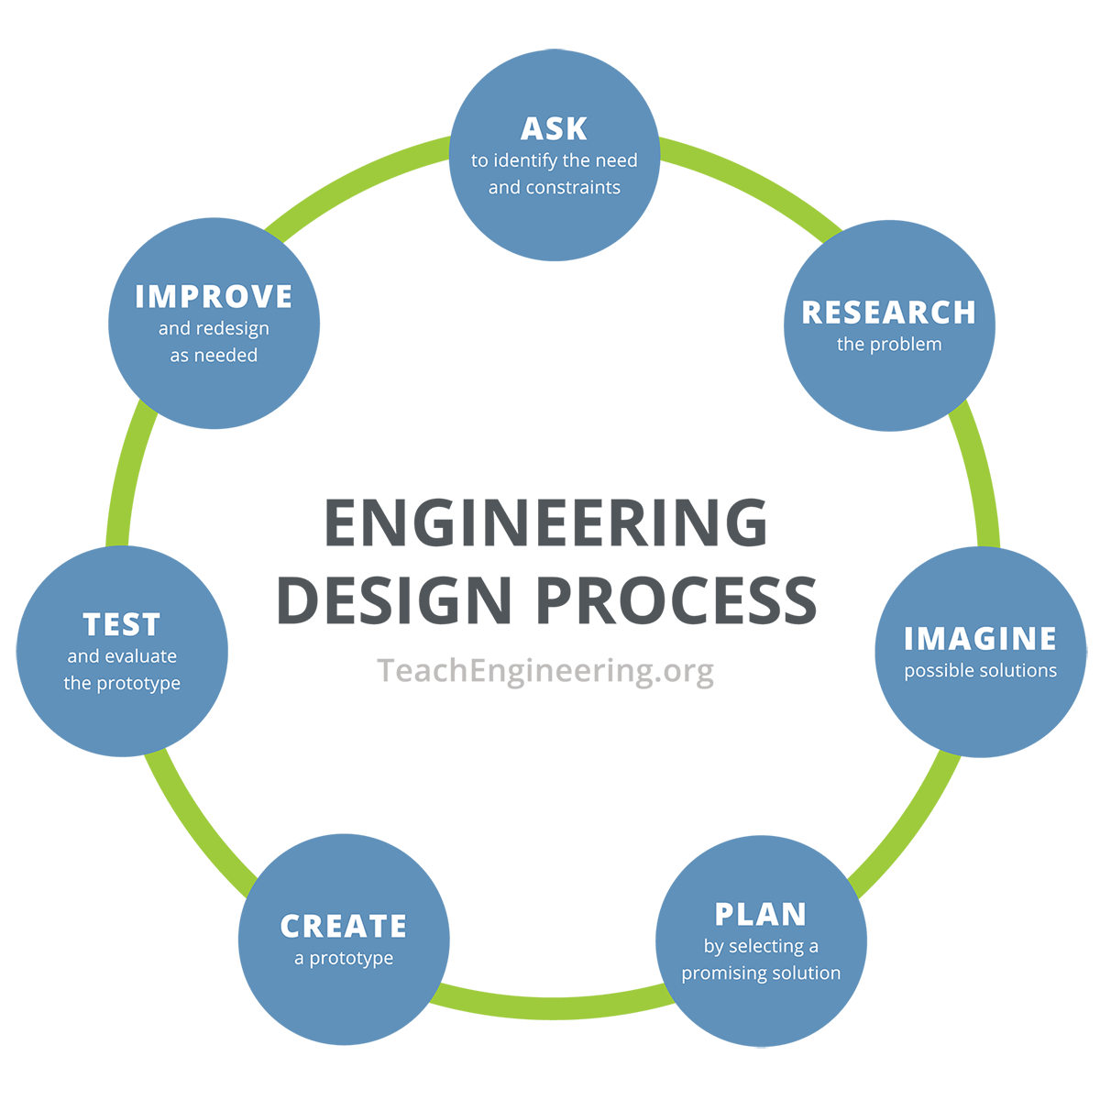

These manufacturers and developers will get together in small groups and work on the challenge at hand. In those groups, they will imitate made-up scenarios to best use product design, improve processes used, continuously test out their products throughout the process, and ultimately decide the best design for the product. Their imitation of scenarios is how they use the research and imagine steps of the design process. By simulating these situations, they can figure out what the problem is with the first design of their product. They can then begin the brainstorming phase, where they begin thinking of how to improve the problems with the design and product.

Usually, research and multiple rounds of testing on the first design are done in their version of the brainstorming phase. Following this, the developers move on to planning out what to add or improve in their new design of the product to make it work better than the first version. This is when they start creating the first prototypes needed and note that these versions may not always come out as amazing as they would expect. Mistakes and failures often happen in the engineering design process, which is why they look to improve the prototype. In every step of this process, or in as many circumstances as possible, the Microsoft team will continuously test the product in question. This aids the developers in finding out what specifically is malfunctioning in each phase of the entire process and in looking to find ways to refine the prototype.

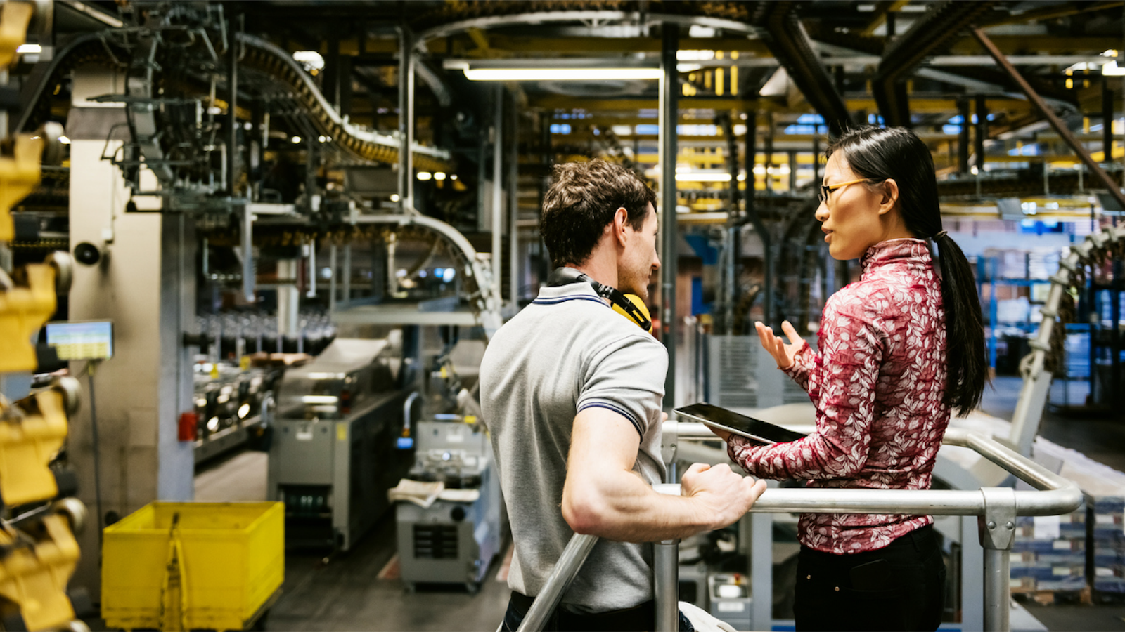

Their process is unique and while it differs from how we personally use the engineering design process, there are similarities here and there. Our team often separates into individual groups to work on a prototype of a component of the robot or just the robot in general, though usually just a component. Teamwork is considered everything to our team, a valuable asset that we depend on, just like how Microsoft values it so much. Without teamwork and having our team join to work on the robot, we would not be doing as well as we are right now. We also test our prototypes ourselves, nearly every week. The results of these quick tests are not recorded and put into the Engineering Book. These so-called tests are generally small, to see if or how a certain component works after a change is implemented onto the robot. It also enables us to fix or secure any components. Our engineers are constantly testing out the robot after modifications to ensure that the component works as well as they wish it to. Unlike our team, the Microsoft production and development team does not ask what the constraints, problems, or needs are. They usually go on and begin their work, knowing what needs to be done and improving any mistakes later in the process.

VEX Robotics has prepared my team and me for a future, differing from a mechanical engineer to a software developer. I have learned a handful of skills that can be used in the real world from being on the team for over a year. These skills include, but are not limited to, leadership skills, teamwork skills, social skills, and learning new ways to solve problems. Learning new problem-solving skills would include the famous Engineering Design Process, which was not familiar to me or my team members before joining the team. From learning it by heart, our team has been able to build amazingly effective robots and efficient coding. Whenever I need to solve a problem, I take the Engineering Design Process into consideration.

VEX Robotics has also bettered my skills in teamwork and socialization, while previously I was not as much of a teambuilder or a socializer. My social skills have improved, and I feel more comfortable talking with strangers than before. I now often prefer to team with a friend or two while working on something, rather than working alone. These skills are necessary for any sort of future career a student wants to pursue if they want to better understand and communicate effectively with their colleagues, even if the career path they want to take is not a STEAM career. These skills are necessary for any type of career, STEAM or not. Leadership skills are also crucial in VEX. Without our team captain, we would not survive. Our team captain was not interested in leadership when she first started on the team last year, yet she is now the reason our team stays in check. Leadership skills are everything in the work field, from keeping a company together to inspiring employees to never give up and reach their potential.

[https://www.microsoft.com/insidetrack/blog/transforming-modern-engineering-at-microsoft](https://www.microsoft.com/insidetrack/blog/transforming-modern-engineering-at-microsoft/)

<https://learn.microsoft.com/en-us/industry/manufacturing/unlock-innovation>

<https://nap.nationalacademies.org/read/10063/chapter/4#19>