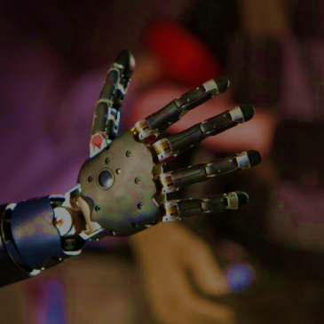







By Maryam, team 1850B ,NLCS_Phantoms

North London Collegiate School

Edgeware, London



C A R E E R R E A D I N E S S

**Biomedical Engineer**

I selected biomedical engineering as a STEM career because it is an increasingly important career, where solutions to global health problems are created, allowing patients to be treated more effectively, as well as lowering the cost of healthcare, which has a universal impact, providing many people with better, more accessible healthcare.



These processes are similar because they both involve changing designs to find the best solution to a problem or challenge, as well as working and co-ordinating with a team. Also, similarly to engineers in other STEM careers, engineers in this field find previously designed technologies and products, and change, build on and improve them to create an original, improved product. They do this by researching existing design solutions to a problem. Our team used a similar method, using examples of robots built for the same purpose, and taking inspiration from these designs, further improving and building upon them. We then created a shared team vision for our robot, allowing us to all have a goal to work towards. By doing this, we were able to come up with an innovative and efficient design. Also, our team came up with multiple different designs, and tested them in order to find the one that worked the best, similarly to the third step mentioned above, of a biomedical engineer’s process.

Biomedical engineers are medical science professionals who apply engineering design processes to solve a variety of problems within the sphere of medicine. They have an important role in creating new technology, which requires them to use design processes, similar to those used by our team, to identify and solve problems. The main steps of this include:

* Identifying a need for a design, or a problem that needs to be fixed with a new design.
* Researching the problem or existing solutions to the problem
* Coming up with possible designs, and selecting the best one
* Creating a prototype of the design
* Testing the design
* Communicating it to a team

However, our design process also differs to that of a biomedical engineer in a few ways. The main difference is that while biomedical engineers would usually develop multiple possible prototypes using 3D printing and select the best one. Our team had a more limited timescale than professionals in this career and therefore were not able to develop prototypes, and then create them. Instead, our team found multiple designs that we could create then changed our design to improve it as we tested it at school and after competitions. Moreover, the design process of a biomedical engineer largely revolved around CAD (computer aided design). On the other hand, our team used sketches and pictures instead, to design our robot as this was more time efficient for us. Moreover, we did not produce physical prototypes of our robot, so creating a CAD model was not essential.

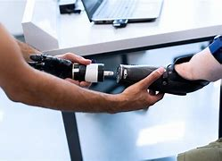

Participating in VEX robotics prepares students for a future career by teaching them how to design and create a product, using an iterative design process. This prepares them for a future career because technology advancing means that more careers require skills such as designing technology using engineering processes as well as creating and applying a piece of code to carry out a function. Vex allows us to further our skills in these areas and go beyond the curriculum, which means that we will be more prepared when it comes to beginning a career in STEM. VEX also prepares students for a future career by developing teamwork and communication skills, which are important for a variety of different STEM and non-STEM careers. Moreover, it improves critical thinking, problem solving and gives students the ability to adapt when thing go wrong. These are fundamental in any career and therefore, participating in VEX is excellent preparation for the world of work, especially in the field of STEM.